SLOs and Assessment: Mapping the Route to the Lost Ark

2008 Curriculum Institute

Marcy Alancraig, Cabrillo
Assessment Coordinator
Janet Fulks, Bakersfield College
Michael Heumann, ASCCC Curriculum Committee, Imperial Valley College
SLOs and Assessment: Mapping the Route to the Lost Ark Thur 3:45-3:15
Student learning outcomes (SLOs) are a tool for curriculum development and program review. But simply writing SLOs is not of much value. Assessing the SLOs and using them to improve curriculum or programs is essential. How do you document that SLOs are present for each course? How do you know if the SLOs are well-written and do you care on curriculum committee? Where does assessment play into the work of the curriculum committee? This session will discuss some of the statewide patterns for SLOs and assessment as a vehicle to develop and improve curriculum. The session will be interactive with opportunities for you to explore the curriculum committee's role when it comes to SLOs and assessment.
Potential Warm up quiz
Strand 1 Assessment
- The goal of the curriculum committee is to
  - rewrite curriculum submitted so that it conforms with education code.
  - correct spelling and grammatical errors.
  - review curriculum to assure it complies with the Education Code.
  - see that the curriculum addresses sound educational practices.
  - provide for continuity of curriculum across the campus.

- Curriculum committee, representing the faculty senate, have primary roles in writing and approving curriculum
  - because it is granted them in AB 1725
  - because they are the most knowledgeable about curriculum structure.
  - because it is granted them through the accreditation process.
  - because it is granted them though the state academic senate.
  - because it is granted them in Education Code.

- It has been proven through research that the type of pedagogy which results in the greatest degree of student expertise and knowledge occurs through
  - Well-developed lecture series
  - Laboratory activities
  - Activities that stimulate student interaction within the classroom
  - Activities and exercises completed by the individual outside the classroom
  - Periodic and cumulative objective testing

- Student learning outcomes refer to overarching specific observable characteristics
  - developed by administrators for accountability.
  - developed by local faculty to demonstrate that learning has occurred.
  - developed by individual faculty to evaluate students.
  - Performed by the faculty member to deliver content.
  - To assist or aid course articulation by providing the roadmap of the course.

- The education code addresses which of the following components of curriculum?
  - The course content
  - The course SLOs
  - Course rigor, hours and units, syllabus, and critical thinking
  - Pre-requisites, limiting their number and type
  - The education code doesn’t address any course level components

- In creating an effective course syllabus, which of the following should be included?
  - Grading policy
  - Attendance policy
  - Student Learning Outcomes
  - A DSPS statement
  - All of the above

- Define SLO
ASCCC Student Learning Outcomes (SLO): Student Learning Outcomes refer to overarching specific observable characteristics developed by local faculty that allow them to determine or demonstrate evidence that learning has occurred as a result of a specific course, program, activity, or process.
ACCJC-WASC definition – Knowledge, skills, abilities, and attitudes that a student has attained at the end (or as a result) of his or her engagement in a particular set of collegiate experiences.
SLOs - Student learning outcomes are the specific measurable goals and results that are expected subsequent to a learning experience. These outcomes may involve knowledge (cognitive), skills (behavioral), or attitudes (affective behavior) that display evidence that learning has occurred, at a specified level of competency, as a result of a course or program. Learning outcomes are clear and assessable statements that define what a student is able to DO at the completion of a course or program. Learning outcomes provide a focus and a standard for the classroom or the student services program
II. Using Outcomes as a Target for Developing and Aligning Curriculum
Curriculum Design and Review BC Curriculum Design was by Inspiration, Now by Assessment for Improvement
How often, or on what cycle, is curriculum reviewed on your campus?
How do you review and design curriculum, by content or outcomes?
Taba Curriculum Design
Problems

Skills General Knowledge

Diagnose
Community & student needs
Attitudes
Behaviors
Formulate
Overall SLOs &

Specific
Objectives

Competencies
& Prerequisite Neglected needs
knowledge Basic Skills
New ideas or information

Evaluate and Revise

Select
Content
Organize Learning Activities based on content needs and learning styles

Organize

Content
Merced Program Review

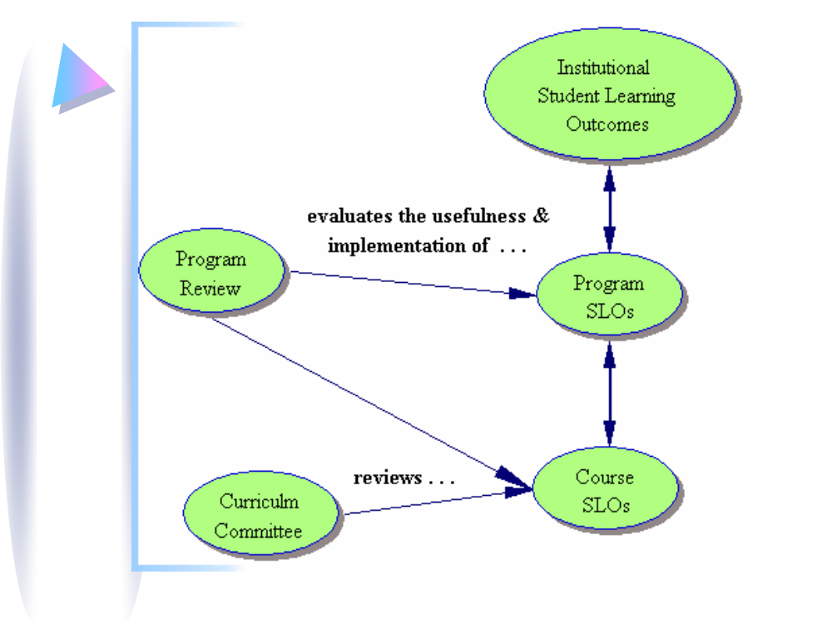
III. Differentiating SLOs from Objectives and Goals

How do learning outcomes differ from course objectives or course goals? Student learning outcomes build upon, but are different from, course objectives and course goals because they represent a different perspective.

Goals | Objectives | Outcomes
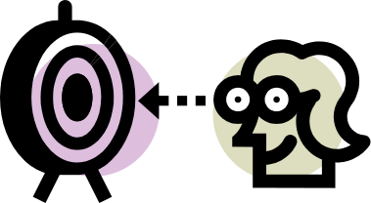 |  | 
A goal is a statement of intent or vision that is not necessarily measurable. The aim, the vision, usually the catalog description of a course or program. | Measurable Objectives are small steps that lead toward a goal. | SLOs overarching specific observable characteristics, developed by local faculty, to determine or demonstrate evidence that learning has occurred as a result of a specific course, program, activity, or process.
 |  | 
b. Writing Student Learning Outcomes (SLOs)

Learning outcomes clearly state what a student is able to DO at the completion of a course or student services program.

- Focus on what the student can do.
- Use active verbs.
- Include an assessable expectation.
- Share the outcomes with your students.
- Modify as you learn from experience.

Learning outcomes provide a focus and a standard for the classroom or the student services program.
Learning outcomes articulate what the instructor or institution expect the students to be capable of doing after exposure to a course or service.
- SLOs should be an integral part of the syllabus.
- SLOs act as a guide for class activities, assignments, and exams.
- SLOs provide a focus for what and how content should be covered.
- SLOs form a framework for services that support student learning.
- SLOs provide a discussion nexus for faculty and an important starting place for course, department, and program learning outcomes.
- Sharply focused SLOs will indicate and direct the choice of valid and appropriate assessment methods.
Write and SLO for your favorite course.
Expanding the Definition of SLOs
Knowledge
The ability to recall what has been learnt
Comprehension
The ability to show a basic understanding
Application
The ability to apply learning to a new or novel task
Analysis
The ability to break up information logically
Synthesis
The ability to create something new
Evaluation
The ability evaluate usefulness for a purpose
Hall, C. & Johnson, A. (1994) Module A5: Planning a Test or Examination. In B. Imrie & C. Hall, Assessment of Student Performance. Wellington, New Zealand: University Teaching Development Centre, Victoria University of Wellington.
Interrelationships between Bloom’s cognitive levels
Cognitive, Psychomotor, Affective Domains

- Bloom (1948) developed classifications of intellectual behavior and learning in order to identify and measure progressively sophisticated learning.

- Three domains of learning are recognized:
  - the cognitive domain (Bloom’s Taxonomy, 1956) defining knowledge classification
  - the psychomotor domain (Gronlund, 1970; Harrow, 1972; Simpson, 1972) defining physical skills or tasks classification
  - the affective domain (Krathwhol, Bloom, and Masia, 1964) defining behaviors that correspond to attitudes and values
- Student learning outcomes should address relevant outcomes for each of these domains but must be appropriate to the course.
- Affective outcomes tend to be the hardest to articulate initially but often represent the outcomes most closely related to deeper thinking and life-long learning.

Cognitive Domain

Learning Outcomes Related To Knowledge

Knowledge | Comprehension | Application | Analysis | Synthesis | Evaluation
Student remembers or  recognizes information or specifics as communicated with little personal assimilation. | Student grasps the meaning behind the information and interprets, translates,  or comprehends the  information. | Student uses information to relate and apply it to a new situation with minimal instructor input. | Student discriminates,  organizes, and scrutinizes  assumptions in an attempt to identify evidence for a conclusion. | Student creatively applies knowledge and analysis to integrate concepts or construct an overall theory. | Student judges or evaluates information based upon standards and criteria, values and opinions.
Cite  Label  List  Enumerate  Identify  Imitate  Match  Name  Quote  Recall  Reproduce  State  Write | Convert  Define  Describe  Discuss  Estimate  Explain  Generalize  Identify  Illustrate  Locate  Paraphrase  Restate  Summarize | Apply  Chart  Compute  Demonstrate  Determine  Dramatize  Establish  Make  Manipulate  Prepare  Project  Solve  Use | Analyze  Compare  Contrast  Correlate  Diagram  Dissect  Differentiate  Distinguish  Infer  Investigate  Limit  Outline  Separate | Assemble  Create  Construct  Design  Develop  Formulate  Generate  Hypothesize  Initiate  Invent  Modify  Reframe  Synthesize | Access  Appraise  Conclude  Critique  Decide  Defend  Diagnose  Evaluate  Judge  Justify  Rank  Recommend  Support

BasicMore Sophisticated
Knowledge Higher Level Thinking
Level Critical Thinking


Psychomotor Domain

Learning Outcomes Related To Skills

Observe | Model | Recognize Standards | Correct | Apply | Coach
Students translate sensory input into physical tasks or activities. | Students are able to replicate a fundamental skill or task. | Students recognize standards or criteria important to perform a skill or task correctly. | Students use standards to evaluate their own performances and make corrections. | Students apply this skill to real life situations. | Students are able to instruct or train others to perform this skill in other situations.
Hear  Identify  Observe  See  Smell  Taste  Touch  Watch  *Usually no outcomes or objectives written at this level. | Attempt  Copy  Follow  Imitate  Mimic  Model  Reenact  Repeat  Reproduce  Show  Try | Check  Detect  Discriminate  Differentiate  Distinguish  Notice  Perceive  Recognize  Select | Adapt  Adjust  Alter  Change  Correct  Customize  Develop  Improve  Manipulate  Modify  Practice  Revise | Build  Compose  Construct  Create  Design  Originate  Produce | Demonstrate  Exhibit  Illustrate  Instruct  Teach  Train

BasicKnowledgeMore Sophisticated Skills
Basic Skills Higher Level Abilities
Level Critical Understanding of Performance


Affective Domain

Learning Outcomes Related To Attitudes, Behaviors, and Values
Receiving | Responding | Valuing | Organizing | Characterizing
Students become aware of an attitude, behavior, or value. | Students exhibit a reaction or change as a result of exposure to an attitude, behavior, or value. | Students recognize value and display this through involvement or commitment. | Students determine a new value or behavior as important or a priority. | Students integrate consistent behavior as a naturalized value in spite of discomfort or cost. The value is recognized as a part of the person’s character.
Accept  Attend  Describe  Explain  Locate  Observe  Realize  Receive  Recognize | Behave  Comply  Cooperate  Discuss  Examine  Follow  Model  Present  Respond  Show  Studies | Accept  Adapt  Balance  Choose  Differentiate  Defend  Influence  Prefer  Recognize  Seek  Value | Adapt  Adjust  Alter  Change  Customize  Develop  Improve  Manipulate  Modify  Practice  Revise | Authenticate  Characterize  Defend  Display  Embody  Habituate  Internalize  Produce  Represent  Validate  Verify

Elementary Values and Behaviors More Highly Developed Attitudes Inherited Value System Well Thought-out Value System
Egocentric View Higher Level Abilities to Identify and
Articulate Others’ Values
- Differentiating terms and linking them to program review and accreditation
Academic Senate for California Community Colleges Definitions
Assessment: The root word for assessment is assidere – to sit beside. Assessment is a means of using explicit criteria to determine evaluative measures to help facilitate student success.
Goal: A Goal is a statement of intent or vision that is not necessarily measurable.
Measurable Objectives: Measurable Objectives are small steps that lead toward a goal.
Measurability: Measurability refers to both qualitative and quantitative means of measuring.
Student Learning Outcomes (SLO): Student Learning Outcomes refer to overarching specific observable characteristics developed by local faculty that allow them to determine or demonstrate evidence that learning has occurred as a result of a specific course, program, activity, or process.
Working with the 2002 Accreditation Standards: The Faculty’s Role
http://www.academicsenate.cc.ca.us/Publications/Papers/AccreditationStandards2005.html
Abstract
The Academic Senate for California Community Colleges has a long standing tradition of encouraging faculty involvement in the self study process and in serving on accreditation teams and at the Commission. Though the Academic Senate takes exception with the 2002 Accreditation Standards, particularly their reliance on marketplace values, faculty roles in accreditation are essential to a healthy peer review process and founded in the Education Code and Title 5 Regulations. This paper identifies the many roles faculty must play in the self-study activities: determining how outcomes and objectives should be defined and evaluated; participating throughout the accreditation process from data gathering to responding to drafts; functioning as visiting team members; serving on the Commission, and finally, by responding to Commission actions and recommendations. Appendices include a brief history and overview of accreditation and a consideration of Academic Senate resolutions and resources related to accreditation. In sum, this paper stresses the faculty’s roles at the local level and how this experience serves as a precursor to contributing to accreditation efforts on other campuses and in representation on the Commission itself.
Recommendations
2. Faculty should recognize their right, duty, and responsibility to participate in every aspect of accreditation, including serving on the Commission, on visiting teams, and in working on their institution’s self study. Faculty authority in academic and professional matters is founded in the legislative intent language of AB 1725, and specified in the Education Code and in Title 5 Regulations;
3. Faculty preparation for accreditation should embody the view that “no quality organization lacks money for professional development”;
6. Faculty senates should work in close cooperation with the administration, student services, the library, and all student support services in the coordination of processes for designing and reporting outcomes;
7. Faculty must insist that all course and program student learning outcomes are developed by local faculty;
8. Faculty are well advised to have a thorough understanding of student learning outcomes, objectives, goals and measurability when engaging in dialogue about the assessment of evidence and what should be included in course syllabi and the course outline of record;
- Writing SLOs

Student learning outcomes are the specific measurable goals and results that are expected subsequent to a learning experience. These outcomes may involve knowledge (cognitive), skills (behavioral), or attitudes (affective behavior) that display evidence that learning has occurred, at a specified level of competency, as a result of a course or program. Learning outcomes are clear and assessable statements that define what a student is able to DO at the completion of a course or program. Learning outcomes provide a focus and a standard for the classroom or the student services program.
When writing SLOs:
- Focus on what the student can do. Don’t address what was taught or presented, but address the observable outcome you expect to see in the student.)
- Use active verbs. Active verbs are easier to measure. For instance, if you want the students to understand how to correctly use a microscope – using the word understand is not measurable. Can you measure understanding? Instead try to imagine the outcome – Students will focus and display an image on the microscope. For this I can both develop criteria and measure ability.
- Include an assessable expectation. It helps if you have clearly defined expectations concerning the criteria related to that outcome. In the above example, some of the criteria related to using the microscope would include:
  - a clearly focused image
  - correct lighting adjustment of the diaphragm and condenser
  - appropriate magnification for the object
  - an evenly distributed specimen field
  - clearly located object identified by the pointer
  - a written identification
- Share the outcomes with faculty from other disciplines and within your own discipline. This helps focus the meaning of the statements. For instance in the above criteria the faculty may ask for clarification of “appropriate magnification.”
- Share the outcomes with your students. Students need to clearly understand what is expected, they are unfamiliar with the discipline specific language. This helps focus the clarity of the statements.
- Modify as you learn from experience. Leave the word “DRAFT” at the top of your SLOs to remind yourself and communicate to others that you are actively improving them.

V. Determining the quality of SLOs
Learning outcomes are clear and measurable statements that define what a student is able to DO at the completion of a course or program use this check list to assess your own SLOs.
Student Learning Outcomes Checklist | Yes | No
Do the SLOs include active verbs?
Do the SLOs suggest or identify an assessment?
Do the SLOs address the expected level of learning for the course using Bloom’s Taxonomy as a guideline?
Does the set of SLOs address more than one domain (cognitive, psychomotor, and affective)?
Are the SLOs written as outcomes rather than as objectives?
- Language indicates an important overarching concept versus small lesson or chapter objectives.
- Outcomes address what a student will be able to do at the completion of the course.
- SLOs address student competency rather than content coverage.
Are the SLOs appropriate for the course or program?
- Consistent with the curriculum document of record
- Represents a fundamental result of the course
- Aligns with other courses in a sequence, if applicable
- Represents collegiate level work
Will students understand the SLOs?
Comments or suggestions:
As you talk to others about SLOs, keep these things in mind:
- Each course and classroom has unique factors.
- Disciplines have unique language and culture.
- Cross disciplinary conversations are invaluable.
- Ultimately discipline-specific conversations best define competencies for students.
- Everyone is a learner when it comes to assessment.
- As professionals, we are guided by the principles of academic freedom.

Examples of differences from course objectives or course goals?
Student learning outcomes build upon, but are different from, course objectives and
course goals because they represent a new perspective.
Goals reflect the targets for a course or program. Goals are where you want to go, objectives are how you get there, and outcomes are proof that you have arrived.
“Outcomes demonstrate an understanding and application of a subject beyond the nuts and bolts which hold it together; objectives represent the nuts and bolts.” (BC Chemistry Prof).

Course Goal – the target for the course
The goal of this general art course is to cultivate a sense of aesthetic significance through analysis of problems and interpretations as they apply to a variety of disciplines

The goal of this general education biology course is to help students acquire and retain relevant biologic knowledge/information, teach them to think/apply this knowledge, and stimulate them to continue learning in the field.

The goal of this nutrition course is to prioritize key nutrition behaviors, identify health and nutrition needs, and integrate these behaviors into health interventions, educational training, and policy.

Course Objectives – the specific teaching objectives usually detailing course content and activities. (see examples for the nutrition course above)
Review nutritional recommendations and components.
Discuss differences in nutritional requirements associated with sex, age, and activity.
Describe causes and consequences of nutritional problems.
Explain complications of underlying physiologic conditions (e.g. diabetes & malabsorption).
Identify key factors involved in correcting nutritional behaviors.
Describe resources and strategies to treat nutritional disorders.

Course SLO – At the end of this nutrition course, a student will be able to analyze a documented nutritional problem, determine a strategy to correct the problem, and write a draft nutritional policy addressing the broader scope of the problem.

Goal, Objective, or SLO?

The statements below were written for programs and courses. Analyze the statements to determine whether they goals, objectives, or student outcomes. Write G for goals, OB for objectives and SLO for student learning outcome.

(Engineering course) This course introduces senior engineering students to design of concrete components of structure and foundation and integrate them into overall design structures.

(Epidemiology course) Given a scenario concerning a specific population, th student will define and assess the health status of that population and identify factors influencing the use of health services.

(History course) The student will function in teams.

- Outcomes with relation to courses

"All the curriculum reform in the world is ultimately useless if students do not learn what faculty teach. Assessment is a response to the realization that—curricular reform, new teaching technologies, testing and grading, and ever-higher tuition notwithstanding—college graduates do not seem to be learning at a level that matches the expectations of employers, parents, or the general public. If assessment is to improve undergraduate education, it must be a faculty-defined, faculty-controlled activity." Wright, 1999

- Outcomes for programs – moving beyond courses

Course 3
SLOs
Course 1
SLOs
Course 2
SLOs
Program SLOs
.
Program
Course
Institutional

- Models for getting started
Merced College Curriculum Audit including Institutional Outcomes
Department Name: | Degree/Competency:  (Associates, Certificate, Competency Met) | Division:
Institutional SLO  The student will be able to . . . | Program SLO  The student will be able to . . . | Course(s) in which this SLO is taught  (include I for introductory, E for in depth, R for additional exposure)
Compose coherent written communication appropriate to the audience
Read and analyze written communication appropriate to the subject | .
Construct and deliver oral communication appropriate to the audience
Comprehend and analyze aural and visual communication in its various modes
Design and deliver presentations appropriate to the audience
Analyze and apply mathematical concepts to an appropriate task
Appraise various aspects of technology and apply them to an appropriate task
Evaluate information and incorporate it into appropriate tasks
Analyze information, develop an opinion, and support it
Examine, create, and/or evaluate materials and objects aesthetically
Analyze and solve problems using logical and creative methods
Assess the impact of science and technology on the world
Relate a healthy lifestyle and wellness to personal choices

Distinguish and understand diverse cultures
Evaluate historical knowledge and relate it to current issues

Evaluate and adhere to ethical principles
Recognize the impact of local, national, and global involvement
Analyze and apply interpersonal skills
Demonstrate an understanding of life long learning
Students will be able to demonstrate effective use of knowledge, skills, and abilities specific to a discipline or career.

- Assessment of Outcomes
Roles of Assessment
Assess to assist, assess to advance, assess to adjust”:
  - Assist: provide formative feedback to guide student performance
  - Advance: summative assessment of student readiness for what’s next
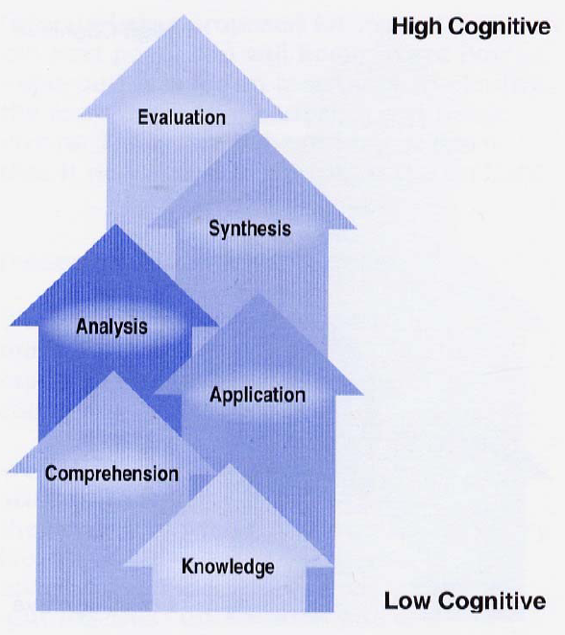
  - Adjust: continuous improvement of curriculum, pedagogy. -
Ruth Stiehl, The Assessment Primer: Creating a Flow of Learning Evidence (2007)
Formulating Assessment Strategies
Classroom assessment is the purest form of assessment-for-improvement, because information gleaned can be immediately used to improve teaching and learning …the further away from the individual classroom you get, the harder it becomes to turn assessment data into useable information” (Miller, 1997).
“Post secondary assessment done right must be rooted in the course and in the classroom, in the individual the cells, to speak metaphorically, where the metabolism
of learning actually takes place” (Wright, 1999).

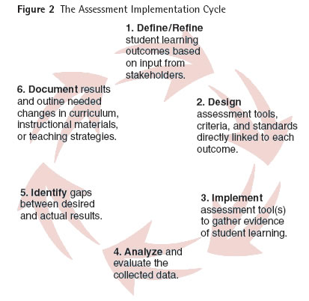

Choosing the Right Assessment Tools
Assessment Tool | Pros | Cons
Multiple Choice Exam | - easy to grade  - objective | - reduces assessment to multiple choice answers
Licensing Exams | - easy to score and compare | - no authentic testing, may outdate
Standardized Cognitive Tests | - comparable between students
Checklists | - very useful for skills or performances  - students know exactly what is missing | - can minimize large picture and interrelatedness  - evaluation feedback is basically a yes/no - present/absent - without detail
Essay | - displays analytical and synthetic thinking well | - time consuming to grade, can be subjective
Case Study | - displays analytical and synthetic thinking well  connects other knowledge to topic | - creating the case is time consuming, dependent on student knowledge form multiple areas
Problem Solving | - displays analytical and synthetic thinking well  authentic if real world situations are used | - difficult to grade due to multiple methods and potential multiple solutions
Oral Speech | - easily graded with rubric  allows other students to see and learn what each student learned  - connects general education goals with discipline-specific courses | - difficult for ESL students  stressful for students  takes course time  - must fairly grade course content beyond delivery
Debate | - provides immediate feedback to the student  - reveals thinking and ability to respond based on background knowledge and critical thinking ability | - requires good rubric  more than one evaluator is helpful  difficult for ESL students  stressful for students  takes course time
Product Creation & Special Reports | - students can display skills. knowledge, and abilities in a way that is suited to them | - must have clearly defined criteria and evaluative measures  "the look" can not over-ride the content
Flowchart or Diagram | - displays original synthetic thinking on the part of the student  - perhaps the best way to display overall high level thinking and articulation abilities | - more difficult to grade, requiring a checklist or rubric for a variety of different answers  - difficult for some students to do on the spot
Portfolios | - provides the students with a clear record of their work and growth  - best evidence of growth and change over time  - students can display skills. knowledge, and abilities in a way that is suited to them  promotes self-assessment | - time consuming to grade  different content in portfolio makes evaluating difficult and may require training  bulky to manage depending on size
Exit Surveys | - provides good summative data  easy to manage data if Likert-scaled responses are used | - Likert scales limit feedback, open-ended responses are bulky to manage,
Performance | - provides best display of skills and abilities  - provides excellent opportunity for peer review  - students can display skills. knowledge, and abilities in a way that is suited to them | - stressful for students  may take course time  some students may take the evaluation very hard - evaluative statements must be carefully framed
Capstone project or course | - best method to measure growth overtime with regards to a course or program - cumulative | - focus and breadth of assessment are important  - understanding all the variables to produce assessment results is also important  - may result in additional course requirements  - requires coordination and agreement on standards
Team Project | - connects general education goals with discipline-specific courses | - must fairly grade individuals as well as team  - grading is slightly more complicated  - student interaction may be a challenge
Reflective self- assessment essay | - provides invaluable ability to evaluate affective growth in students | - must use evidence to support conclusions, not just self-opinionated assessment
Satisfaction and Perception Surveys | - provides good indirect data  data can be compared longitudinally  - can be used to determine outcomes over a long period of time | - respondents may be influenced by factors other than those being considered  - validity and reliability most be closely watched

Collaboration Among Faculty, Administration & Researchers
- Assessment, the auto, and a road trip: an analogy
  - Who should drive the car?
  - Who provides the car, gas, insurance and maintenance?
  - Who brings the maps, directions, repair manual, tool kit, first aid kit, and stimulates the conversation along the journey?

Why Faculty are the Drivers?
- Faculty have the primary responsibility for facilitating learning (delivery of instruction)
- Faculty are already heavily involved in assessment (classroom, matriculation)
- Faculty are the content experts
- Who knows better what students should learn than faculty?


Who Provides the Car and Keeps Gas in It? Administrators!
The Role of Administrators
- Establish that an assessment program is important at the institution
- Ensure college’s mission and goals reflect a focus on student learning
- Institutionalize the practice of data-driven decision making (curriculum change, pedagogy, planning, budget, program review)
- Create a neutral, safe environment for dialogue

The Role of Researchers
- Serve as a resource on assessment methods
- Assist in the selection/design and validation of assessment instruments
- Provide expertise on data collection, analysis, interpretation, reporting, and use of results
- Facilitate dialogue - train and explain
- Help faculty improve their assessment efforts

Faculty DON’Ts…
- Avoid the SLO process or rely on others to do it for you.
- Rely on outdated evaluation/grading models to tell you how your students are learning.
- Use only one measure to assess learning
- Don’t criticize or inhibit the assessment efforts of others.

Faculty DOs...
- Participate in SLO assessment cycle
- Make your learning expectations explicit Use assessment opportunities to teach as well as to evaluate.
- Dialogue with colleagues about assessment methods and data.
- Focus on assessment as a continuous improvement cycle.

