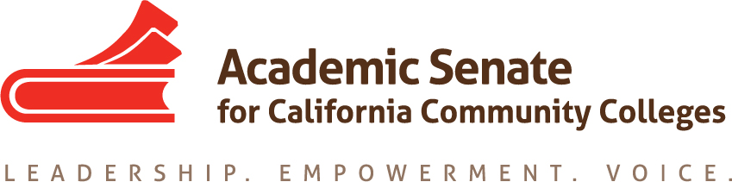

ASCCC CURRICULUM COMMITTEE

April 8th, 2021 8:30AM – 10:00AM
ZOOM

Meeting Summary

- Call to order at 8:36 a.m.
  - Welcome and spring break sharing.
  - Attendance: Carrie Roberson (chair), Michelle Bean (2nd chair), Randy Beach, Alexandra Diamant (SSCCC), Michelle Plug, Josefina Gomez, Jeff Waller, Rose Giordano

- Adoption of the agenda with no additions. Michelle taking notes.

- Approval of minutes
  - 3.4.2021—moved by Jeff; seconded by Randy; approved with no changes.

- Announcements/ Updates
  - CCC System Reports:
    - SSCCC—At their general session, Ethnic Studies discussion and robust debate. Alex shared with students that the process has started and will take time to fully implement. Students are in favor and want to expedite.
    - CIO—hosting conference: April 7-9
      - Randy: Interested in building relationships and pipelines (faculty to VP/admin positions and collaboration with ASCCC)
      - Carrie will place concern on future agenda
    - CCCCO—no report.
    - ASCCC Committees—everyone invited to Plenary resolutions day, Sat. April 17 (see asccc.org for info); currently elections are happening—please be encouraged to consider running next year; CTE/Noncredit Institute coming up at end of April; Part-time Faculty Nexus Workshops filled. Carrie suggested adding a part-time rep position for Curriculum Committee for next year (a suggestion for the End of the Year Report—committee agreed).
    - Other/local reports—Randy’s college approved a graduation competency called Cultural Awareness. Jeff’s college intentionally creating faculty voice/roles on governance committees and for ethnic studies discussion.
    - CIAC—north and south conferences; discussed CPL, CBE, dual enrollment, AB928 and other leg such as common course numbering system; congratulations to Michelle P. for new role as president elect to SCIAC.

- Priorities/Tasks Google Drive UPDATES
  - 2020-2021 Committee Priorities/ Tasks
  - Spring 2021 Plenary Resolution
    - Reviewed amendment to 9.02—concern is for smaller/rural schools who need resources and support for Ethnic Studies, if the Cultural Competencies element is eliminated. Randy has written a new resolution focused only on AB1460 CSU ES requirement impacts.
    - Robust discussion by members happened. Concern with intent to “water down” ES requirement. Concern with no start date in new title 55063 language. Discussion on how the new resolution may become mute if newly amended 9.02 passes.
  - ASCCC Curriculum Institute Planning
*July 7th – 9th 2021: Ensuring Learning: Accessibility & Flexibility in Equity-Driven Curriculum. Committee spent time reviewing program and assigning breakouts.

- Adjournment at 10:04 a.m.

Status of Previous Action Items

Completed
SSCCC Representative
Rostrum (March 2021) Ethnic Studies: Looking Back; Looking Forward

