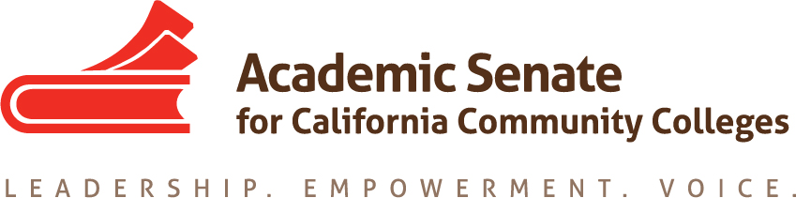

ASCCC Relations with Local Senates Committee (RwLS)

November 20, 2020

TIME 2-3:30pm

Attendees: Howard Eskew, Stephanie Curry, Katie Krolikowski, Nickawanna Shaw, Robert L. Stewart Jr., Hossna Sadat Ahadi

Minutes

- Call to Order and Adoption of the Agenda

- Reviewing Process for Choosing Faculty for ASCCC Committees
  - Stephanie and Robert shared the current ASCCC Committee selection processes
  - Committee discussed the need to open transparency of process to applicants and field including
    - A Written Process
    - Articulated Goal of Statewide Service/ Professional Growth
    - Review Placement of application on website
    - Understanding logistics
    - Clear timeline
    - Highlight contextualize skills (click all that apply) and committee Selection
    - Discussed the need for Context within application
    - Need to update demographic info and Pronoun need definition. Change # 3 to Pronoun on demographics and take out decline to state. Disaggregate Asian populations. Adding context to the demographic questions celebrating inclusiveness. Look at adding political affiliation (broad) to support more inclusivity in voices
    - Turn the new ASCCC mission into the checklist/rubric for decisions and operationalize.
    - Guidance on which skills are desired by or would be helpful for which committees.
  - Committee discussed idea for a thank you note to applicants after ASCCC committees approved for better communication and follow-up
    - Maybe, like thank you for applying to ASCCC committee, since you were not selected on the statewide committee, we would like to offer opportunities such as attending plenary, speaking at plenary, rostrum, etc. (options for them to still be engaged and plugged).
  - Reaching out beyond Senate Events (Presidents bring nominee during Plenary). Nominations for Statewide Committees and ASCCC send out application to nominated faculty—Go through the Senate President/Delegate. Go beyond self-nomination and broaden leadership opportunities
  - Can use Listservs to support broad representation. (make sure all send out so broad representation through ASCCC)
  - Suggestion to celebrate the work of committees at the end of the year. Celebrations to the field. Lift the stories up. Present it as best practice to field.

Rostrum potential article Due January 4, 2020
How can committee application and appointment follow an equity-minded process?

My experience on a Statewide committee.

Breakout Session (Plenary 2020)
Equitizing Statewide Service

Next Steps

- Stephanie will put together a draft of application process to review at next meeting.

- At next meeting the committee will write a Thank you note and Stephanie will bring this to Senate Exec in January 2021

- Turn ASCCC mission into a checklist/rubric look at it next meeting. Citrus College Example https://drive.google.com/file/d/1s-gA_Woy2FCqOMwrHVnwK6_Zhc0ILy-G/view?usp=sharing

- Discuss Committee end of year celebrations shared with the field. Can we celebrate the work of members?

- Planning for Equity Leadership Workshops (Spring 2021)
Moved to next agenda

- Follow up Process for Local Senate Visits
Moved to next agenda

- Review Committee Charge (Aligning with GP)
Moved to next agenda

- Announcements
The committee reviewed upcoming events.
  - Part Time Institute February 18-19, 2021
  - Spring Plenary April 15-17, 2021
  - Career and Non-Credit Institute April 30-May 2, 2021

- Adjournment
The committee adjourned at 3:36pm

