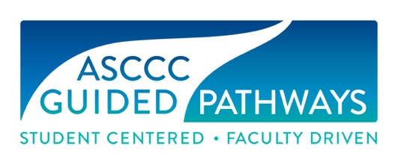

Guided Pathways Task Force Meeting
Minutes
Friday, April 9, 2021
9:00 am – 12:00 pm
Virtual

Members Present: Cheryl Aschenbach, Michelle Bean, Juan Buriel, Stephanie Curry, Sam Foster, Sarah Harris, Jeffrey Hernandez, Ginni May (Chair), Meridith Selden, Erik Shearer

Staff Present: Miguel Rother, Selena Silva

- Meeting called to order at 9:05 am

- Members checked-in

- Minutes from the March 17, 2021 GPTF Meeting were approved by consensus.

- The chair and GPTF members provided updates on upcoming Executive Committee elections, Spring Plenary Session, resolutions (on proposed legislation), Career and Noncredit Education Institution, and Faculty Leadership Institute.

- The Webinars chair reported that all webinars are well underway and presenters are all confirmed.

- The Technical Visits chair reported that one visit is scheduled for April 27 at Hartnell College.

- The Resources chair worked with the GPTF during this meeting to review the website and update the suite if mini canvas courses. It was decided that feedback from the ASCCC Executive Committee regarding Guided Pathways resources on the ASCCC website was needed to determine the following:

Should the Guided Pathways resources remain fluid or static? The response here will depend on the ability of the ASCCC to keep the resources current.
- Guided Pathways Resources page
- Guided Pathways Task Force page
- Guided Pathways Canvas Course

- The GPTF provided updates on their progress on each of the Mini Canvas courses in the Suite of Resources being developed.

- Each GPTF member was requested to provide a brief written report for the May meeting, the last of this academic year, and possibly the last for the GPTF.

- Meeting adjourned at 11:36 am.

