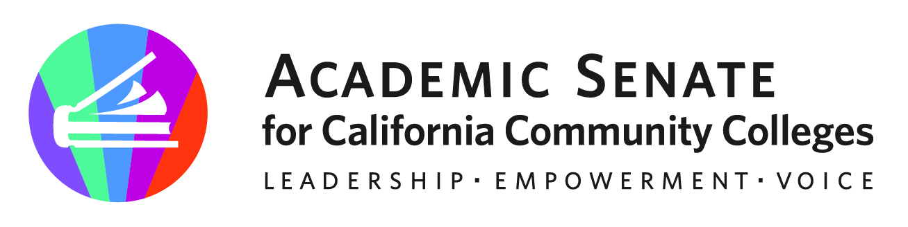

ASCCC Executive Committee Agenda Item

Month: January Year: 2024
SUBJECT: Noncredit Institute
DESIRED OUTCOME: The Executive Committee will review and consider for approval the draft program outline of the 2024 Noncredit Institute.
CATEGORY: Action
REQUESTED BY: Stiemke/Curry
STAFF REVIEW: Carrillo

Item No: III.I.
Attachment: Yes
Urgent: Yes
Time Requested: 30 minutes
TYPE OF BOARD CONSIDERATION
Consent/Routine:
First Reading:
Action: X
Information:
Please note: Staff will complete the grey areas. Staff will review your item and provide additional resources to inform the Executive Committee discussion.

BACKGROUND
The ASCCC Executive Committee approved a Spring 2024 Noncredit Institute at its meeting in November of 2023. The Executive Committee is being asked to review and consider for approval the draft program outline of the 2024 Noncredit Institute.

