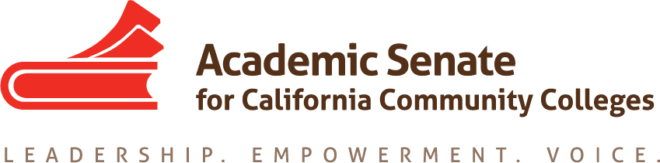

ACADEMIC SENATE FOR CALIFORNIA COMMUNITY COLLEGES
AREA D Meeting
Saturday, March 27, 2021
10:00 – 3:00

Remote
ConferZoom Meeting, Meeting ID: 973 1523 4333
https://cccconfer.zoom.us/j/97315234333Or Telephone:
+1 669 900 6833 (US Toll)
+1 346 248 7799 (US Toll)

Minutes/Notes DRAFT

- Welcome and Introductions
Meeting was convened at 10:00 am, By Area D Rep. Dr. LaTonya Parker. LaTonya welcomed everyone.

- Volunteer Note Taker: Nance Nunes-Gill volunteered

- Additions to and Approval of the Agenda: None made

- Approval of the Fall 2020 meeting minutes/notes
Motion to approve the minutes: Moved by: Dr. Henry Young and Second by Caree Lesh. The minute/notes of the fall 2020 Area D meeting were approved as submitted.

- Future Area D Meetings for Academic year 2020-2021 and 2021-2022
  - Fall 2021– Moreno Valley College (unless another college comes forward)
  - Spring 2022 – Barstow Community College

- Reports – Dolores Davison, ASCCC President
  - ASCCC Update
President's Update March 2021
- April 14th, the Executive Committee Meeting will be held.
- April 15th – 17th online Spring Plenary will be held and will focus on, “Working Collectively: Transforming and Decolonizing Institutions.”
- The challenges that many colleagues, students, and administrators have faced and most recently the targeting of Asians and everyone especially over the past year.
- Consideration of eliminating the BA pilot program and to expand to CCC so that every college could have one, but it couldn’t duplicate what is offered at a CSU nearby.
- The 60-unit cap was mentioned and identified that it doesn’t work for all programs.
- Colleges are laying off faculty and administrators
- Money needs to be spent on counseling faculty as the AB 1111 has no funding built in
- Mention of the AB 1o4o Ethnic Studies bill
- Brown Act (bill being presented) which would require that any meeting under the Brown Act would have a live and online component.
- AB 1432 Cal Bright – questions were raised as to only having 9 students get their degree and 1 being placed in with a job.
- A request for a central repository of information about each college’s reopening plan for Fall 2021 enrollment
  - Academic Senate Foundation for CCC
- President Silvester Henderson ASCCCF Bi - Annual Report - Area Meetings (March 2021) - YouTube
  - Guided Pathways: webinar on data 101, well attended and power points will be posted and resources including hyperlinks (by Sam Foster), funding for GP to the ASCCC embedded in Dec., there is a request to add additional money into the governor’s budget for additional implementation
  - Disciplines List
1. Review of process https://www.asccc.org/disciplines-list
2. Review of any proposals
3. CCC Confer Instructions for Meeting on Apr 16, 2021 5:00 PM

VII Wendy Brill-Wynkoop asked to have delegate forms filled out and submitted by April 5, 2021 additional materials by the 12th. Shared changed of process that will be in effect this April, reminded everyone that the delegate form needed to be signed and submitted. Explained the changes regarding elimination of trickle down, instant runoff voting, and change the order of elections. https://asccc.org/asccc-executive-committee-elections

Lunch Break 11:45 – 12:30

VIII Resolutions
- Resolutions Process Presented by Sam Foster and David Morse
- Resolutions process overview (Please review the Resolutions Handbook)
- Brief orientation about development of resolutions and voting process at session
Resources: https://asccc.org/resolutions-spring-2021
Resolutions for Discussion
Resolutions Handbook
Part III: Resolution Writing and General Advice
- Review and Discussion of the Consent Resolutions
*3.01 S21 Include Cultural Competence in Faculty Evaluations (David Morse shared that this has been pulled from consent)
*3.02 S21 Establishing Local Inclusion, Diversity, Equity and Anti-racism (IDEA) Liaison
*5.01 S21 Support for Additional Guided Pathways Funding
*6.01 S21 Revising the 50% Law and the FON (LaTonya Parker recommended to spell out FON)
*6.02 S21 Support AB 417 (McCarty 2021) as of March 8, 2021
*6.03 S21 Support AB 421 (Ward 2021) as of March 8, 2021
*8.01 S21 Counseling Faculty, Student Success and Transfer
*9.01 S21 Develop a Set of Resources to Assist in Establishing Ethnic Studies (John Crocitti recommended in the resolve: Asian American and not just Asian, Carlos Guerrero shared that Indigenous Studies would open it up more to other areas around the world)
*9.02 S21 Develop a Rubric for Ethnic Studies Courses and Ethnic Studies or Cultural Awareness Competencies (Carlos Guerrero cultural awareness and what it means in relation to ethnic studies is a discipline, agrees with competence part just not sure on cultural awareness, Randy Beach shared that Area B recommended to remove the term "learning outcomes" from the second resolved statement, Margot Lovett asked to have an amendment. Margot Lovett, Maria Figueroa, Thekima Mayasa asked to pull from consent. David Morse will create the amendment and Carlos Guerrero shared he would sponsor it.

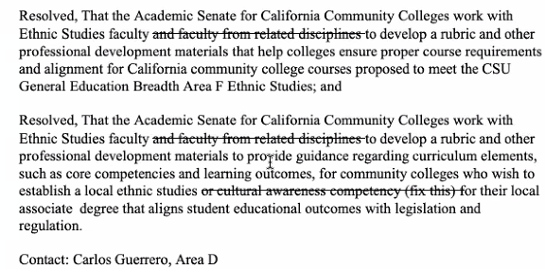
An amendment to strike out the local associate degree (in the last Resolved above) to be created in the next few days.
*10.01 S21 Disciplines List--Film and Media Studies
*10.02 S21 Disciplines List-- Digital Fabrication Technology
*11.01 S21 Urge the Release of Distance Education Guidelines and Related Compendium of Effective Distance Education Practices
*12.01 S21 Approve the Paper Going Beyond Development: Faculty Professional Learning- An Academic Senate Obligation to Promote Equity-Minded Practices that Improve Instruction and Student Services
*18.01 S21 Ensuring Transparency and Input in Improvements to CCC Apply
*20.01 S21 Enabling Preferred Name and Pronouns across Campus and all Digital Environments (amendment recommended see below)
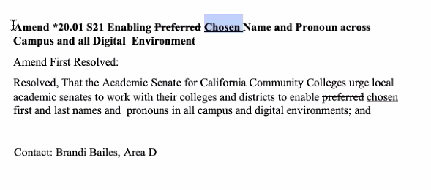
*21.01 S21 Collaborate with Regional Consortia
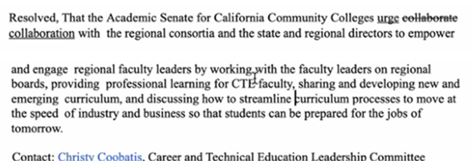

- Development and Discussion of Area D Resolution’s:

Title: Academic Senate for California Community Colleges (ASCCC) Denounces Anti-Asian American Pacific Islander (AAPI) Racism
Sam Foster recommends to create a footnote to define what Gaslighting means. David Morse suggested the last Whereas to make it into two. Clean up some of the wording.
Recommend to change title to Denounces Anti-Asian etc., David Morse shared that he will assist Denise Schulmeyer with the writing. Agreed to send from Area D

Resolution to Update the Paper: “Part-Time Faculty: A Principled Perspective.”
There was great discussion and it was determined to collaborate and write a new paper versus updating or changing the existing paper. Michael Gladych, Anastasia Zavodny and David Morse will work together on this paper.

Title: Defining Ethnic Studies and its Four Core Disciplines

Recommendation that we can’t tell the Chancellor’s office, footnote to add Filipino American and to review and resubmit so it goes to Spring Plenary. There were additional recommendations shared for adding information. Thekima Mayasa will work with David Morse on those changes and it will be submitted to the Spring Plenary, it won’t be sent forward from Area D.

Carlos Guerrero and Crocitti, John wanted a footnote clarifying the meaning of Central American Studies as related to ES.

Recommendation to Update Title 5 Language for Section 55070 Credit Certificates
This is moving forward from Area D.

VIV Announcements
- Executive Committee Spring 2021 Meeting Dates
Executive Committee Meeting - Virtual Meeting
Wednesday, April 14, 2021 -
12:00pm to 6:00pm Zoom Videoconferencing

Executive Committee Meeting - Virtual Meeting
Friday, May 7, 2021 -
11:00am to 5:00pm Zoom Videoconferencing

Executive Committee Meeting
Friday, June 4, 2021 - 11:00am to Sunday, June 6, 2021 - 1:00pm
Coronado Island Marriott Resort & Spa, 2000 2nd St, Coronado, CA 92118

- ASCCC Spring 2021 Plenary Virtual Event
Deadline to Register/Application Deadline: 3/15/21@ 5:00pm
WHEN: April 15-17, 2021
WHERE: Pathable Event Platform

- Awards
2021 Exemplary Program Award
2021 Hayward Award
- Save the Date!
- Additional ASCCC Calendar of Events
- Faculty Application for Statewide Service

- Adjourned 3:14

Submitted by: Nance Nunes-Gill

Present:
Bailes, Brandi Crafton Hills College (SBC District)
Beach, Randy Southwestern College
Bemiller, Quinton Norco College
Bouzar, Pete Golden West College
Brill-Wyncoop, Wendy Elections Committee
Burns-Peters, Davena San Bernardino Valley College
Christensen, LeeAnn Copper Mountain College
Crocitti, John San Diego Mesa College
Davison, Dolores ASCCC President
DeRose, Nicole Chaffey College
Dozier, Kim College of the Desert
Epps, Ric Imperial Valley College
Eskew, Howard San Diego Mesa College
Fererro, Jenny Palomar College
Figueroa, Maria Mira Costa College
Floerke, Jennifer Moreno Valley College
Foster, Sam Fullerton College
Gladych, Michael College of the Desert
Glickstein, Lynne Victor Valley College
Goralski, Caig Cypress College
Greene, Donna College of the Desert
Guerrero, Carlos Los Angeles City College
Haig, Jeff Copper Mountain College
Henry, Deborah Coastline College
Lara, Luke Mira Costa College
Lesh, Caree Southwestern College
Lopez, Pearl Grossmont College
Lovett, Margot Saddleback College
Mancillas-Gomez, Manuel Grossmont College
Mayasa, Thekima San Diego Mesa College
McLaughlin, June Irvine Valley College
Morse, David Long Beach City College
Murphy, Laura San Diego Miramar College
Nunes-Gill, Nance Barstow Community College
Ochoa, Heidi Saddleback College
Omae, Masahiro San Diego City College
Orlijan, Kim Fullerton College
Parker, LaTonya ASCCC Area D Representative
Pasley, Denise Barstow Community College
Rutan, Craig Santiago Canyon College
Safaralian, Leila MiraCosta College
Schulmeyer, Denise Grossmont College
Sellick, Mark Riverside City College
Shahbazian, Roy Santa Ana College
Simpson, Ty San Bernardino Valley College
Tasaka, Bethany San Bernardino Valley College
Vasquez, Eduardo Barstow Community College
Velez, Manuel San Diego Mesa College
Versaci, Rocco Palomar College
Walsh, Dan Saddleback College
Whaley, Carol San Diego City College
Young, Henry Victor Valley College

