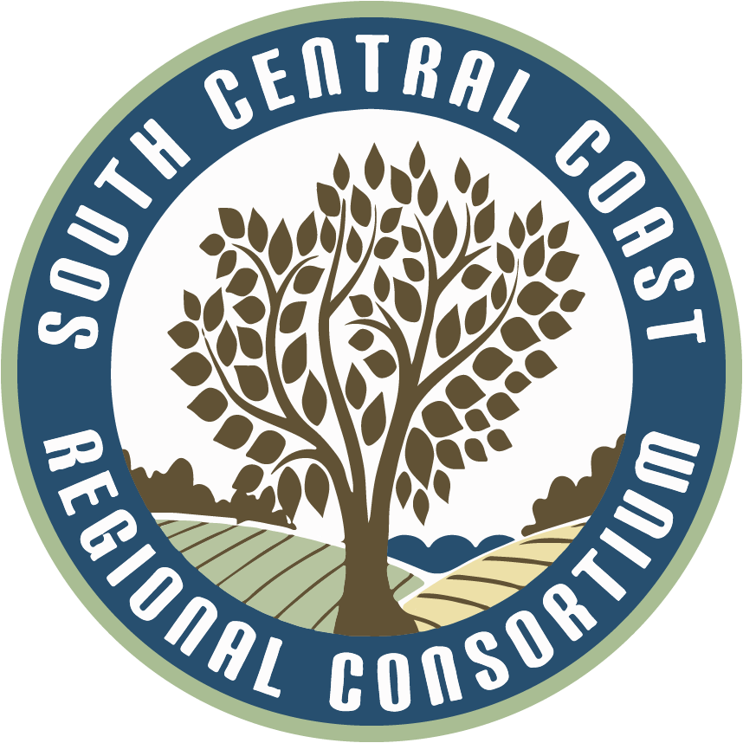
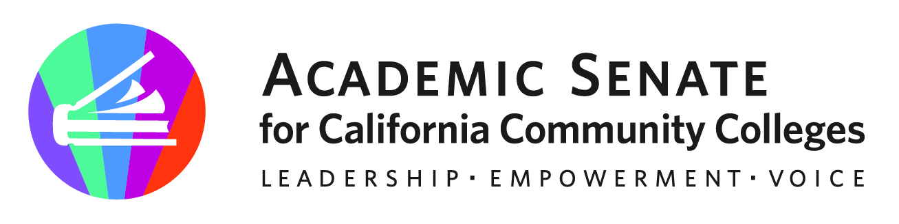

CTE REGIONAL COLLABORATIONS

(South Central Coast)

October 6, 2023

10:00am-3:00pm

AGENDA

- Welcome and Introductions
- CCCAOE
- Working with your Regional Consortium (SCC)
- Working with the ASCCC and Local Senates (ASCCC)
  - 10 +1
  - CTE Liaisons
  - Services and Resources
- What is new in your Region (SSC)
  - Curriculum Opportunities
  - Employer Collaborations
  - Funding Structures
  - What is happening at your college
  - Baccalaureate Programs
- CTE Related Updates/Emerging Concerns (ASCCC & SCC)
  - AB 928 and General Education impacts on CTE
  - CBE and CPL
  - CCCCO Vision 2030
  - CCCCO California State Plan for Career Technical Education (CTE): A Vision for Equity and Excellence in CTE
  - LAEP (Learning-Aligned Employment Program
  - Chat GPT/AI
  - Advocacy
LUNCH

- Minimum Qualifications (ASCCC)
- New Title 5 Regulations- Work Experience
- Dual Enrollment
- Regional Hot Topics (SSC)
- Wrap Up

