Career Technical Education Leadership Committee (CTELC)

CTE Liaisons February 2021 Memo
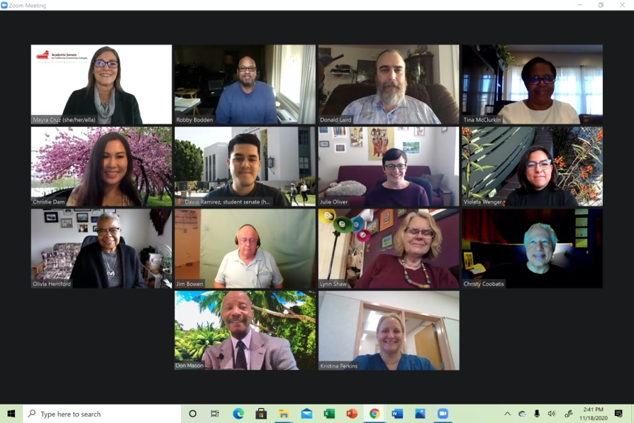

Dear CTE Liaisons,

Over the past several months, we have been providing a space for CTE Liaisons to hold conversation on topics of interest. Join the conversation on March 18th! Register here.

-Mayra

Mayra E. Cruz, CTE Leadership Committee Chair, Julie Oliver, 2nd Chair
Emilda Baghdaserians, Robert Bodden, Jr., Jimmie Bowen, Angelica Campos, Christy Coobatis, Christie Dam, Olivia S. Herriford, Donald Laird, Don Mason, Tina McClurkin, Kristina Perkins, Lynn Shaw, Violeta Wenger
2021 CTE Leadership Committee

Perkins V

The Strengthening Career and Technical Education for the 21st Century Act (Perkins V) was signed into law by President Trump on July 31, 2018. This bipartisan measure reauthorized the Carl D. Perkins Career and Technical Education Act of 2006 (Perkins IV) and continued Congress’ commitment in providing nearly $1.3 billion annually for career and technical education (CTE) programs for our nation’s youth and adults.
Perkins V represents an important opportunity to expand opportunities for every student to explore, choose, and follow career and technical education programs of study and career pathways to earn credentials of value.
As a state, country and globally, it is important to recognize the way in which work is changing- change in automation of tasks, growth and decline of industries, changing demands for skills, economic shifts in response to climate change, expansion of contingent and nonstandard work arrangements, and the introduction of new technologies in the workplace.
Ideas to Consider Funding with Perkins Funds

At the CTE Liaison Coffee hour held on February 9, CTE liaison and participants shared project ideas to fund beyond instructional equipment.

- Evaluate the effectiveness of your CTE program and assess for quality, equity agency (building the abilities of workers and future workers), and sustainability
- Conduct a study of industry and stakeholders to determine where the jobs are and ensure livable wages
- Examine Guided Pathways to evaluate student success and identify gaps
- Integrate diversity, equity and inclusion to serve all students
- Offer a comprehensive pathway from secondary to post-secondary
- Offer resources for students to complete comprehensive exams
- Offer a student-faculty mentorship program
- Engage with industry sectors to create new programs and use Perkins dollars to fund equipment

Resources:

California Community Colleges Chancellor’s Office (CCCCO)Perkins V website

Upcoming events

2021 Career Noncredit Education Institute - Virtual Event
April 30-May 1, 2021

CTE Liaison Coffee Hour - Credit for Prior Learning
March 18, 2021
11:00 AM-12:00 PM

