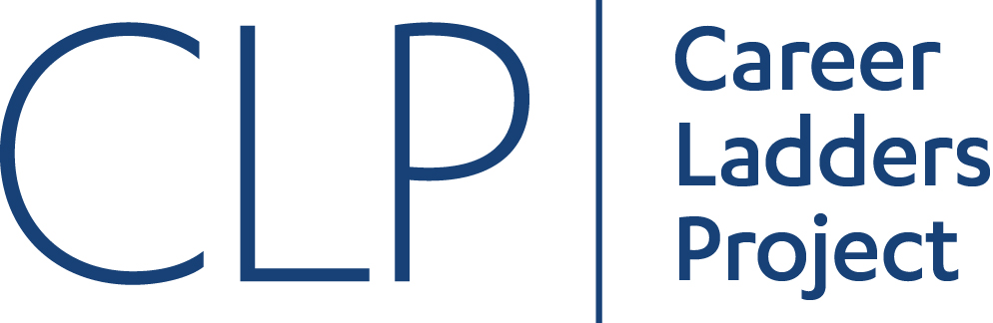

Contextualized Teaching and Learning

Regional Meeting at Palomar College

December 3, 2016 / 9:30am-2:30pm

Room MD-157 and adjoining patio area

9:00-9:30 Check-in / Continental Breakfast

9:30-9:40 Welcome and Introductions
Cheryl Aschenbach, ASCCC Executive Committee, Lassen College
Dr. Lori Waite, Basic Skills Co-Chair, Palomar College
Dr. Joi Lin Blake, President, Palomar College

9:40-10:10 Chancellor’s Office Basic Skills Update
Kirsten Corbin, Dean of Basic Skills and Noncredit Curriculum, CCCCO

10:10-11:10 Contextualized Basic Skills – An Overview
Naomi Castro, Director, Career Ladders Project

11:10-11:25 Break (15)

11:25-12:15 Contextualizing Learning to Teach Basic Skills
Laura Hinckley, El Camino College

12:15-1:00 Lunch & Networking

1:00-1:45 Contextualizing English and Reading
Cheryl Aschenbach, Lassen College, ASCCC Basic Skills Committee
Michael Heumann, Imperial Valley College, ASCCC Basic Skills Committee
Michelle Sampat, Mt. San Antonio College, ASCCC Curriculum Committee

1:45-2:30 Collaborative Activity – Campus Contextualization
Wrap Up

2016-2017 ASCCC Basic Skills Committee
Cheryl Aschenbach, Chair (ASCCC Executive Committee)

Conan McKay (ASCCC Executive Committee)
Geoff Hagopian (College of the Desert)
Lisa Romain (Palomar College)
Michael Heumann (Imperial Valley College)
Alicia Munoz (Cuyamaca College)
April Pavlik (Los Angeles City College)

Interested in volunteering for an ASCCC committee or other state level appointment?
Apply annually online: http://www.asccc.org/content/application-statewide-service

