Changes to Assessment, Placement, and Instruction in Mathematics:
An Examination of AB705 (Irwin 2017)

Introduction
Placement of students in courses in English and mathematics has been a challenge for colleges. For many years, assessment tests were the primary tool used to place students into their first mathematics course. Hoping to develop more consistent and equitable placement across the system, the 2012 Seymour-Campbell Student Success Act created the Common Assessment Initiative (CAI) which called on the California Community Colleges to develop a single set of assessment tests for all students. The hope and goal were to improve the quality of assessment testing while providing students with test results that they could use at any community college. The goal of the assessment process was to place students into the course in which they were most likely to be successful. Students were often placed into pre-transfer-level courses that would help them build their skills and improve the likelihood that the student would complete a transfer-level course.

The adoption of AB705 (Irwin, 2017) shifted assessment from the use of tests to the use of high school data, specifically grade point average (GPA). The use of high school performance data had been part of multiple measures long before AB705. A group of colleges had been working with the Multiple Measures Assessment Project (MMAP) to develop decision trees that placed students into college courses using high school GPA, high school courses completed and their corresponding course grades. The decision trees used prior to AB705 were designed to maximize the likelihood that the student would successfully complete the course in which they were placed.

Whether using an assessment test or high school data to place students, the ultimate goal was to maximize success in the course where the student was placed. With the passage of AB705 a new metric called throughput was created. Throughput is designed to maximize the likelihood that a student will enter and complete a transfer-level course within one year. The shift from likely course completion to throughput is a far greater change than moving from assessment tests to placement based on high school GPA.

With the assistance of the MMAP team, the Chancellor’s Office set minimum throughput levels for students entering into Statistics and Liberal Arts Mathematics (SLAM) and Business - Science, Technology, Engineering, and Mathematics (B-STEM). These default placement rules were based entirely on GPA and would encourage or strongly encourage the requirement of concurrent support, although actually requiring concurrent support can only be done if a college has collected data that shows the requirement increases throughput. In order to place a student into Intermediate Algebra, a college needed to demonstrate that the requirement would increase the student’s projected throughput to be at least as high as the throughput projected for direct placement into a transfer-level course. Additionally, AB1805 (Irwin, 2018) requires colleges to inform students that they have the right to go directly into transfer-level courses.

Colleges took various approaches to implement the requirements of AB705 and align practices with guidance from the Chancellor’s Office. With the recent passage of AB1705 (Irwin, 2022) and the guidance from the Chancellor’s Office in March 2022, colleges are now faced with the challenge of meeting the needs of all students while being able to offer only transfer-level courses with very limited exceptions.

Throughput vs. Success
Prior to AB705, the term “throughput” had not been defined or used broadly anywhere in the CCC system. Faculty were concerned with “student success,” broadly encompassing student course success, pathway success, student agency, and college culture success.

While it is important to guide students into their appropriate programs of study that will meet their educational and career goals, appropriately placing students into courses that honor knowledge they have learned, retained, and are able to apply; and provide appropriate guidance and support to keep students on their curricular paths, the value of exploration and self agency cannot be overstated. The ability to explore and choose is a privilege that students at four-year colleges and universities enjoy, and it’s a value that the community colleges need to also be able to provide to the underprivileged students we serve if that is their desire. The perspective that community college faculty have, therefore, is that we want to have flexibility to offer and support students’ unique educational needs as a mechanism to promote equity. Accelerated curricular pathways, rigid educational programming that discourages both exploration, and eliminating students’ ability to seek help by revisiting course material they may have a tenuous grasp of are antithetical to the original vision that most community college faculty had of higher education in general and the community college system in particular. With the renewed focus on acceleration and the elimination of opportunities to revisit or develop skills, the community college system is becoming less accessible and the equity gaps that were purported to be removed either remain or are widening.

Since the passage of AB705, throughput has been the single metric that colleges are asked to report, and the single metric on which the success of AB705’s impact has been measured. The concept was discussed recently in the 10/28/22 FAQs from the CCCCO https://www.cccco.edu/-/media/CCCCO-Website/About-Us/Divisions/Educational-Services-and-Support/AB705/equitable-placement-and-improvement-plans-faq-a11y.pdf Here they define throughput as: “For the purposes of compliance with AB705, colleges must maximize students' likelihood of completion within one year of their first course attempt in the discipline (i.e., for students who start in a fall term, colleges must maximize students' likelihood of completion of the transfer-level course by the end of the next summer term). This does not mean, however, that placements and enrollments in which students could theoretically complete the transfer-level course within a year is sufficient. Students' likelihood of completion within that time frame must be maximized and, to date, all evidence suggests that that is most likely when students are placed and initially enroll in a transfer-level course, with support if necessary. For the purposes of completing the template, for a first time student who does not enroll in any English courses until the spring term of their second year, colleges would look through a winter term or intersession for completion of transfer-level English.” The term creates a target of completing a college level course within a year regardless of the entering student skill level. When considered in aggregate, the students who are entering with less access to upper levels of math or significant gaps between education are likely to be lost in the aggregated data.

Faculty describe success beyond the passing grade within a single course and were concerned that the essential college-level skills were acquired and provided foundation for success in subsequent coursework, even those courses outside of the disciplines of ESL, English and Mathematics.

In addition, the “artificial” connection to a calendar year, which was not typical with all CCC student pathways, and the connection to funding directly related to numbers of throughput completion was not focused on student-centered needs (e.g. working students, students with varied backgrounds or student confidence) Colleges were incentivized to direct students to pathways that would be completed regardless of major, background, skills or self-agency.

“The version of throughput used for the Student-Centered Funding Formula was designed in that way in part to provide colleges clear incentives to help students enroll in and successfully complete trasnfer[sic]-level coursework in students’ first year, given the association between their early completion and longterm student achievement measures (and in part because of mundane limitations created by the misalignment of annual funding cycles with student attendance patterns).” https://www.cccco.edu/-/media/CCCCO-Website/About-Us/Divisions/Educational-Services-and-Support/AB705/equitable-placement-and-improvement-plans-faq-a11y.pdf

Overview of Law, Regulation, and CCCCO Guidance (Include AB1705 and AB1805) - Use this resource for the reference to the bill https://asccc.org/sites/default/files/AB-705-Regulations%20Approved%203.18.19.pdf or this https://www.cccco.edu/-/media/CCCCO-Website/About-Us/Divisions/Office-of-the-General-Counsel/Regulation-Notices/Text-of-AB-705-Regs-F.pdf

After the passage of AB705, Title 5 55522 was amended to mandate college placement practices in English, ESL, and math with a focus on throughput and data collection to show that placement of students in pre-transfer-level courses would have a higher throughput (within a one-year timeframe) than direct placement into a transfer-level course.

Title 5 § 55522. English and Mathematics Placement and Assessment (Placement methods) contains reference to throughput in (c).1.B..ii A district placement method using localized research must be supported by data and research showing throughput rates at or above those achieved by direct placement into a transfer-level course (or college-level courses where appropriate). Such data and research must be validated within two years of adoption of the method. The Chancellor shall regularly publish throughput rates achieved by direct placement into transfer-level courses (or college-level courses where appropriate), based upon the best available research at the time of publication.and section c.3.B (3) Districts adopting a district placement method under subparagraph (c)(1)(B) or (c)(1)(C) shall, by July 1, 2019, provide an adoption plan on a form prescribed by the Chancellor, explaining the placement method and why the district believes it will be effective. Within two years of the adoption of a district placement method, the district shall report to the Chancellor on the method’s efficacy. The Chancellor may order the district to relinquish the district placement method and adopt a placement method published by the Chancellor’s Office under any of the following circumstances: (A) the district’s failure to report within two years of adoption; (B) the district’s failure to demonstrate that the local placement method meets or exceeds the throughput rate of a placement method published by the Chancellor’s Office.

Overview of Resolutions relevant to AB705 - Since the passage of AB705, AB1805, and AB1705, a large number of resolutions adopted by the delegates at ASCCC plenary sessions indicate faculty concerns over the legislation and implementation of the legislation with regards to student success. Below is a list of the resolutions passed. Spring 2018 07.04, Fall 2018 05.02, Fall 2019 09.09, Fall 2019 07.04, Fall 2019 05.03, Fall 2020 18.01, Spring 2022 09.02, Spring 2022 06.05, Spring 2022 06.04, Spring 2022, 03.04, Fall 2022 17.01.

Summary of the Paper:
- This paper presents the results from a survey of the impacts of AB705 on students. The main questions the survey asks are regarding:
  - Placement, support, and college curriculum changes in response to AB705,
  - Preliminary reports on equitable success and persistence,
  - the impacts of the pandemic: withdrawal rates and success by modality, and
  - the impacts on equity and inclusion in business and STEM majors along with considerations of measuring equitable outcomes in courses and programs.
- The paper then considers prior publications related to AB705 implementation and data sources available to track AB705.
- Finally, we offer recommendations on what colleges can do to measure the impacts of AB705, while working to promote equitable outcomes for our students to maximize student success.

Throughout this paper, we will be careful to distinguish between whether we are writing about student “success” or “throughput.” In addition to examining what colleges have done to implement AB705, this paper will also include strategies colleges may want to consider to tackle the challenges created by the passage of AB705.

ASCCC Spring 2022 Survey Data Collection Methods
In spring 2022, the ASCCC developed a survey consisting of 46 questions and administered it to the field. Several questions were designed with options for respondents to select, and some of these questions invited respondents to elaborate with written responses. We also asked several questions that were entirely free-response. Both quantitative and qualitative data are presented below, and in many cases the qualitative response data are also presented as they reveal important trends and/or diversity in the responses we received. Trends in the qualitative responses were identified by matching similar responses by theme, and at times the number of these similar responses is reported.

Although the survey collected the respondent’s college affiliation and their role there, information will be presented in aggregate form with no information to identify specific respondents or colleges. Questions below are arranged thematically.

We received 59 responses to our survey representing 39 unique colleges along with 10 anonymous responses. Of the 39 colleges, 9 were from Area A, 9 were from Area B, 9 were from Area C, and 12 were from Area D.

Respondents listed as the primary contact describe their role as faculty or department chair (26 responses, of which 22 specifically list Math as their discipline), 10 from Senate presidents, and 8 came from administrators or college researchers. At least 19 responses came from collaborations of two or more individuals or offices.

i. Placement, support, and college curriculum changes in response to AB705
Placement:
The survey asked questions related to placement methods, including whether colleges were using default placement methods prescribed in CCCCO Memo AA 18-40 (cite: https://asccc.org/sites/default/files/AA%2018-40%20AB%20705%20Implementation%20Memorandum__0_0.pdf) followed by free-response questions asking colleges to describe how they determined whether corequisite support course placement was required for students.

The majority of survey respondents followed the CCCCO Guidance Memo AA 18-40 default placement recommendations based on high school GPA and prior coursework taken in high school. There were some nuances in terms of requiring corequisite courses, specifically two responses stated that students in BSTEM pathways with high school GPAs lower than 2.6 and their last math course was algebra 2 or math 2 enhanced were required to take a corequisite course.

Colleges were also asked to describe the types of multiple measures used to place students into transfer-level mathematics.

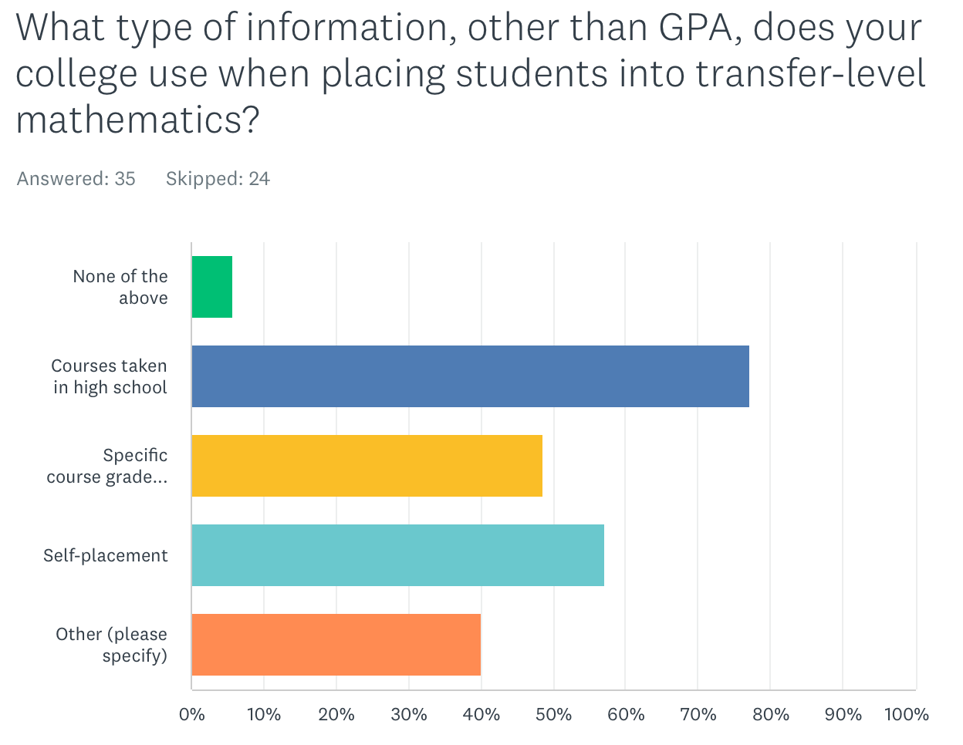
Colleges report that other methods such as self-placement are used in addition to courses taken in high school along with the grade attained in that/those course(s). As for the responses to “other” responses included conversations with counselors and/or math faculty, challenge exams (or a prerequisite challenge process), and student’s declared major were reported as other criteria used to place students.

Guided Self-Placement
Questions related to placement practices included asking about colleges’ guided self-placement models. The majority of respondents (81.6%) have developed a guided self-placement tool or process. Respondents describe using guided self-placement for students who finished high school more than 10 years ago, graduated from a non-US accredited high school, received a GED, completed an adult education program (or high school proficiency certificate), or are currently enrolled as a high school student. Some colleges allow all students the option of guided self-placement. Respondents describe the information collected from their guided self-placement models as asking for the last high school course they completed, some specify the final course grade in the highest-level math course completed, high school GPA. Some guided self-placement tools report considering the students’ major in placement. These guided self-placement tools seem to be computer-based. One college reports requiring a meeting with a counselor to review the guided self-placement results with the student to make placement recommendations. Several respondents report strongly encouraging students to meet with a counselor or math department faculty to review the placement recommendation.

Support Methods
The survey asked questions about the types of support colleges were offering to students in transfer-level mathematics, and (if applicable) the type of support that colleges were requiring students to take along with transfer-level mathematics.

The types of support offered by colleges are shown in the figure below. The question allowed for multiple options to be selected, so colleges may offer one or more of the options.

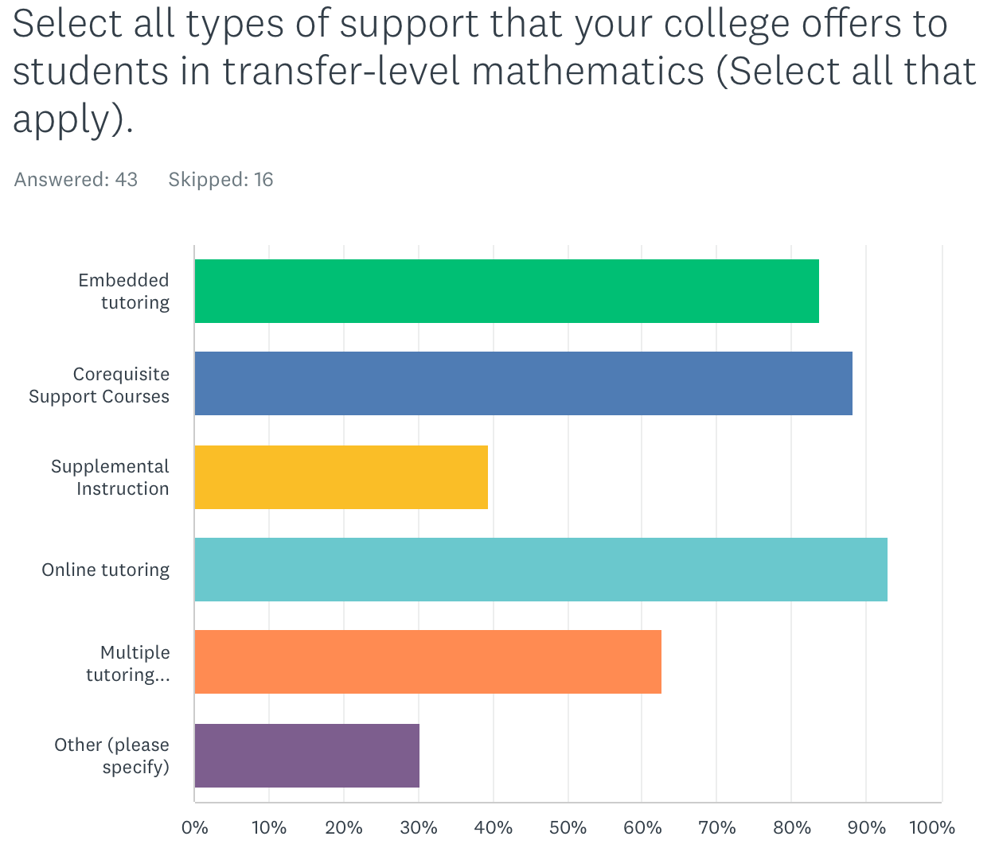

The majority of respondents offer tutoring in various formats and/or corequisite support courses. The responses to “Other” included the following: Math Lab, Math Center, or STEM Center with tutoring, supplemental instruction, or workshops, embedded counselors in courses, Student success seminars in the weeks prior to the semester, linking some math courses to courses in other disciplines like counseling or reading, and the SPARK self-paced free module in Canvas.

Not all colleges require support for courses, but for those that do, corequisite support courses appear to be the most popular type of support. The question does leave room for interpretation by colleges (as evidenced by the responses to “other” below), but the responses seem to imply that corequisite support courses are the most commonly required support for transfer-level courses.

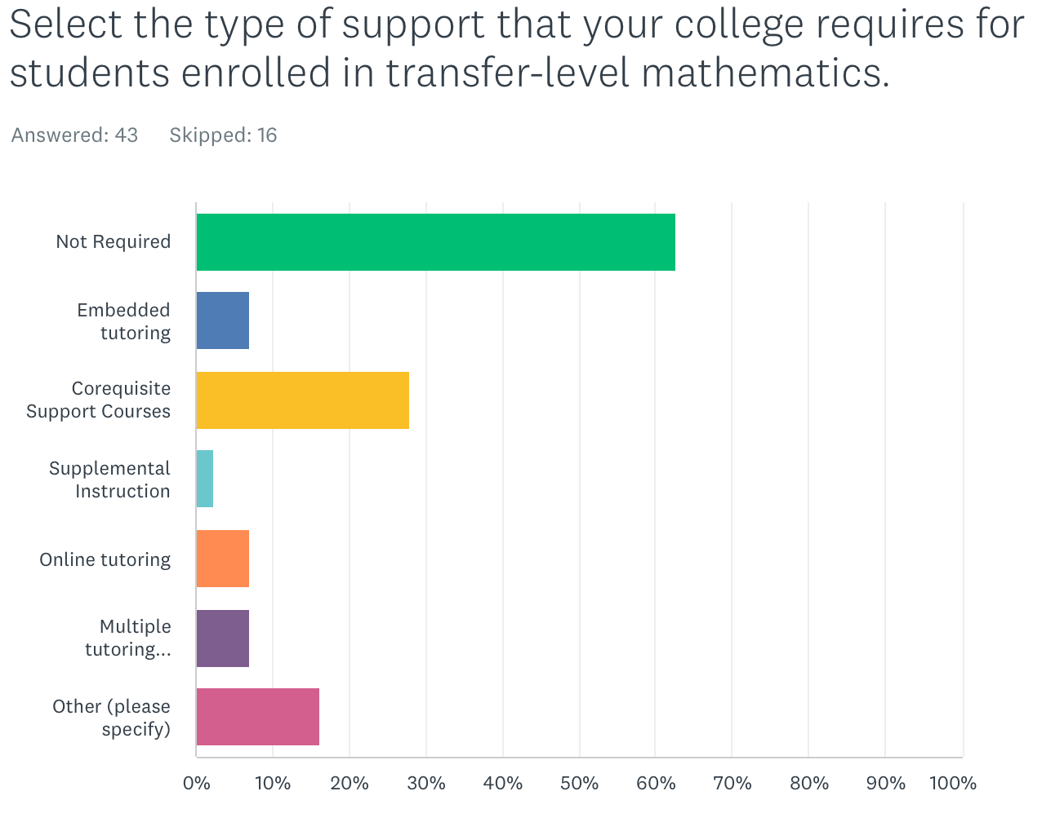

The responses to “Other” either clarified the different corequisite courses that went along with SLAM or BSTEM placement. One response clarified that support is not required for students who are placed directly into transfer-level without a corequisite via multiple measures. Another response stated that corequisite enrollment is only required if a student enrolls into a course with a corequisite, all transfer-level courses were open for enrollment to all students, but not all sections had corequisite enrollment so corequisites were therefore not really required. Aside from corequisite courses, two responses stated that support was available from a tutoring or success center and one of those responses noted that COVID has disrupted available in-person tutoring services.

Corequisite courses, when offered, were reported to be mostly credit courses associated with introductory transfer-level courses in statistics, quantitative reasoning, trigonometry, and college algebra. Typically, the corequisite is taught by the same instructor, and the course (co-requisite) meets after the parent course. The corequisite is typically structured to offer opportunities for students to practice and apply math basic skills. Nine responses were also reporting corequisite support for precalculus (if that was the course into which students were directly placed) with no other lower-level math alternative listed for B-STEM students. Three responses stated that their corequisite course was noncredit. One of those three responses was exploring the possibility of credit corequisite options. 12 responses implied that corequisite support was available in upper-level math courses beyond the introductory transfer-level B-STEM course. Four responses noted corequisite support only for statistics and no other math or quantitative reasoning courses.

Curriculum Changes:
Recognizing that there are many types of transfer-level mathematics courses, we also surveyed colleges on the types of transfer-level mathematics courses colleges offered and which non-math departments offer GE courses that meet CSU-GE Area B4 and IGETC Area 2. We also surveyed to ask which of these courses were newly-developed post-AB705. The most popular answers were statistics for psychology, sociology, social sciences, or business. Some respondents reported increased numbers of sections being offered in these discipline-focused statistics courses, and the majority of these courses existed at the respondents’ colleges pre-AB705. Other examples of GE courses that were not statistics were in the computer science, industrial technology and business/economics disciplines. With the implementation of the single GE pattern for transfer students required by AB928 (Berman, 2021), colleges will need to continue to monitor student interest in these courses and continue to ensure that the course offerings continue to meet student needs.

Ii. Preliminary reports on equitable success and persistence,
To assess the impacts of placement, we asked what percent of students enrolled in a mathematics course for a second time after they did not successfully pass transfer-level mathematics in their first attempt. The majority of survey respondents did not reply to this question. It is possible that these data may not be readily available, and therefore the question was skipped. For example, of the responses that were provided, 12 specifically indicated that they either didn’t have access to this information or their college is not tracking this information. 17 respondents had some quantitative response to the question, but the amount of information varied greatly (for example, some responses specified the term(s) from which the data were obtained, or whether the students did not successfully pass a course with or without a corequisite). Of the 17 responses who cited quantitative data on students who re-enroll, the re-enrollment rates range from 24% to 62% with the following breakdown: 24-30% (5 responses), 30-40% (6 responses), 40-50% (4 responses), 50-60% (1 response), and above 60% (1 response). The majority of responses report fewer than half of students who do not pass transfer-level math initially re-enroll for a second try. It will be important for colleges to disaggregate these numbers by race/ethnicity and disproportionate impact status to look for equity gaps in student completion and students re-attempting a course after initially not passing.

A follow-up question in our survey asked whether colleges disaggregate the data to identify student groups who are less likely to enroll in a second attempt following a first attempt. 12 respondents highlight/stress the needs for local flexibility in placement processes as adverse impacts still are seen on disproportionately impacted student groups. In addition, messaging to students to encourage persistence after an unsuccessful attempt. Respondents report that Latinx, Native American, Pacific Islander, African American, first generation, 18-19 year old, students older than 30, male students, non-athletes, part-time students, multi-racial/ethnic, first-generation, and life-long learning students are less likely to re-attempt transfer-level courses. Methods of identifying disproportionate impact are reflected in the results. For example, one response reports male students, American Indian, African American, Pacific Islander, Latinx and white students were less likely to re-attempt compared to Asian students. A popular method of measuring disproportionate impact is the percentage point gap index minus one (PPG-1) method (https://www.cccco.edu/-/media/CCCCO-Website/About-Us/Divisions/Digital-Innovation-and-Infrastructure/Research/Files/PercentagePointGapMethod2017.ashx). It is also clear that methods of disaggregating with a focus on racial equity are also important to consider. One college disaggregated by whether students were in a standalone course vs a course with a corequisite and noticed that students were equally likely to re-attempt regardless of whether the course had a corequisite, and the pass rates on the second attempt were equal to the first attempt. The response, however, did not disaggregate by student group aside from the course they were in.

Finally, the Student-Centered Funding Formula (SCFF) incentivizes colleges to maximize students completing transfer-level math within one year, and our survey asked about whether the SCFF has impacted instruction. We received four responses that indicated an impact of the student centered funding formula on student outcomes. Even with a small number of responses, there was no consensus thus warranting further study. The quantitative data, when considered in aggregate, from one college reported increased numbers of students successfully completing math within one year. These increased numbers largely reflect the statewide average trends that result from higher numbers of students being placed in transfer-level coursework. Anecdotal data from another respondent show a drop in student readiness for transfer-level classwork and a subsequent negative impact on the morale of both the instructor and students from low performance on initial assessments.`

iii. the impacts of the pandemic: withdrawal rates and success by modality
The survey was administered as most colleges were initially transitioning out of remote operations. To assess the impacts of COVID, colleges were asked whether comparisons of successful math completion were drawn between in-person and online instruction pre-COVID. Below is a graph depicting the responses. A follow-up free-response question allowed colleges to describe the differences in success rates by modality.

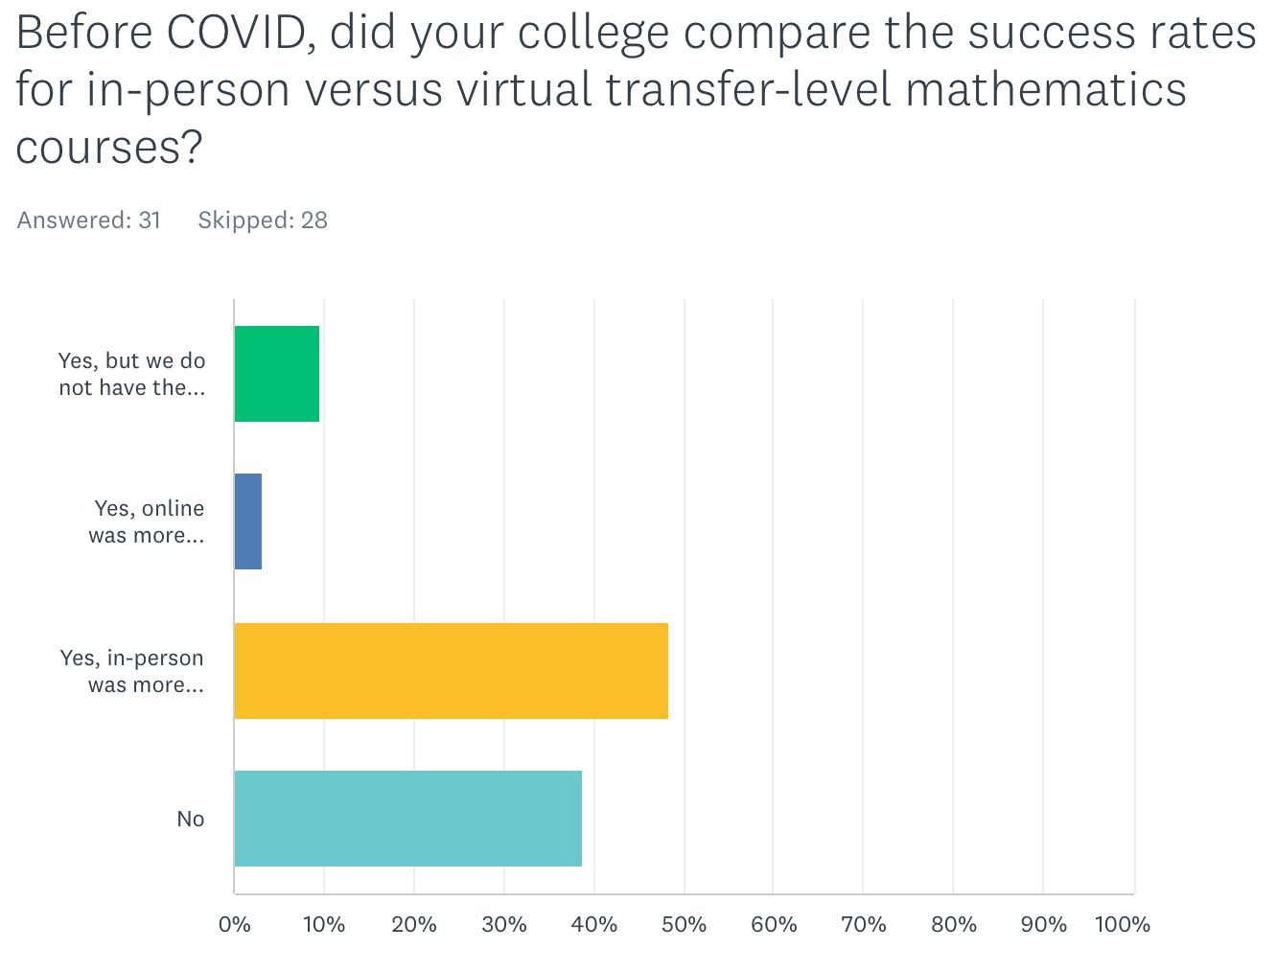

Of the respondents that had data to share, the in-person modality was reported to be much more successful than the online modality. Respondents self-reported their course success rates, and 15 responses were submitted that allow comparison of in-person to online success. one of the 15 reported a higher success rate in online courses. One represented a range of success over terms, with success rates varying over seven percentage points over four years and with no clear tendency for higher success in one modality versus the other. For all other responses, in-person success rates ranged from 6% to 20% higher than online instruction.

We surveyed withdrawal rates pre-COVID and during COVID. Responses ranged from 14 to 36% withdrawals from transfer-level math courses pre-COVID. Comparing the withdrawal rates during COVID to pre-COVID, 11 respondents reported a higher withdrawal rate during the pandemic than pre-COVID. 7 respondents reported the same or lower withdrawal rate during the pandemic than pre-COVID. One of the limitations of this survey was the question did not specify whether to include or exclude excused withdrawals from the numbers. One of the provisions of the pandemic was an emergency declaration that emergency withdrawals were allowed until ______.

For colleges that offered a blend of synchronous and asynchronous remote instruction during the pandemic, we asked whether there was a difference in success rates in each case.

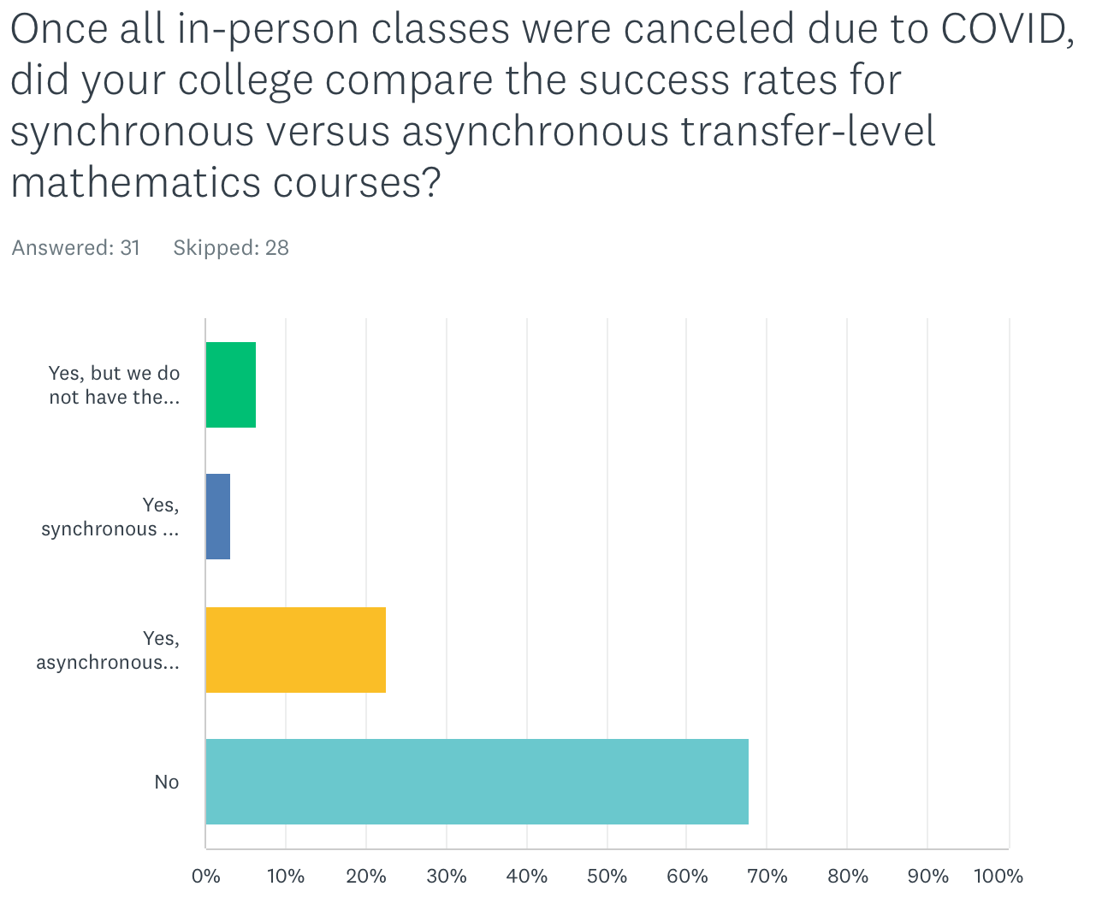

Most respondents reported not comparing the success rates in asynchronous versus synchronous online courses after classes were largely moved to remote instruction during the pandemic. Of those colleges that were able to research the differences, more colleges (seven compared to one) reported higher success in asynchronous online instruction. The one college reporting higher success in synchronous online instruction showed a difference of 24 percentage points. For those colleges with higher success rates in asynchronous courses, the differences ranged from less than one percent to 7.5 percent when presented in aggregate. These success rates in synchronous versus asynchronous rates were also not disaggregated by student group, so an unresolved question of whether there are any equity gaps in student success in either online or remote instruction modality remains.

Iv. the impacts on equity and inclusion in business and STEM majors along with considerations of measuring equitable outcomes in courses and programs.
To assess the impact of AB705 on Business and STEM (B-STEM) pathways and student participation in B-STEM majors. We obtained 19 responses to the question.

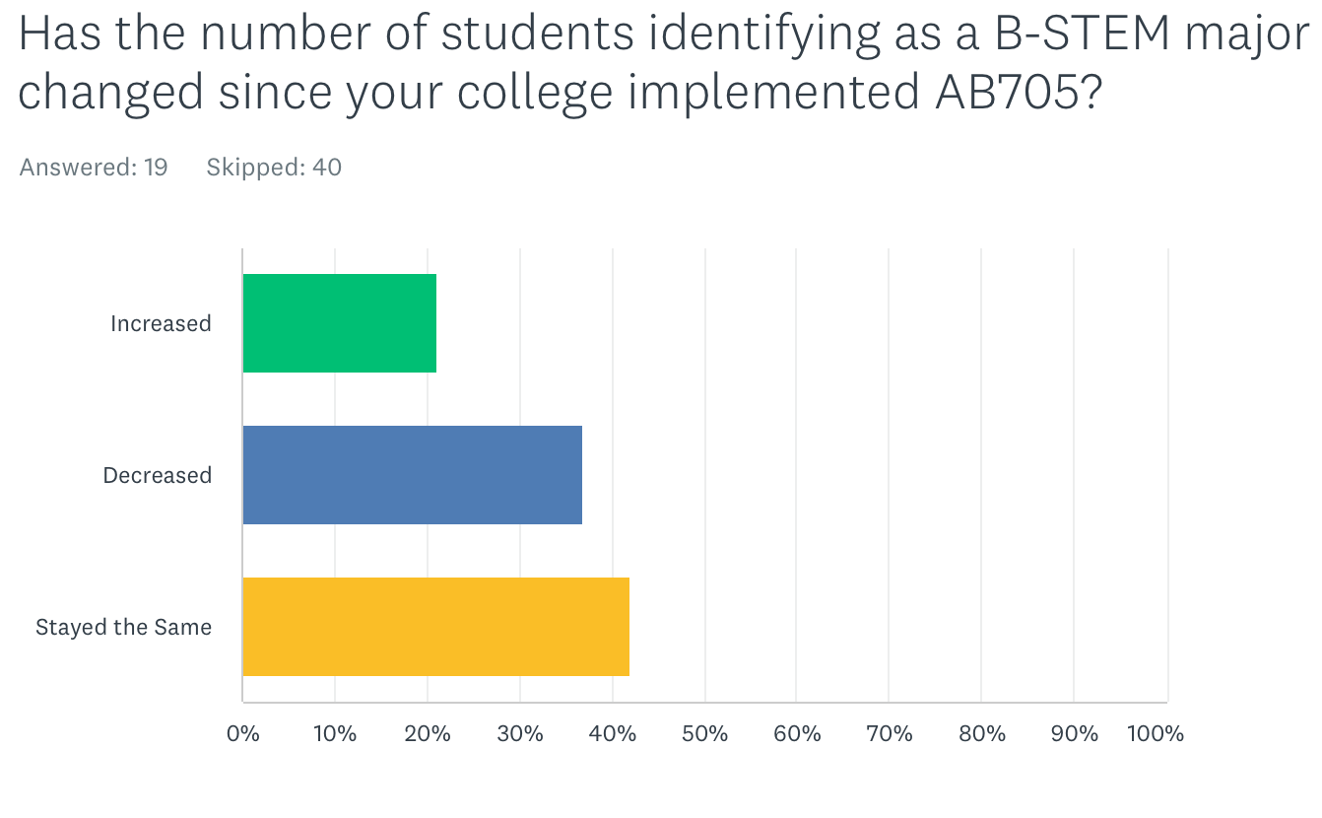
Four reported an increase, seven reported a decrease, and eight reported no change. Interpreting these trends would require follow-up studies to ask students if and how placement into math affected their choice of major. It is also possible that there is no effect (positive or negative) of AB705 on students choosing a major. For many colleges, a student indicates a major (or metamajor/area of focus) first, and that initial choice then guides the student to an appropriate math class. An initial report of student majors pre-enrollment is an important data point to collect. It is important for colleges to continue to monitor persistence in B-STEM majors compared to that initial data point.

It’s also important to recognize and embrace the fact that it is OK for students to not know their major upon entering community college. It is important for instructional faculty and counseling faculty to work together on appropriately guiding undecided students to select the correct first math course that (where appropriate) leaves options open. Colleges might also consider developing curriculum that provides flexibility for students to switch majors, for example, offer courses that might allow a student to transition from a SLAM to B-STEM major.

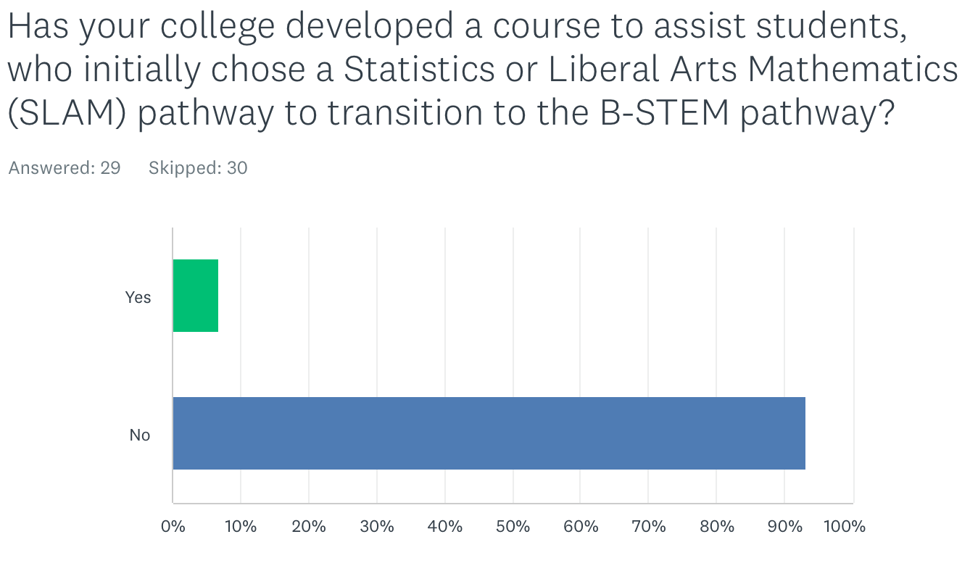
When asked whether there is or will be a bridge course developed that allows students to change from the Statistics and Liberal Arts major (SLAM) pathway to the B-STEM pathway, two respondents reported a bridge course that would support student transitions from the SLAM pathway to the B-STEM pathway. One response showed that it was a college algebra course. The other response also had a college algebra class along with a corequisite to support basic algebra skills if students need it to transition from the SLAM math course to business calculus. The other survey respondents either did not answer the question or confirmed that no such bridge course exists.

Supporting student exploration into B-STEM pathways even after they might have started on a different college pathway is an important mission of higher education. Moreover, there is an equity imperative to expanding access to B-STEM majors and supporting Black/African American and Latina/o/x students in pursuing these majors where underrepresentation in academic fields further widens societal and systemic gaps in healthcare, scientific literacy, and leadership opportunities in the corporate and political arenas. Colleges must continue to use local research data to identify equity gaps in student access to B-STEM pathways regardless of where they are in their educations.

We asked about whether and how the number of students identifying as B-STEM majors has changed, and whether the demographics of B-STEM majors has changed post-AB705. Responses to our survey highlight the fact that most college constituents do not know if the demographics of B-STEM students has changed after the implementation of AB705.

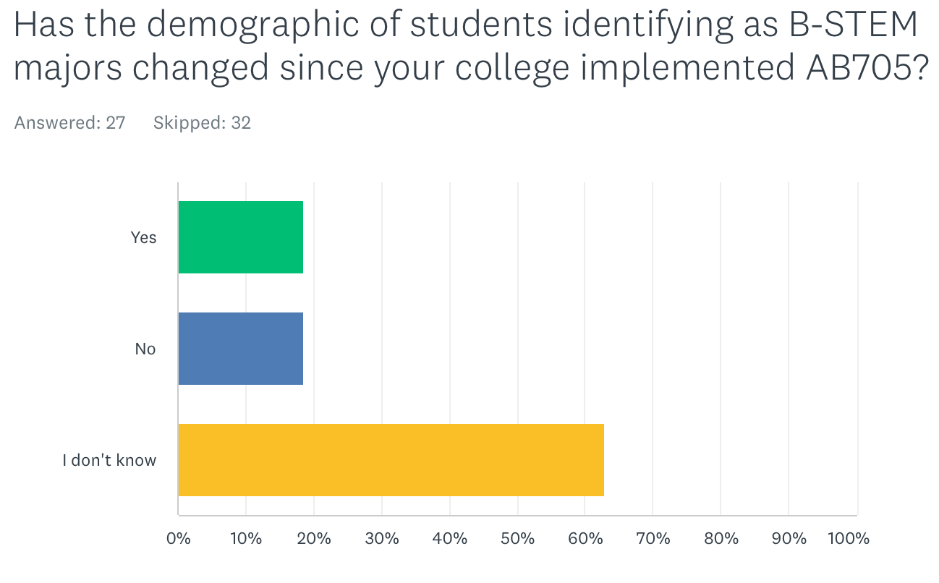

For those respondents who did know, five said that the demographics have changed while five said that the demographics did not change. The follow-up question asking to describe the demographic changes report that the percentage of female students is increasing and the number of incoming students declaring a B-STEM major has increased. Three other responses reported decreases in a variety of student categories notably among the three responses the following student demographic groups were cited by one or more respondents: African American, Latinx, Filipino, Pacific Islander, female, first generation, and economically disadvantaged students.

We asked about the prevalence of Intermediate Algebra as an offering and as a prerequisite. We also asked whether a college plans to continue requiring intermediate algebra before a student enrolls in transfer-level math. As of Spring 2022, 78% of respondents reported offering intermediate algebra. Note that this may not be a representative number of the CCC system as a whole, and it’s unclear whether this percentage might have decreased in Fall 2022 and beyond. Title 5 55063 (Cite: https://govt.westlaw.com/calregs/Document/I43B642004E0E11EDA19AD993669B28BD?viewType=FullText&originationContext=documenttoc&transitionType=CategoryPageItem&contextData=(sc.Default)) sets intermediate algebra as the minimum level of math proficiency to earn an AA/AS degree from a CCC. While Title 5 has not changed, AB1705 figures to de facto increase the math competency standards to graduate from a CCC with an associate degree for most students. The latest CCCCO Memo ESS 22-400-009 specifies limited circumstances where a pretransfer-level course may be offered to students, namely that such a course is explicitly required by an outside accreditation agency or the program advisory board.

Although AB705 requires colleges to adjust how students are placed into transfer-level courses, it was silent on prerequisites. Our survey responses suggest that many colleges might have removed or adjusted prerequisites on transfer level courses as a result of AB705. In light of the CCCCO Memo AA 18-40 (cite: https://asccc.org/sites/default/files/AA%2018-40%20AB%20705%20Implementation%20Memorandum__0_0.pdf), half of the colleges that require intermediate algebra (or high school algebra II) as a prerequisite to B-STEM courses will no longer require intermediate algebra as a prerequisite, presumably this means that curriculum has been changed to no longer require intermediate algebra or algebra II explicitly. The survey responses reported 68% of respondents no longer requiring intermediate algebra (or high school algebra II) for students in B-STEM pathways entering their initial transfer level math course, and this higher percentage may be the result of some colleges eliminating or no longer offering intermediate algebra as of Spring 2022.

Our survey asked follow-up questions on how these changes in course sequencing (i.e. the relaxing or elimination of prerequisites or direct placement into transfer-level courses) may affect students. A follow-up question asked whether the first enrollment success rates in transfer-level courses with intermediate algebra as a prerequisite have changed since the implementation of AB705.

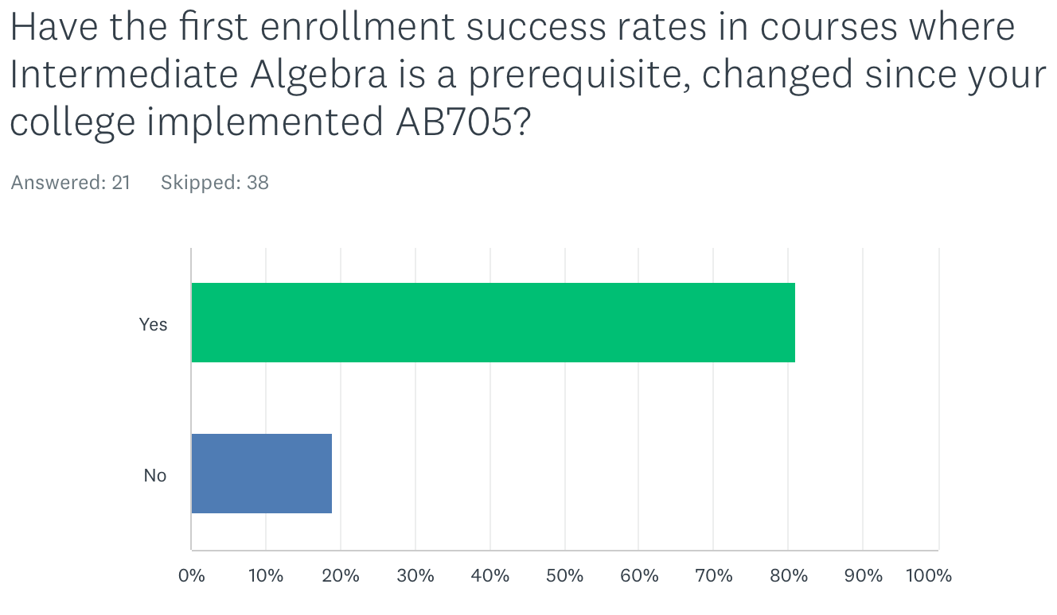

Of the 21 responses, 81% said that they have. Most respondents reported anecdotal evidence that success rates have fallen. Consistent with statewide trends where more students are being placed into transfer-level math or quantitative reasoning, one response reported that enrollment in courses that had intermediate algebra as a prerequisite has increased post-AB705 both in quantitative reasoning courses and in other disciplines (such as biology, chemistry, economics, and psychology) where some courses (due to articulation requirements to transfer institutions Citation: https://www.ucop.edu/transfer-articulation/transferable-course-agreements/tca-policy/regulations-by-subject-area.html ) have also had intermediate algebra as a prerequisite. Some respondents also reported shifts in course offerings with decreased (or eliminated) pretransfer-level math courses and/or increased statistics offerings compared to pre-AB705 when more business and STEM focused math courses were offered.

As curriculum in B-STEM pathways typically requires a sequence of math courses and preparatory math courses establish a foundation for success in higher-level math courses, we asked whether colleges track the success of math sequence completion in B-STEM majors.

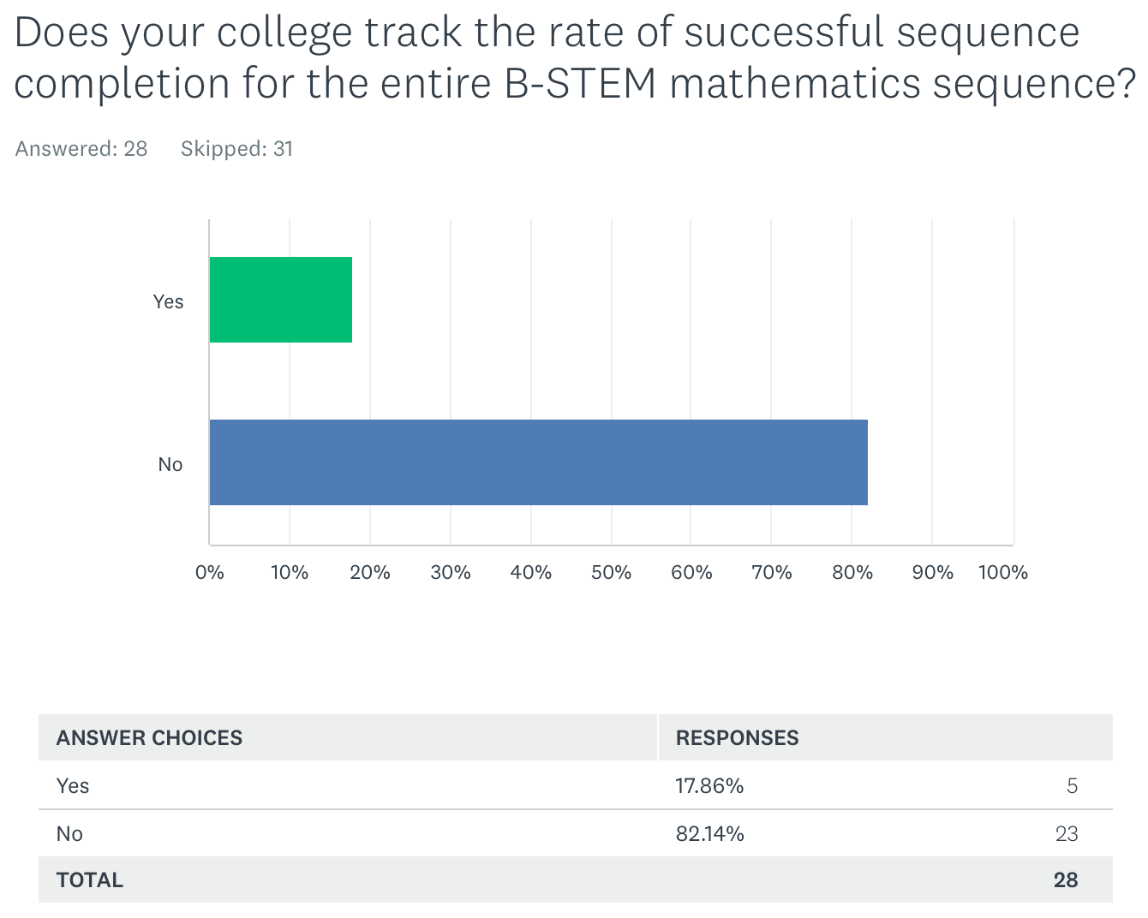

Five responses to our survey reported tracking the rate of successful completion of the entire B-STEM math sequence. Two responses followed-up with their results or how they measured success. One response showed a 16.5 percentage point drop in success post-AB705. The other response reported success rates as the percent of B-STEM majors who earn their certificate, degree, or transfer. Recognizing that AB705 was recently implemented, it is important to continue to monitor success rates in math sequences, measure the persistence and success rates of students intending to major in B-STEM disciplines, and importantly monitor for equity gaps.

To maintain transferability (particularly to UC) and articulation (with C-ID and major prep articulation), some disciplines are required to have prerequisites of algebra or intermediate algebra on courses, for example economics, biology, and chemistry. Where colleges are reducing or eliminating pre-transfer level math courses, there may be impacts on student readiness in these other disciplines either in student course-taking patterns and/or success. Some colleges are offering support for students in other disciplines with courses that have intermediate algebra as a prerequisite. Examples cited by three survey respondents who reported having such supports were all for chemistry classes. The support classes are designed to help with calculations in chemistry, and in one case the support course existed prior to the implementation of AB705.

The passage of AB1705, and the law’s focus on the calculus preparatory sequence will challenge colleges and districts to continue to collect data on student placement and persistence through the prerequisite sequence into Calculus 1 and Calculus 2 (if a program requires it). Faculty will need to be aware of narratives that education is a barrier. Prerequisites are instituted not as barriers, but as tools to promote student success in higher-level courses. While we must continue to validate prerequisites, and evaluate/adjust curriculum through an equity lens, so too must we continue to evaluate the success of initiatives on student access and success both at the course and program level also through an equity lens.

To graduate from high school in California, the minimum level of math proficiency is elementary algebra (Citation: https://www.cde.ca.gov/ci/gs/hs/hsgrmin.asp). In addition, students earning a “D” grade in high school courses receive credit towards graduation, but students headed to UC and CSU must complete the a-g requirements with grades of “C” or better. The California Department of Education DataQuest cohort report of 2021-22 high school graduates shows data disaggregated by race/ethnicity showing high school diploma completion rates along with the disaggregated numbers of students who met the a-g requirements to be eligible for admission to the UC and CSU (Citation: https://dq.cde.ca.gov/dataquest/dqcensus/CohRate.aspx?cds=00&agglevel=state&year=2021-22). The data show equity gaps in high school diploma attainment in Black/African American, American Indian or Alaska Native, Hispanic or Latino, and Pacific Islander students. Overall 51.4% of the 2021-22 high school graduates met the a-g requirements for admission to UC/CSU, but the same student groups with lower levels of high school diploma attainment also have below average numbers of students who met a-g requirements for admission to CSU and UC.

Given that there are discrepancies between the standards for graduation and the a-g requirements for transfer, the CCCs represent an important bridge for those students to access higher education. The UC system has recently initiated a program whereby high school students who were not eligible for UC admission due to not having met the a-g requirements could be guaranteed admission to UC after completing those requirements at a CCC (https://www.universityofcalifornia.edu/news/new-dual-admission-pilot-program-will-help-more-students-transfer-uc). For these students, it is up to the CCCs to offer a high-quality education to prepare students to be successful in their CCC courses and beyond. It should be noted that precalculus is the introductory level course for STEM majors at UC, so for students in the UC dual admission pilot program aspiring to be business or STEM majors, the community colleges must be able to provide courses to support those students’ success at UC. Still, questions persist about why students graduating high school are not eligible for admission to CSU and UC. It is possible that systemic barriers to access a-g courses may still exist where some high schools do not offer one or more courses to meet the a-g admission requirements.

Now that AB1705 was signed into law, colleges’ ability to offer Intermediate algebra is greatly reduced especially for students in B-STEM majors. Per CCCCO Memo ESS 22-400-009 students must be placed into transfer-level courses except under limited circumstances where an accrediting agency or advisory board specifically require a pretransfer-level quantitative reasoning course. In light of the above information about student access to math in high school and high school graduation requirements, devising ways to maintain equitable access and promote equitable student success in B-STEM majors will be a challenge colleges face. We must keep in mind that the students we serve come from diverse educational backgrounds including students who did not graduate from high school and/or come to us with adult school credentials. Many of our students are returning to school after a significant gap in their education including veterans, and many of these students are intending to major in Business or STEM. For students seeking more solid foundations in math, maintaining access and support are key to diverse course offerings is key to advancing equity in the Business and STEM disciplines, and diversity in the curriculum aligns with the mission of community colleges as an open-access institution.

Colleges may have developed local methods of identifying and tracking equity gaps in transfer-level math, we surveyed to see whether colleges have gone beyond the data disaggregation required by the CCCCO’s Student Equity and Achievement (SEA) Program. Our survey asks how those gaps are tracked and whether AB 705 has impacted college tracking methods.

Many respondents report either following the SEA metrics, but the table below summarizes some of the ways that colleges are disaggregating data. Items in bold had more than three responses.

- Gender
- Ethnicity
- Socioeconomic status
- DSPS
- 1st generation
- Foster youth
- Age
- Veterans
- AB540
- EOPS
- English language learner
- Athlete
- Promise grant
- Full-time/part-time
- Residency
- International student
- Dual enrollment
- Rising scholars
- Additional gender identities
- Educational goals
- High school GPA
- Placement
- Enrollment after placement
- Support course enrollment
- Start course first attempt success
- Online/in-person
- Learning Community
- Course session length

As for the impacts of AB705 on the types of data that were collected, colleges are collecting data on access, throughput, success, and withdrawal rates disaggregated by the above criteria (where possible). We are hearing more about the large number of compliance-driven data reports being passed along to institutional research offices. The ability for those offices to work with faculty to design equity-minded research projects to maximize student success is greatly diminished without adequate support from local and system administration.

Given the imperative to maximize the probability that a student enters and completes transfer-level math within one year, it’s important to get a full view of the impacts of AB705 on our diverse student population. Data disaggregation is therefore key to collecting quantitative data. Understanding students’ unique experiences and needs pre-college, during college, can come from qualitative data. Faculty are in the best positions to design questions, and our colleges and system will need to support faculty and our college researchers in these data collection efforts.

Transfer-level meaning CalGETC? An unresolved question
AB1705’s passage along with the passage and implementation of AB928 will create further complexities for colleges. Many quantitative reasoning courses that were applicable to CSU General Education Breadth are not UC transferable, and therefore might not be applicable to CalGETC, the single general education pathway that transfer students may use for admission to UC and CSU campuses or majors that prioritize GE completion among the criteria for admission. It should be noted that not all majors or colleges at a single UC or CSU campus will require or prioritize GE completion as a criterion for admission, and colleges (e.g. colleges of engineering) may have unique GE patterns that are separate from the proposed CalGETC. In addition, CSU-GE will remain as the GE pattern used by CSU. In addition, AB1705’s passage has meant that the focus now is on placing students into transfer-level and according to the CCCCO Memo ESS 22-400-009 for B-STEM majors, placing students into degree-applicable courses. The Memo states that colleges must show that placement into prerequisite courses lower than the degree-applicable course will improve success in courses like Calculus 1 and also improve chances that students will continue to and pass Calculus 2 (if required). The challenges for colleges will be to understand the educational backgrounds of students and have discipline faculty develop innovative curriculum to support students and counselors collaborate to provide effective guidance regarding student placement. In addition, faculty will need to work with institutional research offices to devise research questions to monitor the effectiveness of existing and proposed placement innovations.

Overview of Other Papers Showing AB 705 Outcomes:
After AB705 was enacted, a number of studies reporting throughput data and placement data, were published by the Research and Planning (RP) Group and the Public Policy Institute of California (PPIC).

The RP Group Study, “Transitions in Math from High School to Community College Before and After AB705, Updated through Fall 2021” reports on enrollments in math pre-AB705 resulting in higher numbers of students re-taking the college version (or a lower level) of a math course taken in high school with higher percentages of Black/African American, Latina/o/x, and Native American students represented in the students who were enrolled in a college course with the same title (or lower) than the highest high school course completed. Additionally, the study presents an analysis of CalPASS data showing student success rates in their initial college math course as a function of the highest math course a student completed in high school. The study presents data from Fall 2016 and Fall 2021 showing that success rates for students who took Algebra 2 in high school were approximately the same in 2016 if those students took intermediate algebra or statistics in college, or slightly higher success in statistics compared to intermediate algebra in 2021. In addition, the study reports that the highest success rates were seen in students who repeated a course one or more levels below the course the student completed in high school. (https://rpgroup.org/Portals/0/Documents/Projects/MultipleMeasures/AB705_Workshops/Transitions_in_Math_From_HS_to_CC_Before_and_After_AB705_January2023.pdf?ver=2022-12-30-074239-157)

In December 2021, the Public Policy Institute of California (PPIC) wrote “Community College Math in California’s New Era of Student Access.” https://www.ppic.org/publication/community-college-math-in-californias-new-era-of-student-access/ The article reports an increase in the rates of successful math completion in one term in fall 2020 compared to fall 2019 (46% vs 40%, respectively), and higher numbers of single-term transfer-level completion compared to fall 2018 (reported at 24%). It’s important to note that the reported successful completion rates were all under 50%. Additionally, the low percentage rate in fall 2018 could be due to students enrolling in courses below transfer level, so it would not be possible for such a student to complete transfer-level coursework in a single term. The study also reports on disproportionate impacts on Black/African American and Latina/o/x students both being more likely to be enrolled in below-transfer level courses and one fifth of Black/African American and Latina/o/x students were completing transfer-level coursework the following fall semester. The study also reports Fall 2019 data on non-traditional-aged students who were more likely to have used guided self-placement were almost 9% more likely to pass transfer-level math in a single term. Moreover, the same analysis shows that Black/African American, Latina/o/x, Native American, Pacific Islander, and Foster Youth are 12.6%, 8.6%, 7.6%, 8.2%, and 6.7% less likely to pass transfer-level math in a single term suggesting that there are persistent equity gaps seen in the initial stages of AB705 implementation.

The December 2021 PPIC report https://www.ppic.org/?show-pdf=true&docraptor=true&url=https%3A%2F%2Fwww.ppic.org%2Fpublication%2Fcommunity-college-math-in-californias-new-era-of-student-access%2F cites a concern among math faculty that bypassing intermediate algebra would potentially impact success in later STEM curriculum such as higher math and physics. A preliminary analysis comparing success of students who started in any BSTEM course in Fall 2019 compared to enrollment in any course above Calculus 1 as of Fall 2020. We suggest that different methods using longer timeframes are necessary because a student in a course above Calculus 1 in Fall 2020 had to take Calculus 1 in a prior term, and that student likely started in precalculus in Fall 2019 or earlier. The PPIC analysis presumes that a community college has a combined precalculus and trigonometry course as a gateway transfer-level course for students who did not take Intermediate Algebra in high school. Many community colleges offer separate trigonometry and precalculus courses, and some may offer a college algebra course either as a standalone prerequisite to or combined with one of those courses. Furthermore, a subsequent analysis reported on the percentages of students who completed Calculus 1 as of Fall 2020 depending on where students started their math curriculum also presupposes that students are full-time and are progressing through their math sequence every term. If a student took a semester off from math due to work, challenges fitting a math class in with other GE or STEM courses, life circumstances, the pandemic, etc… there would be a low to zero chance that the student would have completed Calculus 1 by Fall 2020. Additionally, without the context of what type of math preparation a student had in high school, it is difficult to conclude that placing students into precalculus or trigonometry combined with precalculus are effective practices for promoting student success.

Other sources to consider/summarize:

https://education.fsu.edu/sites/g/files/upcbnu3146/files/2022-08/FINAL%20TX%20Coreqs%20Year%201%20Report_20220804.pdf?utm_campaign=In%20Sum

https://www.ppic.org/publication/a-new-era-of-student-access-at-californias-community-colleges/

Data sources available:
As the ASCCC survey and the studies above show, there are several data sources available to find quantitative data on AB705. College or district research offices are a good place to start for local conversations, but as noted above colleges and districts have widely disparate support and faculty access to research offices. Some of the statewide data dashboards available come with limitations, specifically Datamart and Cal-Pass Plus (CPP) as noted below.

During the implementation of AB 705 faculty were concerned about adequately supporting the varied skills First-Generation students had upon entering community college. First-Generation students are typically defined as students who have parents with no post secondary experience, specifically no parent with a bachelor’s degree[1]. Without at least one parent that had completed a college degree, there were less opportunities for families to help students decide on high school preparatory courses particularly in Mathematics, ESL, and English. Students who have at least one parent with a bachelor’s degree have substantially higher college completion rates and a close resource to help provide knowledge about challenges common to secondary higher education[2]^{and [3]} such as, difference between high school and college work, timelines, costs, finances and student expectations.

With the advent of Covid and shift to exclusively online education in high schools and colleges, faculty were even more concerned that virtual learning could increase the difficulties for First-Generation students in this new learning paradigm. Nationally, successful outcomes data for online learning has lagged face-to-face success and the virtual learning environment further distanced students from college faculty and staff who could help bridge the challenges of college culture. Without the ability to access student’s incoming skills in Mathematics, English and ESL and the requirement to place all entering students into transfer coursework, faculty began to report that students were even further behind in fundamental skills. Concerned that first generation students were even further impacted, an analysis of this special population revealed interesting findings.

The CCCCO Datamart reported First-Generation outcomes as a special population beginning in Fall 2011. However, they stopped reporting this data element in Spring 2017. The CCC definition diverged from the national definition[4] (NCES in that it defined a first-generation student with neither parent attending a community college, eliminating the expertise of completing a college goal and identifying community college rather than a Bachelor’s degree. While datamart stopped reporting, the CCCCO Launchboard Student Success Metrics continues to report data on First-Generation success on the Math and English within the first year on the CPP Dashboard. https://www.calpassplus.org/LaunchBoard/Student-Success-Metrics. These data differ from the CCCCO data mart numbers in that they exclusively report on a small well-defined student population that “enrolled in college for the first-time ever in higher education as non-special admit credit students in at least one term of the selected year.“
In the 2020-2021 cohort of first-time college enrolled students, the First Generation students represented 436,444 students, non-first generation were 506,123, and unidentified were 144,516
Transfer Math and English outcomes averaged about 4% lower in First-Generation students success rates through 2021 statewide. Of greater concern on the Guided Pathways dashboard was the decrease in transfer outcomes. The dashboard displays a decrease of approximately 50% to CSU/UC and 50% less to private four-year colleges. Transfer completion was the central reason for legislating placement into transfer Mathematics and English courses.

Since the implementation of AB705, the CCCCO has required colleges to submit an “Equitable Placement Validation Report” on student placement and throughput rates. The extent to which discipline faculty are involved in completing the report or whether the results are even shared with discipline faculty is unclear. Depending on the familiarity of the research office staff with curricular pathways, it’s possible that there could be some discrepancies that could arise between instructor data and the data that are reported to the state. The results of these equitable placement reports are presented in the CCCCO Transfer-Level Gateway Completion Dashboard. This website displays successful transfer completion rates and counts. It is possible to toggle the fields to focus on data disaggregation by a number of factors (many of which overlap with what colleges reported in the ASCCC survey). The dashboard, at first glance, will show that completion numbers and the completion rate of transfer-level math is increasing for all students. The dashboard also plainly shows that equity gaps persist for African American and Hispanic students. A deeper dive into the data dashboard enables one to look at the cohort numbers (the number of students who start in a discipline at a given level (cite: https://www.cccco.edu/About-Us/Chancellors-Office/Divisions/Educational-Services-and-Support/transfer-level-dashboard/definitions-methodology)) to see how many students start compared to how many complete. Some colleges are reporting more students are being placed into transfer-level courses, and more students are passing and greater numbers are also failing compared to pre-AB705. As we emerge from the pandemic, faculty are also challenged with supporting student learning in higher-level math classes when the educational environment in high school or college during the pandemic was challenging to both students and faculty.

Conclusions and Recommendations:
Our survey results highlight that the effect of AB705 has shown some benefits towards improving access to transfer-level math courses, and streamlining math preparatory coursework for students who are most-ready to succeed in math curriculum in a college setting. These findings are consistent with many of the other studies and reports on the effects of AB705.

Still, the impacts of AB705 on equitable achievement have been uneven across the state. The mission of the CCCS has been to be a source of higher education for all, but especially those students have underprivileged academic backgrounds, those from minoritized populations in higher education, and those who are returning to school after a gap. To truly ensure that we are achieving equitable outcomes, we must continue to disaggregate data collection and analysis methods by race/ethnicity and other special populations. To that end, we offer the following recommendations.

Refine the definition of a first-generation college student to align with the more commonly applied definition of no parent with a bachelor’s degree. With the focus on transfer-level coursework seen in AB705, it is clear that defining a first-generation college student as having no parent with any college experience or an associate degree does not align with the curriculum students current students are taking.

Work with IRPE staff and offices to improve and implement methods of data collection, and develop local processes for faculty to be able to access data. Typically, faculty are more likely to respond positively when they are able to access their own data and use the data for improving their own work, rather than having another entity present the data along with the message that faculty need to improve.

Include qualitative data from faculty, student services, and students in continuing analysis. Qualitative data can be obtained from classrooms and offices. The preliminary reports focusing narrowly on throughput numbers statewide without consideration of specific colleges’ challenges, and/or without disaggregating the data have elicited strong reactions from faculty. Namely the faculty experience challenges of watching disproportionate numbers of special population students struggle through higher-unit corequisite courses along with a transfer-level course, and seeing negative impacts on equity, inclusion, and representation in B-STEM disciplines while being told that they need to change their curriculum leaves many faculty feeling unheard and unsupported.

Provide venues (time and space) for front-line practitioners to share with college leadership in the academic senate and administration. Allow practitioners to have agency in finding the best ways to support students is important to ensure buy-in and ultimately success of innovations.

As noted previously, there are many studies and data sources available to examine the effects of AB705 through the lens of throughput. There are also ways to disaggregate those data by student demographics and to a certain extent their educational background. We noticed many colleges or districts do not or cannot disaggregate the data further to look at the impacts beyond what is required for compliance purposes. To the extent that is possible, we recommend continuing to (or develop processes to) assess student success and learning in sequenced curriculum, program completion, and transfer. Collect data on access and completion gaps in B-STEM disciplines. Monitor college-wide impacts of AB705 on other disciplines and course-taking patterns. Finally, most colleges have increased their online instruction offerings since 2020, we recommend that colleges also compare synchronous and asynchronous online outcomes.

Using existing quantitative data, we also recommend expanding the data collection methods to monitor student retention both before and after census date and analyze results for before census to see if there are correlations to student persistence and success. Disaggregate data to identify whether there are populations of students who drop, withdraw, excused withdrawal, or earn substandard grades (D/F/W/NP) are less likely to re-enroll in a math class and/or re-register for college in subsequent semesters. Look for the impacts of substandard grades on student probation and on financial aid eligibility. Consider whether losing eligibility for financial aid or getting on academic probation is/are barriers to student persistence.
Continue to support student exploration to equitize the learning experiences of CCC students to their counterparts at UC/CSU. All higher education students change their majors and education goals, and their academic, personal, and career interests need to be supported. Colleges may want to research how often students might switch from SLAM or CTE to B-STEM majors. We need to also recognize that although the CCC system also serves a different population than the CSU and UC. Curricular offerings at CCCs need to (at a minimum) match what is available to CSU students (including trigonometry and college algebra). Though we must also be aware of the need to offer foundational courses that will support students who need the extra help. Reduced placement options and removing student agency to seek the help they need by narrowing course options or enrollment options makes dangerous assumptions that our students come to us with fairly equal access to preparatory coursework.

Provide clear messages to students and the community about the differences between college-level work and high school work. Higher education general education patterns are often criticized because there is the perception that the coursework was already completed in high school. This same line of thinking has now been applied to math curriculum, and we are seeing various outside groups challenge higher education for requiring students to “repeat” courses. The pace of learning and the skills necessary to be successful are fundamentally different in high school compared to college, and they need to be. College develops critical thinking, problem solving skills, and seeks to promote agency as we hope to produce students who will be leaders who will be able to make good decisions and empower others to also make good decisions. When students come to our institutions, they come with the expectation that we provide a unique experience that expands on their prior learning. Community college professionals must challenge the narrative implicit in comments like “why do we require students to repeat courses,” that education is a barrier. In other disciplines, we do not ask why students are “repeating” courses they completed in high school. Higher education was founded largely to advance the privileged, those who were most likely to have good academic foundations right out of high school. Community colleges exist as a mechanism for achieving social equity, and we need to recognize that the students we serve are not all from educationally privileged backgrounds. Therefore it is our responsibility to provide the education students need to be successful in our colleges and beyond.

[1] National Center for Education Statistics (NCES) https://nces.ed.gov First-Generation and Continuing-Generation College Students: A Comparison of High School and Postsecondary Experiences, 2017 https://nces.ed.gov/pubs2018/2018009.pdf

[2] First-Generation College Graduates Lag Behind Their Peers on Key Economic Outcomes. May 18, 2021 Pew Research Center https://www.pewresearch.org/social-trends/2021/05/18/first-generation-college-graduates-lag-behind-their-peers-on-key-economic-outcomes/

[3] First-generation college students face unique challenges
Dick Startz Monday, April 25, 2022 Brookings https://www.brookings.edu/blog/brown-center-chalkboard/2022/04/25/first-generation-college-students-face-unique-challenges/

