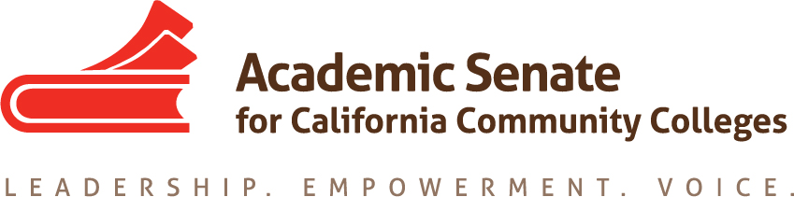

Equity and Diversity Action Committee

Minutes

Time: Dec 2, 2020 11:00 AM Pacific Time (US and Canada)

Join from PC, Mac, Linux, iOS or Android: https://cccconfer.zoom.us/j/7503831898

Or iPhone one-tap (US Toll): +16699006833,7503831898# or +12532158782,7503831898#

Or Telephone:

Dial:

+1 669 900 6833 (US Toll)

+1 253 215 8782 (US Toll)

+1 346 248 7799 (US Toll)

+1 646 876 9923 (US Toll)

+1 301 715 8592 (US Toll)

+1 312 626 6799 (US Toll)

Meeting ID: 750 383 1898

International numbers available: https://cccconfer.zoom.us/u/acdWOxOWOb

Or Skype for Business (Lync):

SIP:7503831898@lync.zoom.us

The Equity and Diversity Action Committee (EDAC) responds to resolutions from the session that deal with the issues of equity and diversity in hiring, equal opportunity, and cultural diversity in the curriculum. The EDAC committee recommends strategies that promote student equity and student success, including effective teaching and student learning styles and fostering a campus climate conducive to faculty diversity and student achievement. The Committee advises the Executive Committee on guidelines, laws and regulations relating to equal opportunity and cultural diversity and promotes the integration of equity and diversity issues in appropriate ASCCC activities.

- Call to Order
- Agenda Adoption: M.___Campo_________ S. __London___________
- Check-in with members.
Peggy Campo |  | 2020-21
Virginia "Ginni" May |  | 2020-21
Jamar London |  | 2020-21
LaTanga Hardy |  | 2020-21

- Action Minutes
November 18, 2020 M. London S. Hardy Approved (1 abstention-Campo)

- Committee Responsibilities-
- ASCCC Areas of Focus for 2020-21
- Guided Pathways Implementation and Integration to Transfer and Careers
- Culturally Responsive Student Services, Student Support, and Curriculum;
- Equity Driven Systems

B. From the Chancellor’s Office Diversity, Equity, and Inclusion (DEI) Workgroup:
- ASCCC, HR, and local union to review existing evaluation procedures. (Tier 1)*
- ASCCC, HR, and local union to create a process where conversations about cultural competencies can happen outside the evaluation process. (Tier 1)*

*Tier 1 and Tier 2 activities are strategies that involve policy changes, changes to existing procedures, and or activities that promote supportive and inclusive behaviors. Aligned to the Vision for Success commitments, Tier 1 activities can be achieved in a 6-12 months’ timeline (CCCCO Call for Action June 2020)

Action Item: Tier 1 Recommendations
1. ASCCC, HR, and local union to review existing evaluation procedures.
2. ASCCC, HR, and local union to create a process where conversations about cultural competencies can happen outside the evaluation process.
C. DEI Follow up Planning Items:
- Webinars – discipline specific near spring FLEX days for faculty professional development
- LaTanga Hardy – ECE and DEI Education one-hour webinar in mid-January

Dr. Hardy will be meeting this Friday with the group to discuss. Proposing 1/15/21 or 1/21/21 from 1-2pm. Title, description, and presenters TB confirmed.

- Jamar London – STEM and DEI Education one-hour webinar in mid-February, Sam Foster, Janet Fulks, Peggy Campo

Dr. London proposed 2/9/21 and 2/12/21 11-12 to present “Culturally Relevant Curriculum in the STEM Classroom”. First meeting will present sample assignments by presenters and second discuss ideas participants have.

- One-hour webinar in mid-March

Dr. Parker and Dr. May proposed the topic “The Role of the Academic Senate in Faculty Evaluations Incorporating DEI” for 3/10/21 1 pm.

- EDAC and GPTF Recommendations

The GPTF has recommended EDAC to modify their charge to incorporate the aspects of GP that apply, since they will no longer exist next academic year. Make sure during the March meeting we review EDAC’s charge with GPTF’s recommendations to try to map GP goals and pillars.

- Webinar Ideas – webinar suggestion #2 from above, and possibly #3
- Mentor program – Recommendation to the FELA
Dr. Parker needs to speak with Dr. Sylvester Henderson, who leads FELA. Dr. Bui has ideas as recommendations to incorporate into the leadership academy.

General Information: the Rostrum article “Why We Do What We Do; Tapping into Our Why” is due 1/4/21. Next deadline for possible articles is 3/8/21. Articles need to be 900-1500 words; possible future articles might include examples of culturally relevant curriculum. Dr. Hardy will try to write on DEI in ECE as well as Dr. Campo for STEM.

- Spring 2021 Committee Meeting Date: TBD

- Adjourn meeting

