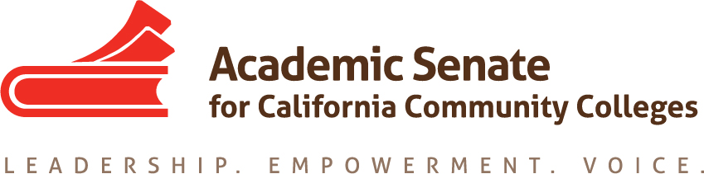

Educational Policies Committee

2 March 2021, 10:30 a.m.

Zoom Teleconference Information

Join from PC, Mac, Linux, iOS or Android: https://cccconfer.zoom.us/j/5462550600

Or iPhone one-tap (US Toll): +14086380968,5462550600# or +16465588656,5462550600

Dial: +1 408 638 0968 (US Toll) or +1 646 558 8656 (US Toll)

Meeting ID: 546 255 0600

Minutes

- Call to Order and Adoption of the Agenda
In attendance: Sam Foster (Chair), Victor Hernandez (SSCCC), Leigh Anne Shaw, David Morse, James Preston, Darcie McClelland, Mayra Cruz

- Volunteer note taker- Mayra to take notes

- Approval of Minutes- February meeting notes tabled to April

- Draft of PD Paper
  - Feedback on Title: Going Beyond Development: Faculty Professional Learning—An Academic Senate Obligation to Promote Equity-Minded Practices that Improve Instruction and Student Success.
No objections to the title.
  - Review Recommendations (attached) See attached.
  - Additional input

- Resolution 13.02 F19 Data Paper and Equity-Minded Practices considering resource development
  - Resources that demonstrate effective practices
  - Data resources and practices that may advance equity
Sam sent and reviewed the document with ideas generated by the members. (attachment) Possibility to partner with GPTF by using their resources
Tool for faculty use:
- Why data is important (Mayra)
- How do we have meaningful conversation about data (James)
- What questions can I ask about the data? How not to be snowed by data?
- What data sources are available and purpose
- How to use the data resources
- Importance of evaluating longitudinal data
- Disaggregation of data for specific populations (Leanne)
- How do I make data actionable (James)

Add general information and use guiding questions to help faculty work through data. Develop narratives for each component of the tool. Add links to resources. Add a one liner describing each component. Consider the “started kit” concept.

Next steps: Continue the discussion to decide how to develop the resource and content.

- Future Meetings
  - March 23, 2021
  - Other dates- April 20 & May 18 10:30am-12noon. Sam to send the calendar invites

- Other Items for Discussion

- Adjournment

