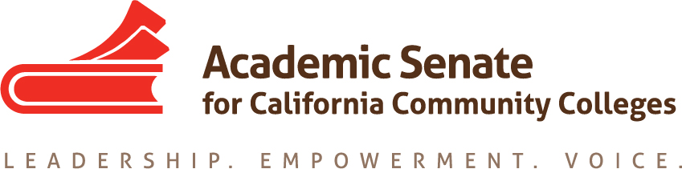

Educational Policies Committee

December 15, 2020, 11:00 a.m.

Meeting Minutes

In attendance: Sam Foster (Chair), David Morse, Darcie McClelland, Adrean Askerneese, Victor Hernandez (SSCCC), Alexander Manjarrez (SSCCC), Teresa Aldredge, Mayra Cruz (2nd Chair)
Absent: James Preston, Leigh Anne Shaw
Guest: Janet Fulks

- Call to Order and Adoption of the Agenda

- Volunteer note taker- Mayra

- Check-ins and Affirmations
Share one thing that you are looking forward to doing over the break.

- Draft of PD Paper
  - General discussion of draft
  - Opportunity for feedback and comments on Google doc
Need to finalize the fist draft; move the submission timeline to Jan for the Feb meeting
For 1st read
Page 12- Methods of Delivery for PD
Using Data to… (incorporate today’s discussion; see below)
Review the paper, comment and edit in the goggle doc.

- Timeline for the paper -Revised timeline
  - January 19—Submit the paper for February 5-6 Exec meeting for 1st reading
  - February 16—Deadline for March 5-6 meeting for 2nd reading

- Resolution 13.02 F19 Data Paper and Equity-Minded Practices requesting a paper or other resource
  - Type of resource needed
  - Possible path forward
Janet Fulks joined the conversation. The team will be developing a resource to address Resolution 13.02 F19. https://asccc.org/resolutions/data-paper-and-equity-minded-practices

Resolved, That the Academic Senate for California Community Colleges develop a resource, whether a paper or in some other form, in collaboration with systemwide partners to evaluate the current use of data and recommend effective practices; and
Resolved, That the Academic Senate for California Community Colleges explore and identify web resources that include promising practices for data analysis that faculty can utilize to better serve students and advance equity on college campuses.
Brainstorming and discussion:
Develop a resource to address the resolves. How do we want to proceed? What kind of a resource? Can we get support from the RP group?

Janet shared that the RP has done research focused on equity data and focuses on statewide work. The Resolution calls for faculty to be more directed in understanding data from an equity minded frame. Ideas shared by Janet and others:
- Look at Datamart and look at a few years to see where the trend is going to advance equity
  - Questions that students have asked
  - Datamart employee disaggregated data
  - Easy to write up instructions
  - Success data by student groups, not able to disaggregate by ethnicity
  - LaunchBoard is a statewide data system and a tool to search and disaggregate the data
  - The Guided Pathways Taskforce published a data paper/report recently. The report is located here. Report on useful data to observe changes.
  - Tool to navigate websites to locate data
  - Look at special populations Umoja, Puente, others
- New CSU analytics webpage, disaggregates by ethnicity- # of CC students from specific colleges who have transferred to CSU and success data https://www2.calstate.edu/csu-system/why-the-csu-matters/graduation-initiative-2025/Pages/Leading-with-Data.aspx
Community Colleges https://partners.dashboards.calstate.edu/cc/search
- Review the ASCCC Data 101 Paper

Discussed by members:
Develop a series of questions that can help examine the data to help faculty make sense of the data. Working with a colleague to walk through the data.
- How does the data relate to what I do?
- How do I read it?
- What does this mean to me? and Why?

Connect data with outcomes. Ex. Faculty hiring

It was reported that the EDAC/GP tool drafted last year was shared with the group- “Equity Assessment in the Implementation of AB 705: AB705, Equity, and Closing Equity Gaps”

Next steps:
Assemble a tool or set of tools
- Cohort data
- Tool for one quick access to data
- A series of questions that can help examine the data. Find examples of guiding questions or use existing key questions, including questions to go deeper into the data
- Place the resource tool in an accessible location

Be clear on what we want to do. What is the goal?
- Student performance and success, cohort data
- Representation and faculty diversity
- Faculty hiring (include PT/FT ratio)
- Student experience
- Disaggregation of data
- Understanding success programs data (including Puente, Umoja, Student Workers)

What questions should you asked when you are presented with data?

Need to be general to appeal to various faculty and specific enough to address the use of data

Successful practices: Potential to focus on the Puente, Umoja, EOPS and other programs data- What understanding do faculty have on the success of these programs? What practices are in place? What elements of these programs can be scaled-up? What practices are low cost-high impact to take to scale? Teasing these elements.

Review notes and draft a proposal to address Resolution 13.02 F19 (Sam/Mayra) https://asccc.org/resolutions/data-paper-and-equity-minded-practices

- Future Meetings
  - Spring semester planning
- Sam to send a Doodle Poll for the Spring meeting schedule Tues/Thursday
- Next meeting: January 19th at 10:30am

- Other Items for Discussion
N/A

- Adjournment 12:10pm

