Step 1: Develop a team –

Discipline & Student Services reps – student input, high school input

Step 2: Examine Research

Multiple Measures in Assessment: The Requirements and Challenges of Multiple Measures in the California Community Colleges
ASCCC RECOMMENDATIONS:
- Ensure that assessment procedures and the way placement decisions are made are clearly communicated to students. Students should be informed about the entire set of multiple measures that are being used to assess their level of knowledge and skill and how those multiple measures will be analyzed.
- Ensure that multiple measures are applied consistently for all students.
- Collect multiple measures before students complete assessment tests or as part of the assessment test process so that multiple measures are being applied to all students who are assessed, not just those who appeal their assessments.
- Use measures that have a high degree of predictive validity.
- Involve discussions by the local senate and discipline experts at each college.
- Create a local selection of validated measures policy and data.
- Include periodic review of multiple measures assessment policies.
- Provide discipline experts and counseling faculty with information on why certain multiple measures have been selected for use at the college and the role that multiple measures can play in accurate placement.
- Strive to produce an objective process and carefully examine the use of local measures that may be overly subjective, such as interviews.
- Make weighting of multiple measures transparent and research based.
- Consider a regional consortium among the counseling faculty and discipline experts to discuss how assessment outcomes might be portable and accurate
http://www.asccc.org/papers/multiple-measures-assessment-requirements-and-challenges-multiple-measures-california

CCRC Research
Belfield and Crosta (February 2012) Predicting Success in College: The Importance of Placement Tests and High School Transcripts http://ccrc.tc.columbia.edu/media/k2/attachments/predicting-success-placement-tests-transcripts.pdf
Scott-Clayton, J (February, 2012) Do High-Stakes Placement Exams Predict College Success? Community College Research Center, Teachers College, Columbia University http://ccrc.tc.columbia.edu/publications/high-stakes-placement-exams-predict.html
Clayton, Crosta, Belfield (Oct 2012) Improving the Targeting of Treatment: Evidence from College Remediation. National Bureau of Economic Research www.aeaweb.org/aea/2013conference/program/retrieve.php?pdfid=106
John Hetts & Terrence Willet
RPGroup (2013). Long Beach City College STEPS (Student Transcript-Enhanced Placement Project) http://www.rpgroup.org/projects/student-transcript-enhanced-placement-project
Local Research
Peter Bahr -Bakersfield College Report
Pathways in Developmental Math and English at Bakersfield College: Historical Analysis of Student Course-Taking Behavior, 2000 to 2013 by Peter Riley Bahr ,Center for the Study of Higher and Postsecondary Education, University of Michigan

Step 3: Define the Pathway and the Cost
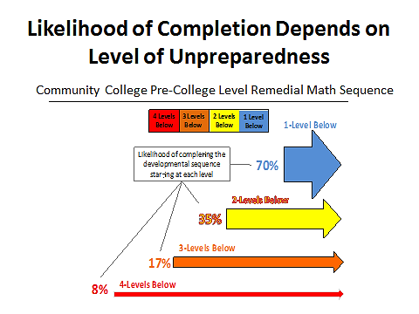
Source: Adapted from slide by Greg Stoup, Senior Dean Contra College. Data from the CCCCO's Basic Skills Cohort Tracker for a Fall 2011 cohort with an observation window that went through Spring 2014.

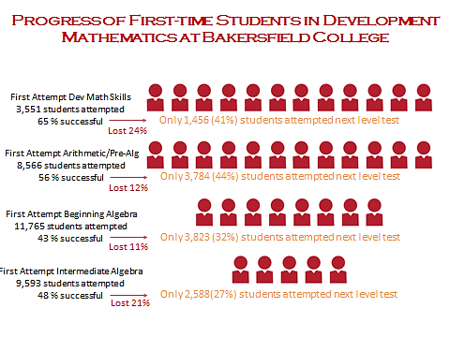
Pathways in Developmental Math and English at Bakersfield College: Historical Analysis of Student Course-Taking Behavior, 2000 to 2013 by Peter Riley Bahr

Step 4: Examine Statewide Multiple Measures data and Suggestions

Step 5: Consider the Implementation Strategy for Multiple Measures

Will you use a cohort?

Will you apply it to first-time students and re-entry students?

Will you do it electronically or by hand (e.g. using Accuplacer algorithm for now or hand review of transcripts)?

What is your overall strategy – 1) to place students using a particular measure or 2) to use multiple measures and place them at the highest placement or 3) provide a backstop – meaning students will not be placed below their last successful level in high school or at another college.

Determine how you will track the results. How will you indicate who has been placed by what methods.

Step 6: Determine how you will inform your campus community, counselors, local high schools and students about Multiple Measures.

Challenges and blessings we have experienced have made us value the following things:
1) Not all grades are equal – be sure you indicate the difference between courses that are not traditional and are not part of the typical pathway – Consumer Math, Special studies etc.
2) Communicate with the high schools and other private pathways (home schooling).
3) Communicate with the local transfer institutions – some are sending their students to you, explain your placement to them.
4) Test students at the high schools if possible. They perform better.
5) Students should receive their placement that includes multiple measures at one time. Do not provide test scores first and then change the placement. Students will opt for the lower, less successful, more expensive route because they do not trust their own grades above the test results (just like we didn’t).
6) Send people (peers and counselors) and train high school personnel to help students register. Provide them the highest possible priority. Help students complete basic skills first but consider their holistic picture.
7) Re-evaluate the schedules. This is a sea change for enrollment management.
8) Provide adequate direction and support. This can be through supplemental services at the college (Supplemental Instruction, Tutoring, Study Hall, Habits of Mind, Study Skills, Metacognition, Textbook access, computer access, etc.).
9) Evaluate the results with data AND talk to students, staff, faculty and the community.

BC Philosophy behind MMs and Assessment
- Tests aren’t always the best measures
- Tests alone are TERRIBLE measures
- The goal is to predict success
- More information provides better placement
- We need to simplify the algorithm – junior year grades
- Not perfect, iterative – don’t wait
- Thousands of reasons to START NOW

