Helpful Tips for Resolutions – Saturday, April 17, 2021

- The deadline for pulling resolutions from consent is 8:20am.
- Voting begins at 9:00am.
- Spring 2021 Resolutions for Debate Saturday April 17, 2021
- If you need to access the Zoom link outside of Pathable, use the information below:
Join Zoom Meeting
Meeting ID: 889 6226 3807
Passcode: 865020
One tap mobile
+16699009128,,88962263807#,,,,*865020# US (San Jose)
+13462487799,,88962263807#,,,,*865020# US (Houston)

Having Technical Problems?
Please send an email to eventtechsupport@asccc.org. Although this email will be actively monitored, your patience is extremely appreciated.

Helpful Poll Everywhere Resources and Reminders
- The direct link for Resolutions Session for Saturday, April 17, 2021 is: https://pollev.com/ascccresolut876
Only registered delegates should access this link. Live results can be accessed at the Zoom link provided above.
- If you are struggling with smaller fonts, try launching the app in a different browser.
- If you have never logged in to the app, be sure to create an account by choosing “sign up.” When signing up, be sure to select that you are a participant:

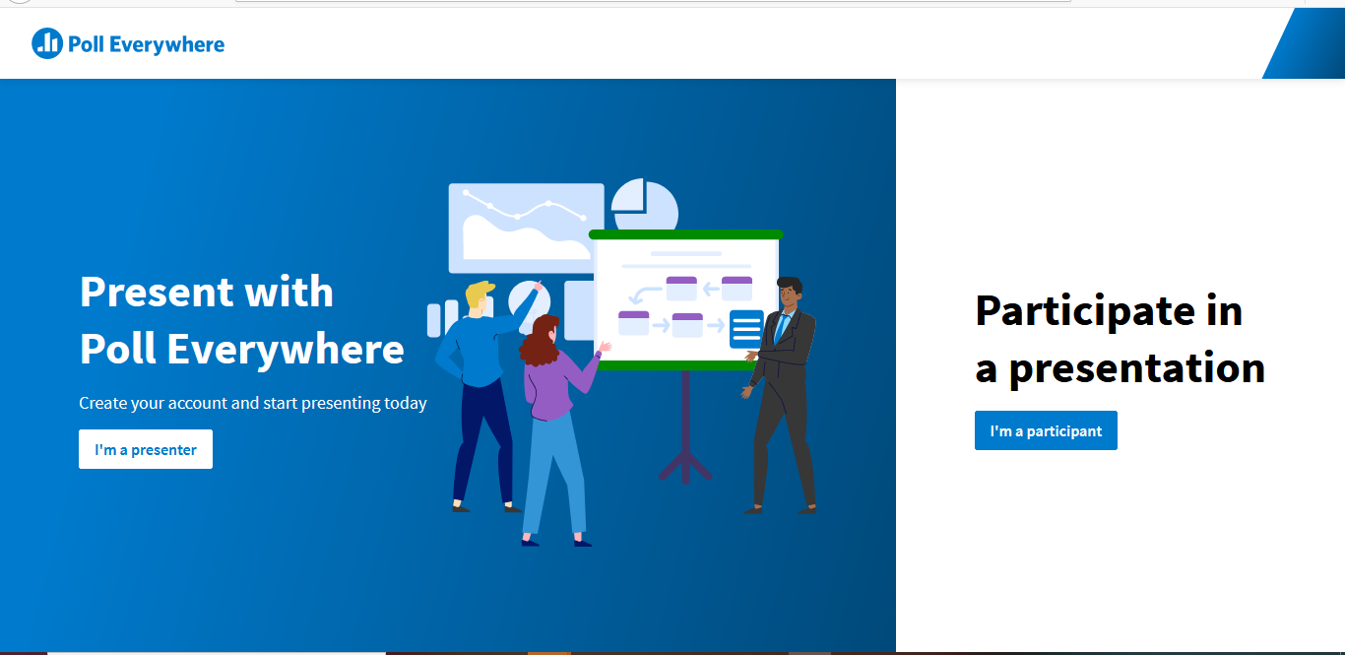

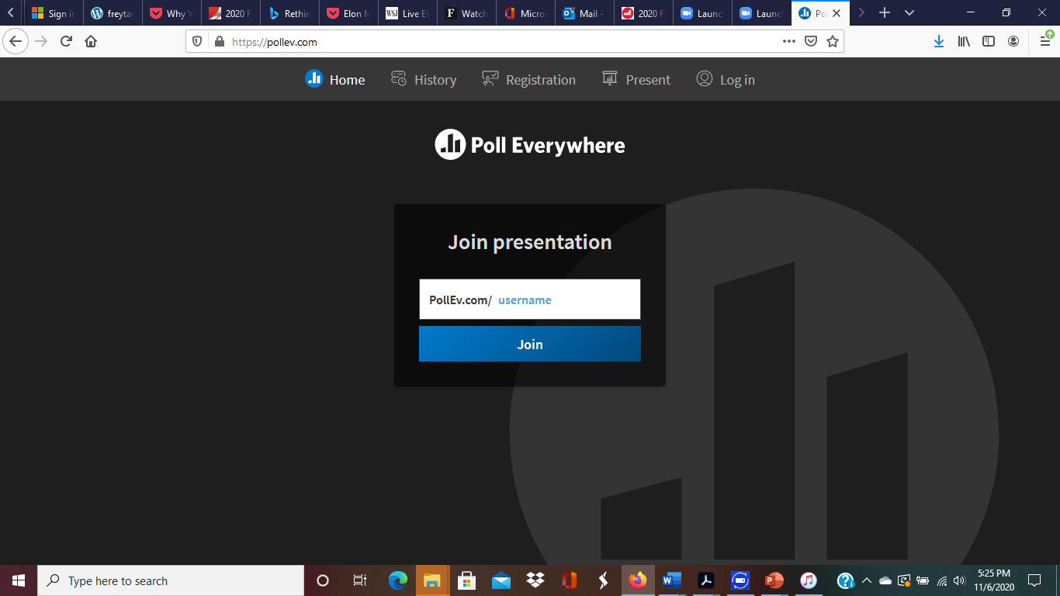
- Enter the link provided by the ASCCC to enter the Resolutions Session on this page, OR

enter the direct link https://pollev.com/ascccresolut876 into your browser. This link will also be provided in the Zoom chat at the beginning of the Resolutions Session for your convenience.

- Before voting begins, please update your screen name to be your college (see images below). Your account name should remain their first/last name.

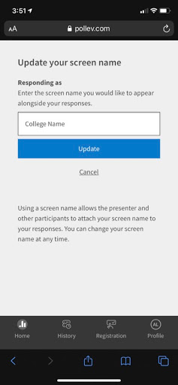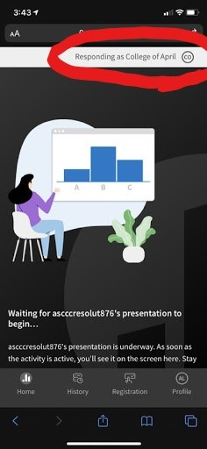
- Here is a video that explains Poll Everywhere a little more in-depth (Many thanks to Katherine Krolikowski!): youtu.be/PgBYCPBgT1M
During the Debates
- We will only be using the chat feature in Zoom. We will not be monitoring the Pathable chat feature.
- Please note that the chat in Zoom is for parliamentary motions, inquiries, and indicating that you would like to debate. If you would like to make a motion or debate an item, please use the following format:
PM, Your Name, Your College/District Name
CON, Your Name, Your College/District Name
PRO, Your Name, Your College/District Name

