ASCCC Mock Plenary Resolutions Voting Guide

Important Deadline Reminders
- Submit your mock resolutions using the online form and signature page found at https://tinyurl.com/ASCCCResolutions by THURSDAY, JUNE 16 before 6:00 p.m.
- Submit your mock amendments using the online form and signature page found at https://tinyurl.com/ASCCCResolutions by FRIDAY, JUNE 17 before 1:00 p.m.
- Pulling resolutions from consent must be done by 9:50 a.m. on Saturday, June 18.
- Debate and voting begin on SATURDAY, JUNE 18 at 9:45 a.m. both in-person and on Zoom which is accessed through the Pathable online platform.

Voting Information
- We will be using Poll Everywhere app during the mock plenary session to conduct online voting. For mock resolution voting, no registration is required. All registered attendees will be authorized to vote.
- The direct link for voting in Poll Everywhere is https://pollev.com/ascccresolutions233.

In-Person Participants: Using the Mics for Debate
During the mock plenary voting session, delegates are invited to participate in debate or to make parliamentary motions or inquiries of the chair.

Microphones for Debate
We will use three microphones to conduct in-person debate. Please line up at the appropriate microphone: 1) parliamentary motions or inquiries, 2) pro debate, or 3) con debate.

If you would like to make a parliamentary motion or inquiry (PM) or you would like to debate a resolution (PRO or CON), please state your name and your college or district name before asking your question or making your argument at the microphone. You will have three minutes to speak once recognized by the chair.
The Resolutions Committee will monitor the online Zoom and in-person delegate line ups and alternate as appropriate; participants will be called on in the order they appear in the Zoom chat or the in-person line.

Online Participants: Using the Chat for Debate
During the mock plenary voting session, delegates are invited to participate in debate or to make parliamentary motions or inquiries of the chair.

Zoom Chat for Debate
We will use Zoom to conduct online debate. Participants will notify the chair of intent to debate or request a parliamentary inquiry/motion through the Zoom chat feature; however, please be advised that the Zoom chat is reserved only for making parliamentary motions, parliamentary inquiries, and “lining up” at the parliamentary mic.

If you would like to make a parliamentary motion (PM) or debate a resolution (PRO or CON), please provide your intent, your name, and your college or district name in the Zoom Chat in the following format:
PM, Your Name, Your College/District Name
CON, Your Name, Your College/District Name
PRO, Your Name, Your College/District Name

The Resolutions Committee will monitor the Zoom chat and delegates will be called on in the order they appear in the Zoom chat. You will have three minutes to speak once recognized by the chair.

Pathable Chat for Cheers or Informalities
The Pathable chat is available for cheers and peer affirmations only; that is, be advised that the resolutions team will not be monitoring the Pathable chat for parliamentary motions, parliamentary inquiries, or “lining up” at the parliamentary mic. Please use the Zoom chat for those formal debate procedures.

About Poll Everywhere
For voting, the ASCCC uses the Poll Everywhere app. Poll Everywhere can be accessed as a mobile app on your cell phone or your smart device or via a web browser on your desktop computer. We recommend that you do not login both on the mobile app and desktop computer app at the same time. Your app may timeout and you may miss the opportunity to vote.

Poll Everywhere is well supported by the following web browsers: Chrome, FireFox, SafariOS, and Windows Explorer.

Logging In to Poll Everywhere
To join resolution voting, visit pollev.com. (Figure 1). On the home page, enter in the ASCCC's username: “ascccresolutions233” and select “Join.”
Figure 1: Join PollEV Session
NOTE: Once you have an account, you can also enter the direct link into your browser: https://pollev.com/ascccresolutions233.

This link will also be provided in the Zoom chat at the beginning of the resolution session for your convenience.

Preparing to Vote on Poll Everywhere
Before voting begins, please update your screen name to your college name. This allows the ASCCC to ensure that only a single delegate is voting during Plenary sessions. During this Mock Plenary, however, voting is open to all.

To change your name to your college name, click on the “Responding as” icon (Figure 2).
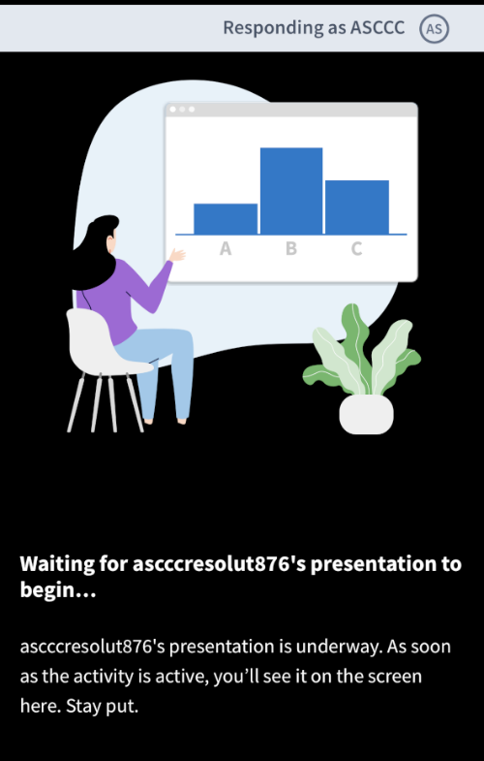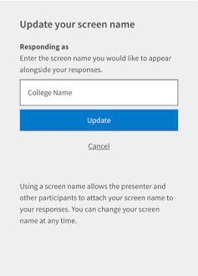
Figure 2: Update “Responding as”
Figure 3: Use College Name for “Responding as”
Once you click the icon, you will be prompted to change your “Responding as” field. Please enter your college name and select “update” (Figure 3).

Congratulations! You are now ready to vote!

What If I am Experiencing Technical Difficulties?
No problem! We’re here to help. Please send an email to eventtechsupport@asccc.org. Although this email will be actively monitored, your patience is extremely appreciated.

