Navigating the Pathable Event Platform

Logging into Pathable
All attendees will receive an invitation to access the event on the Pathable platform one week before the event. All emails from the platform will all be sent from no-reply@pathable.com and the sender will be “ASCCC Sandbox”. If you are unable to locate the email, search the email and sender name in your inbox and spam folders.
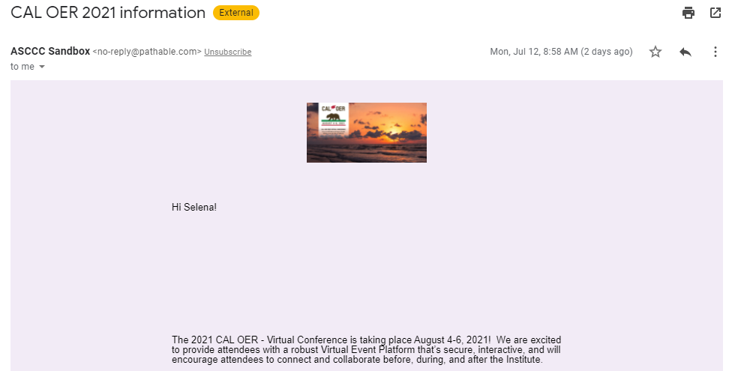
The invitation will include a link to sign-in to the website and set up your profile if you are a first-time Pathable user. Please follow the link and complete your profile as prompted by the platform.
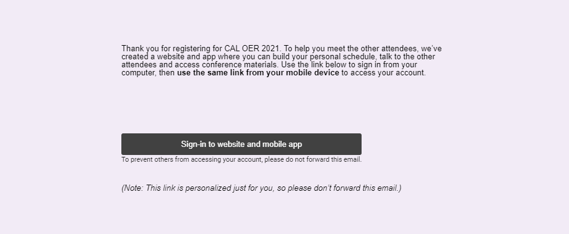

Creating Your Agenda
Pathable allows you to customize your agenda for the conference. To view the entire conference agenda, hover over “Schedule” on the toolbar and select “Agenda”.
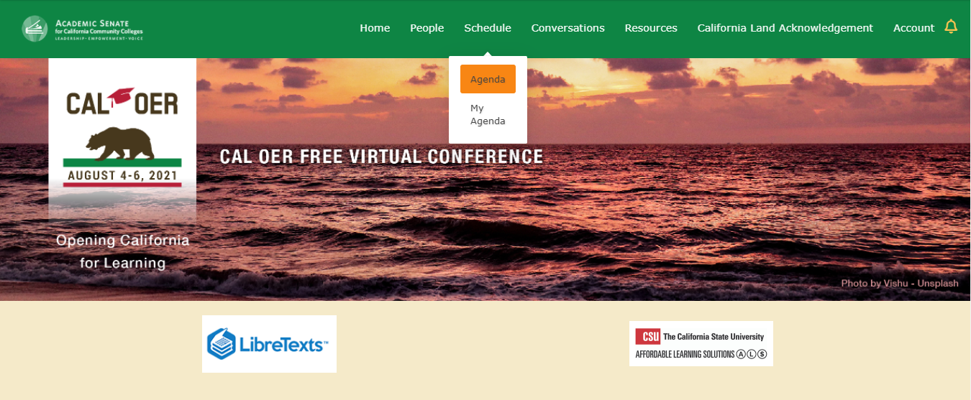
To add session to your agenda, select the “+” symbol next to the session name. For additional information, click on the session name. This will also show you the full list of breakouts for each breakout session.
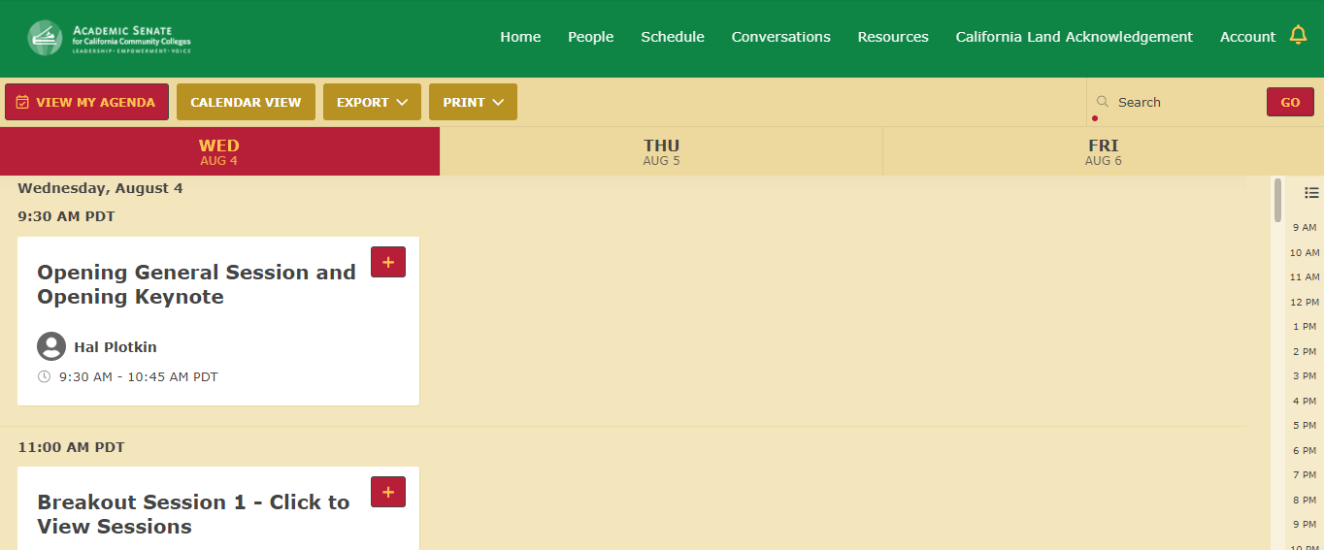

Joining a Session
On the session page, there will be a count-down to the start time. As an attendee, you will be able to enter the session on this page one minute prior to the start time. One minute prior to the start time, a “JOIN MEETING” button will appear in the area where the count-down is.

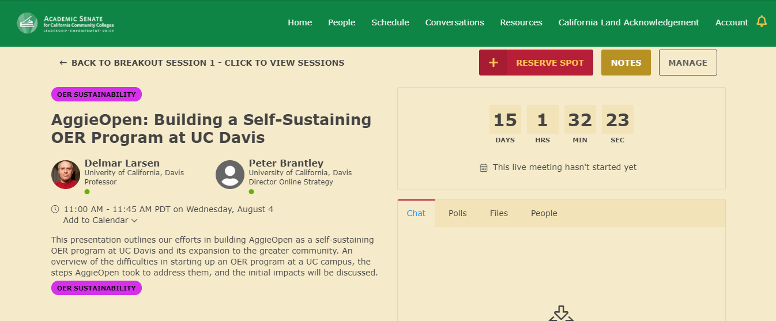
As a reminder, the Zoom chat will be disabled. The chat will be available on the session page in the chat box. This area is where attendees can see any polls and files affiliated with the presentation as well.
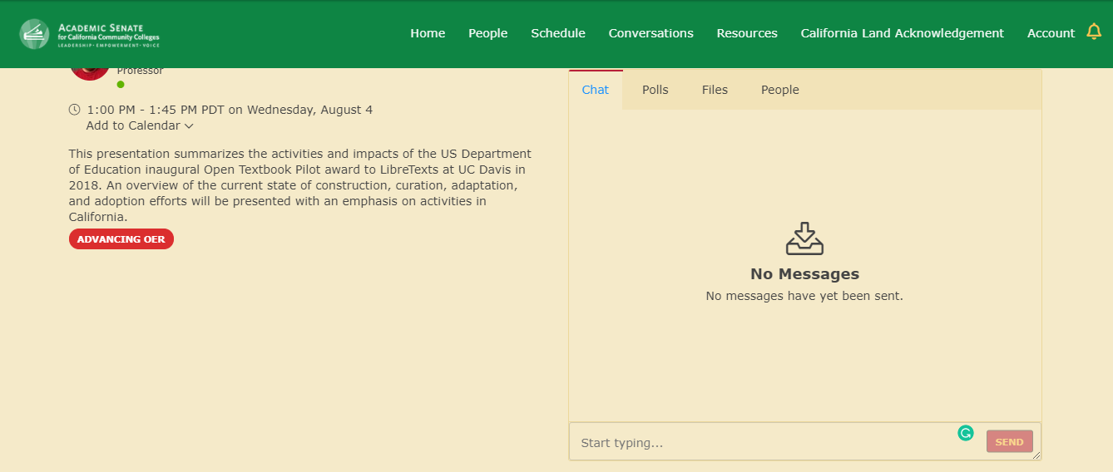

It is best to have two windows open side by side to view both the presentation as well as the chat box.

