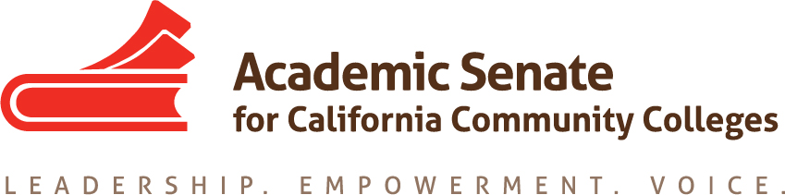

Part-time Committee
Thursday, February 11, 2021
2:30 p.m.—4:00 p.m.
Zoom Meeting
Join from PC, Mac, Linux, iOS or Android: https://cccconfer.zoom.us/j/95061207497
Or iPhone one-tap (US Toll): +16699006833,95061207497# or +13462487799,95061207497#
Or Telephone Dial:
+1 669 900 6833 (US Toll)
Meeting ID: 950 6120 7497

AGENDA
The part-time faculty committee provides recommendations to the Executive committee on academic and professional matters that affect part-time faculty members. The committee recognizes that part-time faculty make up the majority of California community college faculty and serve disproportionately-impacted students. This committee advocates for diverse part-time faculty colleagues, ensuring their access to professional and leadership development offerings as well as shared governance opportunities at the local and statewide levels. The part-time faculty committee collaborates with the executive committee to develop and provide opportunities where part-time faculty gain additional insight on issues germane to academic and professional needs. This committee is also focused on promoting diversity within part-time faculty pools with the goal of having educators who reflect the student population, and this committee further commits to empowering part-time faculty voices who have been historically excluded (e.g., colleagues of color).

- Members Roll Call:

Michelle Bean—Chair | Grace Chee | Alpha Lewis
Karen Chow—2nd Chair | Chelsea Hull | Emilie Mitchell
Steven Chang | Theodore Kagan | Luis Zanartu

- Call to Order and Agenda Adoption (Google Shared Folder)

- Minutes
  - Volunteer
  - January Summary Approval
  - Community norms: empathy, communication, responsibility

- Shout Outs, Affirmations, and Lean-in

- Part-time Institute: February 18-19, 2021
  - Final Program
    - Pathable Platform goes live February 10
    - Conference proceedings e-publication— due March 12
    - All PTC members should be at every General Session
    - Table Talks and Social/Networking Hours attendance highly encouraged
  - Breakout Sessions
    - Session leads
      - Keep theme in mind as you design: Driving Change: Building Unity, Culture, and Equity-mindedness
      - Zoom Background—send to your co-presenters
      - Pathable—explain to co-presenters that Zoom link embedded in Pathable and need to sign up with personal password (email from ASCCC Sandbox)
      - Lighting and video—be sure to use bright light in front of you and you are on screen
    - Presentation slides—send to eventmaterials@asccc.org
    - How was training?
      - Session Zoom links available in Pathable 20 minutes before the meeting and meet w/co-presenters (ASCCC staff available for support)
      - Live to attendees 1 minute before session
      - Will shut off 10 minutes after end of scheduled time
    - Presentation—remind attendees of housekeeping things:
      - Use Pathable chat
      - Mute to avoid background noise
      - Closed caption available
      - Session survey in Pathable
  - Send a thank you email to your co-presenters
  - Any questions?

- Plenary
  - Spring pre-Resolutions due February 16—any ideas?
  - Elections and bylaws—part-time faculty eligible

- Committee Goals and Priorities--PTC work plan
  - Google unofficial listserv volunteers (Chelsea)
  - Regionals in spring
    - Google site (Chelsea)
    - Cover letter review component and CV tips
    - Small group mentoring/networking
    - Which dates are good?

- PTC Resolution 1.02 (Steven)
  - Next steps for resource
    - Notification of ASCCC elections and leadership positions
    - Google site
      - Listserv link
      - Annotated bibliography
      - Links to resources and registries
      - Mentoring resources
      - Hiring and CV tips
      - Anything else?

- Rostrum
- PTC Articles
  - Mentoring programs--Chelsea completed January 2021
  - Part-time voting rights and seniority rights—Grace and Luis (in progress)
- Spring deadline March 8. Articles due to Michelle on March 1.

- Announcements
  - Check for ASCCC upcoming events at here
  - Sign up for ASCCC listservs—Part-time listserv available
  - Forward Application for Statewide Service to peers
  - ASCCC Foundation Innovation Scholarship for professional development opportunities
  - Plenary Scholarship due March 8 at 5 p.m.
  - CCC Registry virtual event
  - Interesting legislation introduced: AB 375

- Next meeting: Mar 18 at 2:30 p.m.--4:00 p.m.

- Closing Comments--any other final comments or suggestions?

- Adjournment

In Progress:
- Part-time Institute
- PT Institute Proceedings e-Publication
- Part-time Google Listserv
- Rostrum article: PT Voting and Seniority Rights
- Spring Regionals

Completed Tasks:
- Rostrum article: Mentoring Programs
- Resolution Fall 2020 1.02: Develop a Resource to Communicate and Encourage Part-time Faculty Leadership
- Plenary sessions: Mentoring Programs and Hiring Principles Canvas Tool
- Rostrum article: Faculty recommendations to second level interviews—focusing on diversifying the faculty
- ASCCC President Special Plenary Invitation Email (on 9/29/20 to local senate presidents and part-time listserv)
- PTC Workplan and Goals
- Updated ASCCC Part-time Committee Charge

