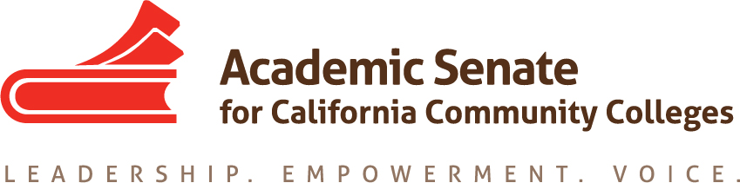

Part-time Committee
Thursday, March 18, 2021
2:30 p.m.—4:00 p.m.

Zoom Meeting
Join from PC, Mac, Linux, iOS or Android: https://cccconfer.zoom.us/j/95061207497
Telephone Dial: +1 669 900 6833 (US Toll)
Meeting ID: 950 6120 7497

AGENDA
The part-time faculty committee provides recommendations to the Executive committee on academic and professional matters that affect part-time faculty members. The committee recognizes that part-time faculty make up the majority of California community college faculty and serve disproportionately-impacted students. This committee advocates for diverse part-time faculty colleagues, ensuring their access to professional and leadership development offerings as well as shared governance opportunities at the local and statewide levels. The part-time faculty committee collaborates with the executive committee to develop and provide opportunities where part-time faculty gain additional insight on issues germane to academic and professional needs. This committee is also focused on promoting diversity within part-time faculty pools with the goal of having educators who reflect the student population, and this committee further commits to empowering part-time faculty voices who have been historically excluded (e.g., colleagues of color).

- Members Roll Call:

Michelle Bean—Chair | Grace Chee | Alpha Lewis
Karen Chow—2nd Chair | Chelsea Hull | Emilie Mitchell
Steven Chang | Theodore Kagan | Luis Zanartu

- Call to Order and Agenda Adoption (Google Shared Folder)

- Minutes
  - Volunteer
  - January Summary and February Approval
  - Community norms: empathy, communication, responsibility

- Shout Outs, Affirmations, and Lean-in

- Part-time Institute
  - Send a thank you email to your co-presenters
  - Attendance numbers:
    - 2018: 209
    - 2019: 134
    - 2020: 128
    - 2021–virtual: 286 (461 registered--175 no-shows)
  - Conference proceedings e-publication— due March 12

- Plenary
  - April 15-17: click HERE to register (early reg deadline March 15 by 5 p.m.)
  - Elections and bylaws—part-time faculty eligible (click HERE for info)

- Committee Goals and Priorities--PTC work plan
  - Google unofficial listserv update (Chelsea)
  - Part-time Faculty Spring Nexus Workshops: Need volunteers
    - Thursday, April 22 at 2:00—5:00 p.m.
    - Friday, April 23 at 2:00—5:00 p.m.
  - Workshop Outline:
    - Welcome Activity
    - Introduction of Part-time Faculty Nexus (website)
    - Hiring Tips—breakout in large groups by region
    - Break
    - 20-minute Mentoring—breakout in small groups/pairs for CV reviews, lean-in, or informal Q&A (would recruit local senate leaders and ASCCC Executive members to assist)
    - Break
    - Closing and Reflection
  - Things to complete:
    - Nexus Google site (Chelsea and Michelle)
    - 10 Things Every Potential Hire Should Know sheet—need volunteers to write
    - Cover letter and CV tips sheet (should this go into Mentor Handbook?)
    - Small group 20-minute mentoring/networking ideas and Mentor Handbook
    - Closing volunteer and reflection activity ideas
    - Entry and Exit Survey—need a volunteer to write

- PTC Resolution 1.02
  - Notification of ASCCC elections—PT official listserv on March 12 and unofficial listserv
  - Nexus Site
    - Listserv link
    - Professional Learning: Hiring and CV Tips Sheets
    - Publications: Links to resources (annotated bibliography?)
    - Mentor Resources: Mentoring Handbook and CCC Registry
    - What in the FAQ?
    - Anything else?

- Rostrum
- PTC Articles
- Mentoring programs--Chelsea published in winter Rostrum
- Submitted for spring Rostrum:
  - Part-time voting rights—Grace
  - Two adjunct pathways—Luis

- Announcements
  - Check for ASCCC upcoming events at here
  - Sign up for ASCCC listservs—Part-time listserv available
  - Forward Application for Statewide Service to peers
  - ASCCC Foundation Innovation Scholarship for professional development opportunities
  - Interesting legislation introduced: AB 375 and AB 1269

- Next meeting: April 22 and 23 Nexus Workshops

- Closing Comments--any other final comments or suggestions?

- Adjournment

In Progress:
- PT Institute Proceedings e-Publication
- Spring Regionals: Nexus Workshops
- Mentor Handbook

Completed Tasks:
- Rostrum article: PT Voting Rights
- Rostrum article: PT Paths of Employment
- Part-time Google Listserv
- Part-time Institute
- Rostrum article: Mentoring Programs
- Resolution Fall 2020 1.02: Develop a Resource to Communicate and Encourage Part-time Faculty Leadership
- Plenary sessions: Mentoring Programs and Hiring Principles Canvas Tool
- Rostrum article: Faculty recommendations to second level interviews—focusing on diversifying the faculty
- ASCCC President Special Plenary Invitation Email (on 9/29/20 to local senate presidents and part-time listserv)
- PTC Workplan and Goals
- Updated ASCCC Part-time Committee Charge

