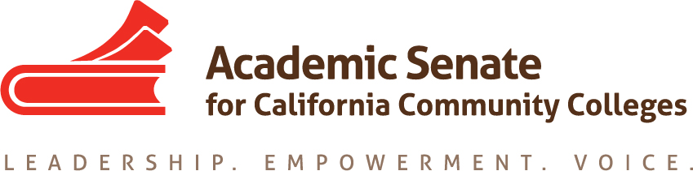

Part-time Committee
Thursday, October 22, 2020
11:30 a.m.—1:00 p.m.
Zoom Meeting
Join from PC, Mac, Linux, iOS or Android: https://cccconfer.zoom.us/j/92917124345
Or iPhone one-tap (US Toll): +16699006833,92917124345# or +13462487799,92917124345#
Or Telephone Dial: +1 669 900 6833 (US Toll)
Meeting ID: 929 1712 4345

AGENDA
The Part-time Faculty Committee provides recommendations to the Executive Committee on academic and professional matters impacting part-time faculty members. The committee advocates for part-time faculty access to professional and leadership development offerings and shared governance opportunities at the local and statewide level. The Part-time Faculty Committee works collectively with the Executive Committee to develop and provide forums where part-time faculty gain additional insight on issues germane to academic and professional needs of the part-time faculty.

- Members Roll Call:

Michelle Bean—Chair | Grace Chee | Alpha Lewis
Karen Chow—2nd Chair | Chelsea Hull | Emilie Mitchell
Steven Chang | Theodore Kagan | Luis Zanartu

- Call to Order and Agenda Adoption (Google Shared Folder)

- Minutes
  - Volunteer
  - September Summary Approval

- Shout Outs, Affirmations, and Lean-in
  - Thank you for the PT Conference marketing paragraph!
  - Community norms: empathy, communication, responsibility

- Part-time Institute: February 18-19, 2021 (virtual)
  - Institute Outline (Exec reviewing at Nov 4 meeting)
    - Asked for name change to Part-time Conference
    - Asked to consider conference proceedings
    - Need breakout session commitments
  - Breakout session titles, descriptions, and presenters due Nov 16
    - Email Michelle any co-presenter requests by Nov 12
    - Session lead—communicate with co-presenters and ensure registration; plan meeting(s) to design session slides
    - Virtual platform (Pathable) training for presenters on Feb 2 or Feb 3
  - Any other ideas or questions

- Committee Goals and Priorities
  - Resolutions assigned: Mentor Program
  - Review PTC work plan
    - Assigned actions
    - Regionals—CV review component and mentoring
    - Other ideas: Google unofficial listserv volunteers

- Plenary Fall 2020 (November 5-7)
  - Break-out sessions
    - Mentorship Programs as a Recruitment and Retention Strategy of Faculty of Color (Chelsea)
    - Introduction to ASCCC Model Hiring Principles and Practices Canvas Tool (Emilie)
  - Ideas on increasing participation
    - Email went out from president on Sept 29 to part-time listserv and local senate presidents
    - Did you all sign up for Plenary and invite a friend?
  - PTC Resolution (Steven)
    - Resolution packet
    - Info on resolution process found HERE

- Highlights of Meetings
  - Area meetings
  - Part-time hiring webinar hosted by San Diego City

- Rostrum
- Articles due to ASCCC by January 4—email Michelle before January 1
- Length—average around 700 words but could be up to 1,500 words

- Announcements
  - Sign up for FELA mentoring program—applications due November 1
  - Check for upcoming events at here
  - Sign up for ASCCC listservs—Part-time listserv available
  - Forward Application for Statewide Service to peers
  - Use Amazon Smile (smile.amazon.com)—select Foundation of the Academic Senate for California Community Colleges

- Closing Comments
  - In Progress Review
  - Any other final comments or suggestions?

- Adjournment

In Progress:
- Part-time Institute Planning
- Plenary sessions: Mentoring Programs and Hiring Principles Canvas Tool

Completed Tasks:
- Resolution Fall 2020 1.02: Develop a Resource to Communicate and Encourage Part-time Faculty Leadership
- Rostrum article: Faculty recommendations to second level interviews—focusing on diversifying the faculty
- ASCCC President Special Plenary Invitation Email (on 9/29/20 to local senate presidents and part-time listserv)
- PTC Workplan and Goals
- Updated ASCCC Part-time Committee Charge

