Look at the data below comparing the use of new placement methods in SUNY
Multiple Measures Placement Using Data Analytics An Implementation and Early Impacts Report https://www.mdrc.org/sites/default/files/CAPR_Multiple_Measures_Assessment_implementation_report_final.pdf
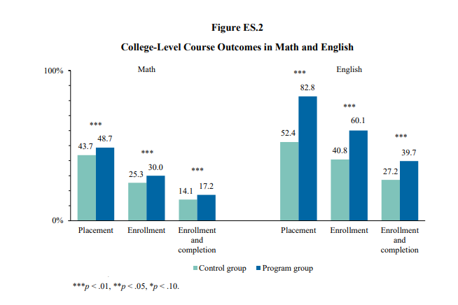
Discuss some questions you may have about these data? Write some thoughts down.

Now dig in as a group. Try and discuss a common research question you want answered for your college regarding AB 705 implementation. There may be many things you want to research, but focus on one that relates to the issues most of you are interested in.
- Collaborate to select and create a research question important to all of you.

- Create a draft plan
      - What data will you measure?
      - What is the best timeline?
      - Who needs to be involved?

- Generally, what opportunities might these data provide for action and implementation? How might you act on these data?

