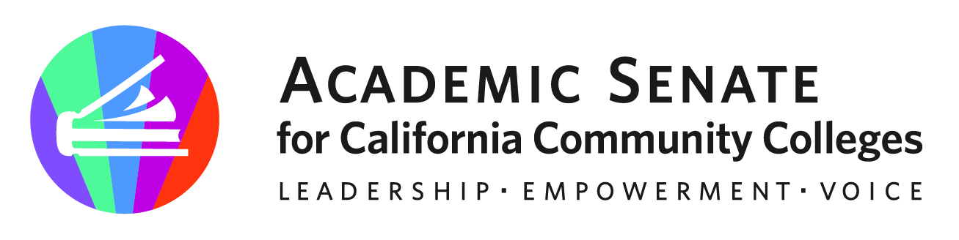

ASCCC Part-Time Faculty Committee

April 25, 2023, 2023

Minutes

Attendees: Elbina Rafizadeh, Ian Colmer, Anastasia Zavodny, Sonja Downing, Lindsey Weiler, Stephanie Curry, Suji Venkataraman, Joseph Ferrerosa

- Call to Order and Adoption of the Agenda
  - The meeting was called to order at 11:02am. Agenda was adopted by consensus

- Approval of March 2023 Meeting Minutes
  - The minutes were approved by consensus

- Areas of Focus 2022-2023 (as assigned by the ASCCC President)
  - Potential Partnership with FACCC on professional Development
  - Working with Part-Time Faculty Liaisons
  - Part-Time Faculty Paper (Spring 2023 Plenary)

- ASCCC Spring 2023 Plenary Debrief
  - Committee discussed past weekend Spring 2023 Plenary.
  - Congratulations to Anastasia for presenting at the General Session, Inclusion Works: Centering Authentic Voices and Lived Experiences through a Vision and Mission
  - Resolution 1.01 on Adding a Part Time member to ASCCC Exec passed with 2/3 vote
  - Announcement of 4 Part time scholarships to 2023 Curriculum Institute (committee members encouraged to apply)

- Part-Time Paper Survey Updates
  - Stephanie will contact Gina to get survey results and forward them to committee members

- Part Time Faculty Equity Paper Planning/Timeline
  - Committee reviewed the draft there https://docs.google.com/document/d/1cLjhNADDX3_6AOmfkV0sNonE9RmhtX8RFJ0AZPY3TFU/edit?usp=sharing
  - Committee members encouraged to flesh out the paper by next meeting in May. Goal is to have a draft ready for the June Exec Meeting for a first draft.

- Future Meetings
  - Stephanie will send Doodle poll for the next meeting

- Adjournment
  - Meeting adjourned at 11:35am

Status of Previous Action Items

- In Progress (include details about pending items such as resolutions, papers, Rostrums, etc.)
- Part-Time Faculty Paper

- Completed (include a list of those items that have been completed as a way to build the end of year report).
- Presentation at FACCC Part Time Faculty Symposium (December 9, 2022)
- Part-Time Faculty Survey (February 2023) 2300+ Individual Respondents
- Resolution on Designated Part Time Faculty Exec Member (1.01 S23)
- Part Time Faculty Virtual Regional in Partnership with FACCC- 98 Attendees
- Part-Time Committee Member participation in ASCCC Plenary General Session- Inclusion Works: Centering Authentic Voices and Lived Experiences through a Vision and Mission

