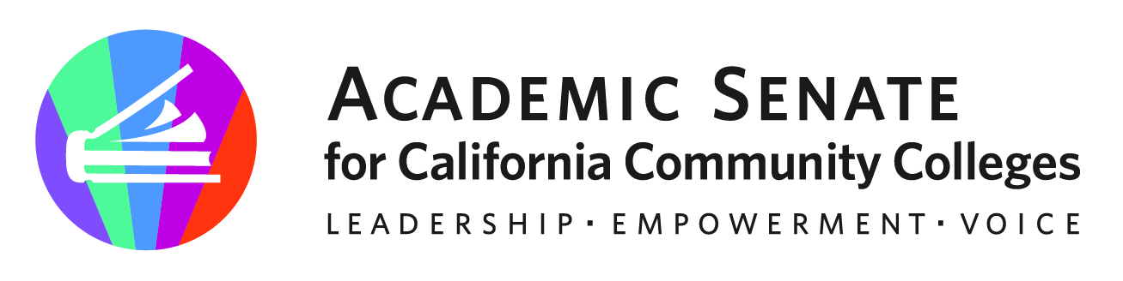

ASCCC Part-Time Faculty Committee

April 25, 2023, 2023

Minutes

Attendees: Anastasia Zavodny, Suji Venkataraman, Ian Colmer, Robert L. Stewart Jr. Mussie O.Michael, Lindsay Weiler, Stephanie Curry

Guests: Gina Lam (ASCCC)

- Call to Order and Adoption of the Agenda
The meeting was called to order at 12:02pm

- Approval of April 2023 Meeting Minutes
The committee approved the meetings by consensus

- Areas of Focus 2022-2023 (as assigned by the ASCCC President)
  - Potential Partnership with FACCC on professional Development
  - Working with Part-Time Faculty Liaisons
  - Part-Time Faculty Paper (Spring 2023 Plenary)

- Part-Time Paper Survey Updates
Gina Lam from ASCCC provided a look at the preliminary data from the ASCCC Part Time Survey including demographics including ethnicity, annual income, number of districts, how many years as an adjunct, exposure to ASCCC events, professional development access.

- Part Time Faculty Equity Paper Planning/Timeline
https://docs.google.com/document/d/1cLjhNADDX3_6AOmfkV0sNonE9RmhtX8RFJ0AZPY3TFU/edit?usp=sharing
- Goal is to have a draft for Exec Committee review at June Exec Committee Meeting
- Stephanie will send in agenda item by May 18, 2023
- Committee will finalize draft by May 22, 2023.
- Exec committee will review draft June 2, 2023
- Stephanie will set up meeting second week of June for committee to review Exec comments
- Finalize paper for First Draft Review in August 2023

- End of Year Report
  - Key Accomplishments
• Presentation at FACCC Part Time Faculty Symposium (December 9, 2022)
• Part-Time Faculty Survey (February 2023) 2300+ Individual Respondents
• Resolution on Designated Part Time Faculty Exec Member (1.01 S23)
• Part Time Faculty Virtual Regional in Partnership with FACCC- 98 Attendees
• Part-Time Committee Member participation in ASCCC Plenary General Session- Inclusion Works: Centering Authentic Voices and Lived Experiences through a Vision and Mission

  - Recommendations for next years committee
- Review data from Part Time Survey to help plan ASCCC Part Time Events
- Support bylaws drafts changes to address the resolution
- Continue partnership with FACCC and professional development opportunities
- Use Data to write additional resources for Part Time faculty including Rostrum, Toolkits and resolutions
- Plan for ongoing surveying of Part-Time Faculty, Longitudinal Data and outreach to districts not participate in this survey (Data planning)
  - Plan smaller/targeted survey to address questions from survey/paper
  - Find a way to get qualitative data from part-time faculty
  - Work with Gina to create annual data questions for longitudinal study

- Future Meetings

Stephanie will set up a June meeting

- Adjournment

Status of Previous Action Items

- In Progress (include details about pending items such as resolutions, papers, Rostrums, etc.)
- Part-Time Faculty Paper

- Completed (include a list of those items that have been completed as a way to build the end of year report).
- Presentation at FACCC Part Time Faculty Symposium (December 9, 2022)
- Part-Time Faculty Survey (February 2023) 2300+ Individual Respondents
- Resolution on Designated Part Time Faculty Exec Member (1.01 S23)
- Part Time Faculty Virtual Regional in Partnership with FACCC- 98 Attendees
- Part-Time Committee Member participation in ASCCC Plenary General Session- Inclusion Works: Centering Authentic Voices and Lived Experiences through a Vision and Mission

