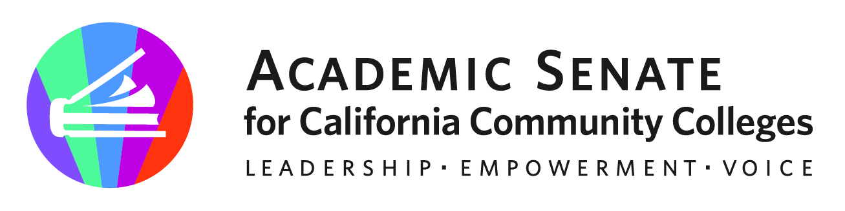
f

ASCCC CTE Leadership Committee

November 20, 2023

10-11am

Via Zoom

Meeting Summary

- Call to Order and Adoption of the Agenda – The chair called the meeting to order at 10:00am
(*notes present for meeting)
Stephanie Curry – Chair* | John Grounds* | Marie Templo-Capule
Christopher Howerton – 2nd Chair* | Alexander Jones* | Sigrid Williams*
Amar Abbott | Nicole Marquez*
Jimmie Bowen* | Brian Palmiter | Lynn Shaw*
Alana Gates* | Stephanie Rowe

- Approval of October 30, 2023 Minutes – The committee approved our last meeting minutes by consensus. The chair will forward to ASCCC Executive Committee.

- ASCCC and Regional Consortium Planning – Prior to this topic discussion the chair shared that Lynn and herself facilitated a breakout session during the recent ASCCC Plenary. Other members of the committee shared sessions they attended and perceptions from the event. As other announcements, the chair shared there will be an upcoming noncredit institute and CTEL may have an opportunity to participate.

There are some leadership transitions happening with some of the regional consortiums. The chair, Lynn, and CJ will work on preplanning meetings for the early spring collaborative events. In planning,

- Webinar Planning/Support – Discussion: The chair reminded the group about the approved upcoming webinars and the secured presenters for these upcoming webinars. Based on some informal conversations with administrators and the faculty practitioners in the field, there is a need for some clarity and “lessons” from those who are involved with the CBE Pilot. Especially clarity on how CBE is different than credit by examination. As additional information another conference was shared about the Fall 2023 Inaugural California Regions at Work Conference hosted by Orange County Regional Consortium. The chair is encouraging faculty involvement in addition to the primary audience.

The committee discussed the format options as a “webinar” or “meeting” using zoom and other online collaborative tools as desired.
  - CBE (December 7, 2023) – Event Information
  - Work Experience (February 7, 2024) – A planning meeting will be scheduled soon.
  - Gender and CTE Fields (March 7, 2024)

- Rostrum Brainstorming – The committee continued to brainstorm and discuss possible upcoming topics for the following submission deadlines. The recent November Rostrum publication was shared with the committee as well as the Rostrum Editorial Guidelines
  - January 14, 2024
    - Working with Regional Consortiums
    - Evolution of MAP –
  - March 3, 2024
    - MQs and Equivalency
    - Gender and CTE

- Brainstorming Ideas for Supporting CTE Faculty with MQs and Equivalency – Lynn shared some of the history and overview of the current CTE Faculty MQ Toolkit and some of the “high level” recommendations and expectations. Committee members shared some of the challenges and some of the unique needs and perception from CTE equivalency processes locally.

If the committee would recommend an update to align the toolkit with recent changes to GE, especially considering those who received their degrees prior to the recent GE updates.
GE Section Update: on the Ethnic Studies
Need to also push this tool to our HR colleagues (ACHRO) possible a joint presentation or communication to the districts.

Stephanie and CJ will submit an ASCCC proposal for an update/ “senate addendum” for the Toolkit on practical application. The need for equivalency training, HR collaborations, professional learning, update to the GE pattern (including Ethnic Studies), and possible other topics such as eminence, etc.

The CTEL may forward a proposal for ASCCC Spring plenary or curriculum institute BO session or GS with HR/Senate for CTE and CTE MQ Toolkit with possible scenarios.

- Future Meetings – Next meeting will be in January. The chair will send out a future poll to establish date/time.

- Upcoming Events – The chair shared these upcoming events with the committee.

Central/Motherload Regional Collaborative Event | February 2, 2024
Inland Empire Regional Collaborative Event | February 9, 2024
San Diego/Imperial | March 2, 2024
North Far North Regional Collaborative Event | March 27, 2024
Los Angeles Regional Collaborative Event | May 3, 2024
Bay Area Regional Collaborative Event | May 10, 2024

- Adjournment – The meeting adjourned at 10:54am

Status of Previous Action Items

- In Progress (include details about pending items such as resolutions, papers, Rostrums, etc.)
- Demystifying CBE Webinar (December 7, 2023)

- Completed (include a list of those items that have been completed as a way to build the end of year report).

- Orange Country Regional CTE Event -September 21, 2023- Orange Coast College
- South Central Coast Regional CTE Event- October 6, 2034 – Ventura Community College District Office
- Rostrum Article- Zoos, Planes, and Urban Agriculture: Celebrating the Diversity and Scope of California Community College CTE Programs (November 2023)

