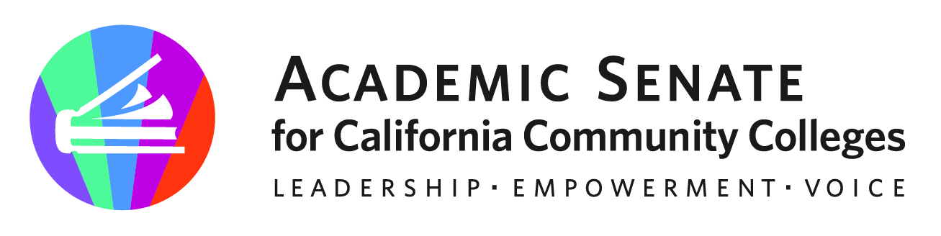
f

ASCCC CTE Leadership Committee

September 25, 2023

Meeting Summary

- Call to Order and Adoption of the Agenda – Meeting started at 4:02pm

Stephanie Curry – Chair* | John Grounds* | Marie Templo-Capule*
Christopher Howerton – 2nd Chair* | Alexander Jones* | Sigrid Williams*
Amar Abbott* | Nicole Marquez
Jimmie Bowen | Brian Palmiter* | Lynn Shaw*
Alana Gates | Stephanie Rowe

- Approval of September 1, 2023 Minutes - The chair shared the draft meeting summary from 9/1 and shared the practice of submitting to ASCCC Exec for posting. No objection to the draft meeting summary. The chair will forward and post on the committee website.

- ASCCC and Regional Consortium

  - Debrief of Sept 21, 2023 Event – The first CTE Regional was held at Orange Coast College. The event was held in the college’s planetarium. This event was well attended near 50 attendees. The chair shared the topics and some observations from other attendees. Materials from the event will be uploaded to the ASCCC website with the event material.
  - Planning for Future Events – The chair shared the list of upcoming CTE Collaborative events that are scheduled (see below). One day workshop on CPL was shared by Sigrid Williams. CPL Summit: CPL Summit https://rccd-edu.zoom.us/meeting/register/tZcpdeygrTMtHd0rtwRGWTKgAx4NyRiEUWvt#/registration

- Proposed Resolutions Fall 2023
  - The chair shared some preliminary information about the upcoming Fall 2023 Plenary.
  - As we discussed the Plenary, the chair shared a tentative breakout session on CTE and sought if there were any committee members who wanted to be co presenters. The chair will follow up with an email to the committee.
  - The title and description for the breakout session are in draft form and will be adjusted before the event.
  - Sigrid offered the idea about the funding at the federal level with CTE focus on livable wages and lifelong skills. Certificates vs. associate degrees Especially as it relates to Dr. Christian’s new CCCCO Vision 2030, the Governor’s expressed focused, and CPL.

- Proposed Professional Learning
  - 8 Regional Collaborative Events (listed below)
  - The chair asked if there were any ideas on professional learning from the committee for the field. Such as webinars, etc.
    - CBE Webinar: There is some gap in understanding around CBE in the field, and if there is any need for some targeted sharing of why it’s important to have faculty involved, the challenges, and what it will really take to fully have CBE processes supported in an institution. This would allow some update on those practitioners who are starting this work and sharing experience. Brian Palmiter and working with some others. (Southwestern and Orange Coast College)
    - Work Experience and CPL Webinar: Example of ASL (Late Jan/early Feb)
    - Nontraditional Roles Webinar (March)
  - The chair asked the committee to continue thinking of any needed resources/tools that maybe need in the field.

- Rostrum Brainstorming
  - Amar suggested a possible topic on DEI in CTE
  - Lynn and Amar will work together to draft a Rostrum submission for the next deadline (January 14)
  - MAAP could be another topic for a Rostrum. History, evolution, and potential.
  - The chair is drafting a quick Rostrum Article on highlighting a few unique CTE programs. (e.g. Moorpark 50th anniversary on their exotic animal and training Management program, drone, airflight, etc.)
  - Follow up on the regional collaboration this year.

- Future Meetings – The chair will be sending out a poll for an October meeting, probably after CCAOE.

- Upcoming Events – The chair shared the following events:

AB 928 Webinar | September 27, 2023
Central Coast Regional Collaborative Event | October 6, 2023
Area Meetings | October 27, 2023
Fall 2023 Plenary | November 16-18, 2023
Central/Motherload Regional Collaborative Event | February 2, 2024
Inland Empire Regional Collaborative Event | February 9, 2024
San Diego/Imperial | March 2, 2024
North Far North Regional Collaborative Event | March 27, 2024
Los Angeles Regional Collaborative Event | May 3, 2024
Bay Area Regional Collaborative Event | May 10, 2024

- Adjournment – The meeting was adjourned at 4:54pm

Status of Previous Action Items

- In Progress (include details about pending items such as resolutions, papers, Rostrums, etc.)
  - South Central Coast Regional CTE Event – October 6, 2023 – Ventura District Offices

- Completed (include a list of those items that have been completed as a way to build the end of year report).

- Orange Country Regional CTE Event -September 21, 2023- Orange Coast College

