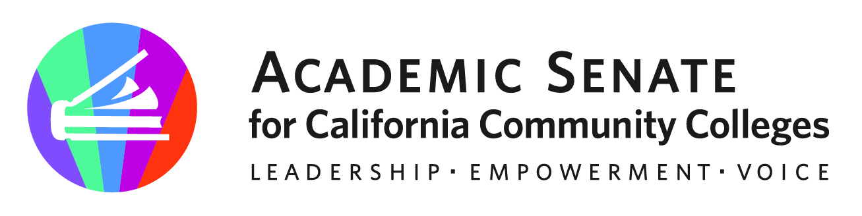

Equity and Diversity Action Committee

Tuesday, August 24, 2021

4:00 p.m.—6:00 p.m.

Zoom Info:

The Equity and Diversity Action Committee (EDAC) responds to resolutions from sessions that deal with the issues of equity, diversity, and inclusion in hiring, equal opportunity, and cultural diversity in the curriculum. EDAC recommends strategies that promote student equity and student success, including effective teaching and student learning styles and fostering a campus climate conducive to faculty diversity and student achievement. The committee provides overall guidance to colleges and recommendations to the Executive Committee with regard to the inquiry, design, and implementation of Guided Pathways frameworks and engages in broad, and inclusive discussion and inquiry about the diversity, action and inclusion integral in the Guided Pathways approach, framework and evidence. The Committee advises the Executive Committee on guidelines, laws and regulations relating to equal opportunity and cultural diversity and promotes the integration of equity and diversity issues in appropriate ASCCC activities.

Join from PC, Mac, Linux, iOS or Android: https://cccconfer.zoom.us/j/94576472664

Or iPhone one-tap (US Toll): +16699006833,94576472664# or +12532158782,94576472664#

Or Telephone Dial: +1 669 900 6833 (US Toll)

Meeting ID: 945 7647 2664

# **AGENDA**

1. Call to Order and Roll Call

|  |  |  |
| --- | --- | --- |
| Michelle Bean—Chair | Juan Arzola | Hermelinda Rocha |
| Robert Stewart, Jr.—2nd Chair | Nadia Khan | Roberto Rubalcaba |
|  | Theresa Oda-Burns | Lesile Shull |

1. Adoption of Agenda, Minutes Volunteer, and [Google Shared Folder](https://drive.google.com/drive/folders/1lCq_57cpHGVnZl_RcxU4HciMUHXLITaO?usp=sharing)
2. Shout-outs, Affirmations, and Lean-In: Laughter and Joy [Video](https://youtu.be/eQZmUxQ6j_8) and Prompt
3. Committee Charge Review (above) and [Committee Member Guidelines](https://drive.google.com/file/d/1U06EsumBJtQ3jPGDBnFJHxP70n8yYzdY/view?usp=sharing)
4. ASCCC Areas of Focus for 2021/2022: Culturally Responsive Student Services/Support and Curriculum, Equity Driven Practices, Transfer in the Higher Education System
5. Community Agreements Activity (Breakout Rooms)
6. 2021-2022 EDAC Goals and Priorities
   1. Review [RESOLUTIONS assigned](https://docs.google.com/spreadsheets/d/1MZXd_r_wVZZYu6AS_JOKv2IvZDtNlpIJ/edit?usp=sharing&ouid=111725550502413512650&rtpof=true&sd=true) and [last year’s committee recommendations](https://docs.google.com/document/d/1y3zdolOWE0Pc6of28mzMPqIuHZ8AKZMx/edit?usp=sharing&ouid=111725550502413512650&rtpof=true&sd=true)
   2. Review [ASCCC Strategic Plan](https://drive.google.com/file/d/1jAgtSE842fLKwss0j_shSBjLWJwZ2qnk/view?usp=sharing)
   3. Develop an EDAC work plan—priorities and volunteer assignments?
      1. Model Committee Appointment Process and Rubric
      2. ASCCC [Cultural Competency Plan Drafts](https://drive.google.com/drive/folders/11walv8Rr-IJspeTchvmlpMbH_sDeoK7u?usp=sharing)
7. EDAC/ACHRO Collaboration
   1. Virtual Fall Webinars
   2. Spring Regionals In-Person
   3. Suggestions and ideas?
8. *Rostrum* Articles
   1. Due September 24
   2. Ideas and suggestions?
9. Plenary Fall 2021
   1. Theme Ideas—add your thoughts [HERE](https://docs.google.com/document/d/1oz5-s_1uJhp-plpa0Ejp27bd1MBuhuc5BnHqIUS0JZg/edit?usp=sharing)
   2. Resolutions due September 17—any ideas and suggestions?
   3. Breakout presenters and session descriptions due October 1
10. CO/ASCCC Equity and Diversity Summit—save the date in January 2022
11. Monthly Meetings—what days and times work for you?
12. Announcements
    1. Check for upcoming events at [here](https://asccc.org/calendar/list/events)

* Academic Academy (October 7-8)
* Area Meetings (October 15 and October 16)
* Plenary (November 4-6)
  1. ASCCC office is now open (hybrid)—able to send out hard copies of handbooks, 10+1 cards, and papers again to colleges
  2. ASCCC Awards—new online portal for submissions coming this year
  3. Amazon Smile (smile.amazon.com)—select Foundation of the Academic Senate for California Community Colleges to donate
  4. [Application for Statewide Service](http://asccc.org/content/application-statewide-service)

1. Closing Comments
   1. In Progress Review
   2. Any other final comments or suggestions?
2. Adjournment

**In Progress:**

* EDAC Workplan and Goals

**Completed Tasks:**