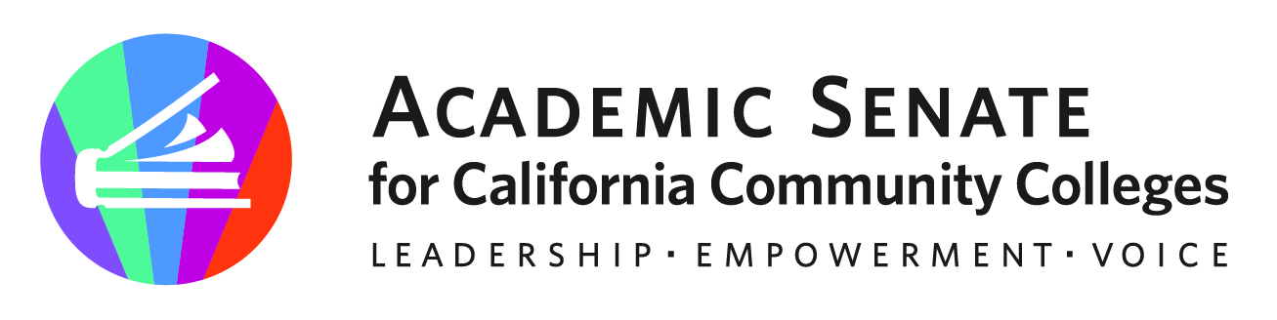

ASCCC Part-Time Faculty Committee

January 24, 2023

Attendees: Ian Colmer, Stephanie Curry, Suji Venkataraman, Robert L. Stewart Jr, Lindsay Weiler, Anastasia Zavodny, Elbina Rafizadeh

Guest: Gina Lam, ASCCC Researcher, Evan Hawkins, FACCC

Minutes

- Call to Order and Adoption of the Agenda
The meeting was called or order at 4:00 pm. The committee adopted the agenda by consensus

- Approval of November Meeting Minutes
The committee approved the November meeting minutes by consensus

- Part Time Faculty Symposium Debrief
The committee debrief on their participation at the FACCC Part Time Symposium. Committee members were also reminded of the upcoming FACCC Policy Webinar on Feb 3 “The Two-Tier System: Strategizing for Change”

- Part-Time Paper Survey Finalization
Committee members over the last month have provided input on the survey. Request from ASCCC to get it down to 40 questions. Gina will be finalizing the survey this week and sending out final version. We will be making this a central focus of the Regional Meeting in February. Questions will focus on areas where ASCCC an make an input.

- Part Time Faculty Equity Webinar Planning (Feb 24, 2023)
Committee discussed planning for the webinar. Recommended two 10-minute breaks, 50-minute sections, and interactive presentations. Committee members signed up to working on different sections. Stephanie will reach out to other committee members who were not able to attend today’s meeting to see their preferences.
Current Groups
  - Introduction (ASCCC VP Cheryl Achenbach) – Stephanie
  - Part Time Equity and Data – Elbina, Ian, Anastasia
  - Part Time Survey – Stephanie and Robert
  - Part Time Advocacy (in partnership with FACCC) – Evan and Suji
  - Part Time Role in Governance and Academic Senates- Lindsay

Stephanie will send out templates and groups are asked to get PPTs finalized by February 20, 2023. Stephanie will then send them to ASCCC to post for the event.

Stephanie asked members to share out the information on the webinar. Currently have 77 attendees signed up. Committee members stated that they had gotten notification of the event through the ASCCC and local senate representatives.

- Proposed Resolution
Committee reviewed a resolution that proposes a new Executive Committee member designated as an At Large Part Time position.
Feedback included
- Adding more emphasis on DEIA/IDEAA goals
- Address the current barriers for Part Time Faculty to qualify to run
- Need to address barriers for compensation

- Future Meetings

- Adjournment

Status of Previous Action Items

- In Progress (include details about pending items such as resolutions, papers, Rostrums, etc.)
- Part-Time Faculty Paper
- Part-Time Faculty Survey Revision
- Planning for ASCCC Part Time Faculty Regional Meeting Feb 24, 2023

- Completed (include a list of those items that have been completed as a way to build the end of year report).

- Presentation at FACCC Part Time Faculty Symposium (December 9, 2022)

