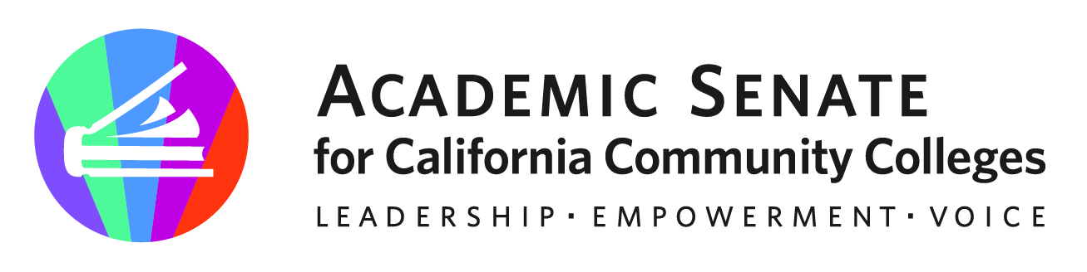

ASCCC Part-Time Faculty Committee

October 17, 2022

Attendees: Attendees: Stephanie Curry, Robert L. Stewart Jr. Anastasia Zavodny, Lorraine Levy, Sujatha Venkataraman, Elbina Rafizadeh, Ian Colmer,

Guests: Gina Lam, ASCCC

MINUTES

- Call to Order and Adoption of the Agenda

The meeting was called to order at 9:04am and the agenda and minutes were approved by consensus.

- Part-Time Paper Survey

The committee reviewed the survey created by last years committee to support the writing of the paper on Part-Time Faculty Equity. There are concerns that the survey may be too long. Committee members worked with Gina Lam ASCCC Research Associate in reviewing questions. Discussion topics included
- Narrowing down questions to those needed for paper data
- Looking at other sources including recent CCCCO survey on Professional Development
- Survey logistics including prioritizing order or questions and how much of a survey needs to be completed to be counted in the data.
Stephanie will post the survey draft in the committee’s shared Google Folder and committee members were asked to review the survey in light of the data needs for the paper.
Stephanie will send links and a reminder out to committee members.
Next meeting the committee will finalize the survey and plan for distribution.

- Adjournment

The committee adjourned at 9:02am.

Status of Previous Action Items

- In Progress (include details about pending items such as resolutions, papers, Rostrums, etc.)
- Part-Time Faculty Paper
- Part-Time Faculty Survey Revision
- Presentation at FACCC Part Time Faculty Symposium (December 9, 2022)

- Completed (include a list of those items that have been completed as a way to build the end of year report).

