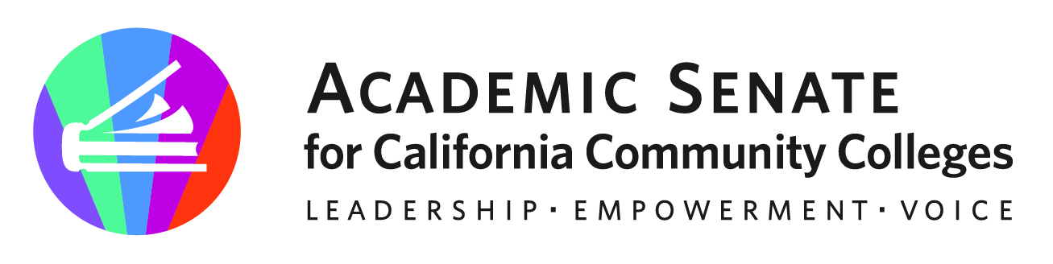

Rising Scholars Faculty Advisory Committee

March 15, 2023

via Zoom

MINUTES

Members: Cheryl Aschenbach (chair), Amber Gillis (2nd), Jacki Alvarez, Anne-Marie Beck, Ashley Knowlton, Arshia Malekzadeh, Donna Necke, Jessica Paisley, Edward Pohlert, Ariana Resendi, Angela Rhodes, Sarah Shepard, Teresa Ward (present in bold)

- Opening Business
  - Welcome – Cheryl welcomed committee members. Many absences due to spring breaks and schedule conflicts.
  - Agenda adopted.
  - Meeting Minutes for January 25, 2023 approved by those present.

- Reports
  - Member Reports-Members shared reports relative to their local work
    - Ariana shared info about a healing arts event (also shared via email) and explained more about It to members present. All are invited to share with others (students, faculty, and staff) and submit work for consideration as well as to attend the healing event.
    - Angela shared that she has been asked to present at an LA County social workers event that has a focus on currently and formerly incarcerated students so is looking for connections to learn more about local college services and community collaborations.
    - Ashley and Sarah talked about adjusting to the Canvas roll-outs in CDCR. A couple of problems that have surfaced are that there is very little memory on student devices for them to download instructional support materials or to save their own work. It was agreed that students should be able to keep their own work, perhaps with a cloud space dedicated to every student.
  - ASCCC/Rising Scholars Mellon Grant Update (Cheryl)
Cheryl shared that the Mellon Grant faculty team have organized and facilitated in-person regional events for clusters of colleges teaching in CDCR. These events have been well received. Work continues on further developing the faculty resources in Canvas and in holding monthly webinars for faculty points of contact at CDCR-aligned colleges.

- Discussion & Actions to Consider
  - Rostrum Articles-Members were encouraged to continue considering preparing and submitting a Rostrum article even though the last Spring 2023 deadline passed. Rostrum articles can be submitted in advance of the next due date in summer or early fall.
    - Provide input on ideas and volunteer if interested: https://docs.google.com/document/d/1W4Qn4bnGypmWvq9ZUNdWnrs8o9uBvm_plBt4henPPKs/edit (Thanks, Ari, for the page)
  - Spring Webinars
    - Potential for RS Ally training with Kellie. Cheryl talked with Kellie, a Rising Scholars Regional Coordinator, who is willing to do an ally training for or with us. Cheryl will follow-up with Kellie to organize a date.
    - Other ideas: https://docs.google.com/document/d/1W4Qn4bnGypmWvq9ZUNdWnrs8o9uBvm_plBt4henPPKs/edit
  - Initial Ideas for Committee Annual Work Plan (to be developed by May meeting)
Cheryl shared that partly because this is a new committee and partly to continue some of the Mellon grant efforts post-grant that she’d like this committee to make recommendations for a 2023-2024 work plan. We’ll discuss this more at the April meeting.
    - Review charge, consider revisions as needed
    - Webinars
    - Regional gatherings
    - Community of practice

- Other Items of Interest

- Adjournment

- Spring Meeting Schedule
  - Wed. April 26 @ 12:00-1:00 | link here
  - Wed. May 17 @ 12:00-1:00 | link here

- Resources
  - Rising Scholars Network Resources
  - ASCCC Rising Scholars Committee webpage
  - Rostrum Editorial Guidelines
  - USC Race and Justice Center Issues Briefs: Supporting Justice System-Impacted Students

