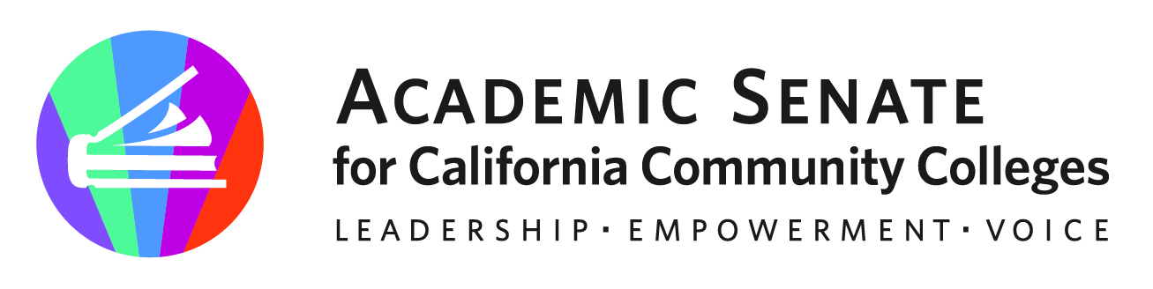

Rising Scholars Faculty Advisory Committee

April 26, 2023

Meeting Summary

Members Present: Cheryl Aschenbach (chair), Amber Gillis (2nd), Jacki Alvarez, Anne-Marie Beck, Ashley Knowlton, Donna Necke, Jessica Paisley, Angela Rhodes, Sarah Shepard

- Opening Business
  - Called to Order at 12:04pm.
  - Welcome
  - Agenda adopted
  - Meeting Minutes for January 25 and March 15, 2023 approved.

- Reports
  - Member Reports: Ashley shared current updates with local programs, including Humboldt State starting a BA program for incarcerated students, as well as concerns and challenges with using Canvas and teaching digital literacy in the classroom withing the existing parameters. Jacki also shared some successes that their local college with using computers and other hardware at their locations. Their local district uses a computer cart system that stays at the prison location so that there are computers available for classroom use. Ashley was expressing a need for one-pagers for technology help for students and Jacki offered the resources that she has and uses with their students. Sarah provided some updates, including the need for part-time faculty to have the same opportunity as full-time faculty that are paid an additional 30-minutes for every day that they work at a prison to offset time spent going through security. Sarah reported that they have not heard any definite no’s regarding this request. Jesy added that their local district is on board with compensation for all faculty (full-time and part-time) as they go through security or training, regardless of the outcome. Sarah offered contract language to Jesy to help their local district conversations. Jesy also shared some challenges and successes around peer mentoring for their students. Jesy also shared that title 5 language is restrictive and will share with the committee. Anne-Marie shared their local work, challenges and successes, including hiring formerly incarcerated persons at their local college and existing militaristic, problematic language in oaths of allegiance. Cheryl and Anne-Marie both learned that these oaths are not necessarily a local requirement but more of a state requirement. These oaths are keeping formerly incarcerated students from taking positions at their local college. Angela shared progress on upcoming presentation for formerly incarcerated students. They also shared progress in their local Admissions and Records to remove triggering language around academic probation. They also shared the success in removing the requirement for students to upload death certificates when having lost loved ones. Cheryl and Anne-Marie shared that Palomar College is creating videos for formerly incarcerated students. Jesy also shared challenges with their local college regarding language for “Academic Probation” and seeks help with ideas about how to have these conversations with their local district. Angela shared the recent ASCCC resolution that was just passed at the spring plenary session regarding triggering and punitive language around academic probation.

  - ASCCC/Rising Scholars Mellon Grant Update
Cheryl shared that two aspects of the Mellon Grant are developing a community of practice and developing professional learning resources to support high quality, equity-focused teaching in CDCR facilities. The Mellon Grant team facilitated 5 regional events in January, February, and March which brought together faculty teaching in CDCR in coordinated geographic clusters. Events were well received by attendees. There have also been 3 of 4 monthly faculty point of contact webinars for the 20 colleges doing CDCR instruction. The Canvas resources are under continued development.

- Discussion & Actions to Consider
  - Draft Committee Annual Work Plan
    - Review charge, consider revisions as needed – Sarah noted that there needs to be clarification regarding the various Rising Scholars-related committees and their purposes.
    - Webinars
      - RS Ally Training
      - Monthly point-of-contact webinars
      - Monthly office hours webinars
    - Regional gatherings
    - Community of practice
    - Other ideas: https://docs.google.com/document/d/1W4Qn4bnGypmWvq9ZUNdWnrs8o9uBvm_plBt4henPPKs/edit
  - Rostrum Articles
    - Provide input on ideas and volunteer if interested: https://docs.google.com/document/d/1W4Qn4bnGypmWvq9ZUNdWnrs8o9uBvm_plBt4henPPKs/edit (Thanks, Ari, for the page)
- Other Items of Interest

- Adjournment

- Spring Meeting Schedule
  - Wed. May 17 @ 12:00-1:00 | link here

- Resources
  - Rising Scholars Network Resources
  - ASCCC Rising Scholars Committee webpage
  - Rostrum Editorial Guidelines
  - USC Race and Justice Center Issues Briefs: Supporting Justice System-Impacted Students

