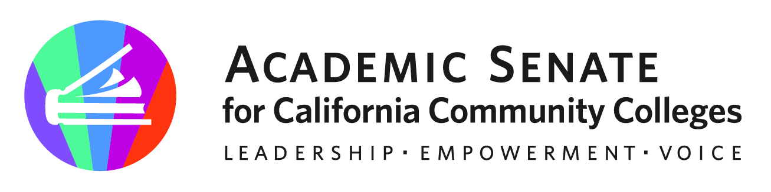

ASCCC Transfer, Articulation and Student Services Committee (TACCC)

November 14,2022

Attendees: Eric Wada, Stephanie Curry, Elizabeth Ramirez, Ty Simpson, Michelle Plug,

Minutes

- Call to Order and Adoption of the Agenda

The meeting was called to order to at 1:00 pm and the agenda was adopted by consensus

- Review of October 2022 Meeting Minutes
The committee approved the October Meeting minutes as amended to update the title acronym.

- Plenary Update

Committee members discussed the Plenary and the passing of multiple resolutions on General Education. Including supporting Cal-GETC, a new Local GE Pattern proposal and a CCC Baccalaureate Degree GE pattern.

Both resolutions submitted buy the committee were passed on the consent calendar.
o 4.01 General Education in the California Community College System Resources
o 4.02 F22 Proactive Planning and Support for Articulation and Counseling

Discussed how the committee can support discussions of General Education. Committee suggested workshops in the Spring on 1) What next 2) Supporting students in the transition of GE Patterns.

- RP Group Report on African American Transfer Tipping Point Report

The committee discussed the new RP Group Report on Transfer Tipping points and the negative impact of Probation on transfer velocity. Committee discussed the need to revise Title 5 language not just on the title of Academic Probation but also the negative impact on students. Perhaps a resolution in the spring and workshop.

- Rostrums (Due January 20, 2023)
  - Counseling and Systemic Changes (Elizabeth and Ty)
  - Supporting Early College (Eric, Stephanie and Stephanie)
  - CBE, Credit by Examination and Credit for Prior Learning and Transfer (Michelle)

- Future Meetings
Stephane will send out a Doodle Poll for a December Meeting.

- Adjournment
Status of Previous Action Items

- In Progress (include details about pending items such as resolutions, papers, Rostrums, etc.)
- Rostrum Article- The Articulation Officer’s Key Role in Curriculum, General Education and Transfer (November 2022)

- Completed (include a list of those items that have been completed as a way to build the end of year report).
- GE Webinar Series Fall 2022
Date | Subject | # of Attendees
Monday, Sept 12, 2022 (9-10:30am) | General Education Requirements of the Associate Degree, Baccalaureate Degree, and Associate Degree for Transfer | 179
Tuesday, Sept 13 (3-4:30pm) | General Education Requirements of the Associate Degree, Baccalaureate Degree, and Associate Degree for Transfer | 150
Tuesday, Sept 27 (12-1:30pm) | Role of local Academic Senates and Curriculum Committees in regard to general education | 128
Wednesday, Sept 28 (2-3:30pm) | Role of Articulation in Transfer in regard to general education | 120
Monday Oct 3, 2022 (9-10:30am) | Addressing the impact of CalGETC, as proposed on local colleges, programs and course and students | 200
Thursday Oct 6, 2022 (2-3:30) | Addressing the impact of CalGETC, as proposed on local colleges, programs, courses and students | 128
 |  | 902 Total Duplicated Attendees
- Rostrum Article- The Articulation Officer’s Key Role in Curriculum, General Education and Transfer (November 2022)
- Approved Resolutions (Fall 2022)
  - 4.01 General Education in the California Community College System Resources
  - 4.02 F22 Proactive Planning and Support for Articulation and Counseling

